SQL ASSIGNMENT – 8

Formatting Query output

Q1) Assume each Salesperson has a 12% commission.Write a query on the orders table that will produce the order number,the salesperson number and the amount of the Salesperson’s commision for that order.
Ans:
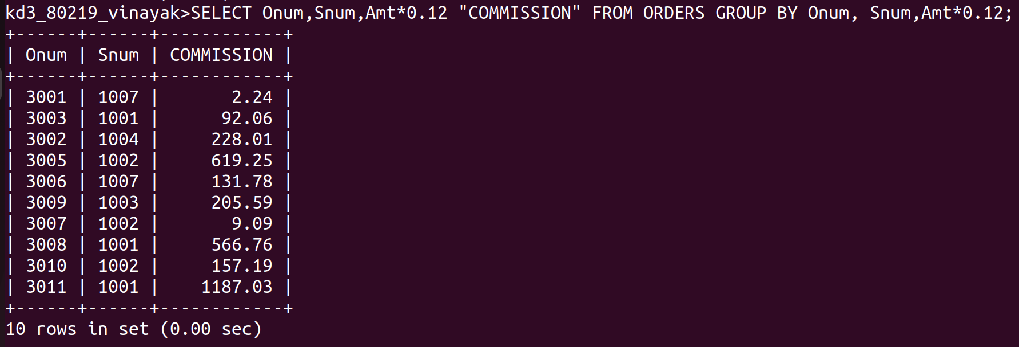

Q2) Write a query on the Customers table that will find the highest rating in each City. Put the output in this form :For the city (city), the highest rating is :(Rating)
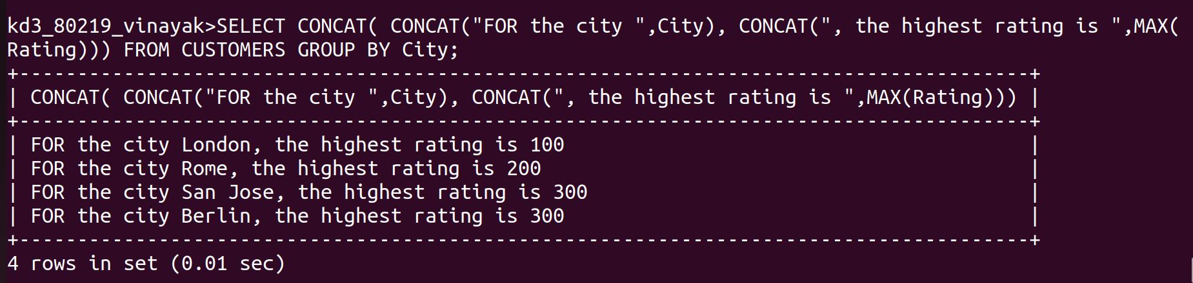
Ans :
Q3) Write a query that lists Customers in descending order of rating. Output the rating field first,followed by the Customer’s name and number.
Ans :

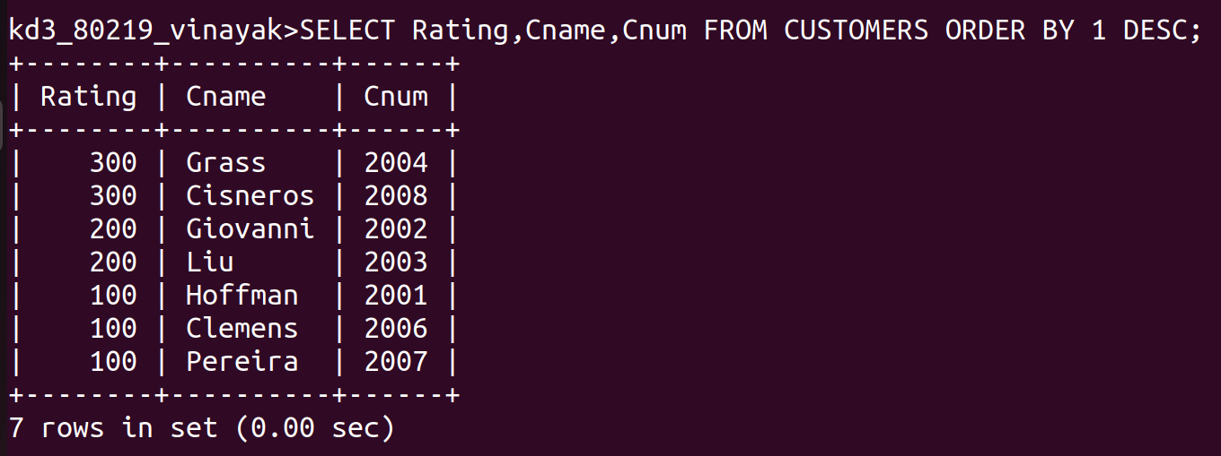

Q4) Write a query that totals the orders for each day and places the results in descending order.
Ans :

