SQL ASSIGNMENT – 5

Relational and Logical Operators.

Q1 ) Write a query that will give you all orders for more han Rs. 1,000

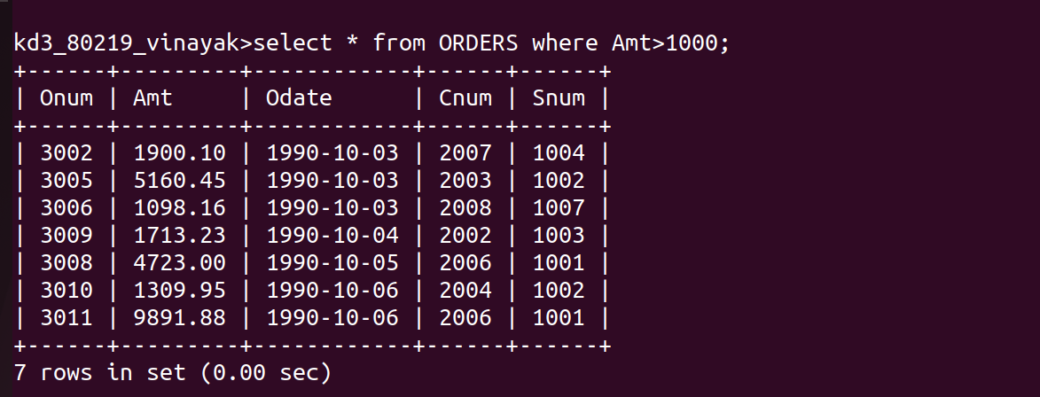

Q2) Write a query that will give you the names and cities fall salespeople in London with a commission above 0.10.

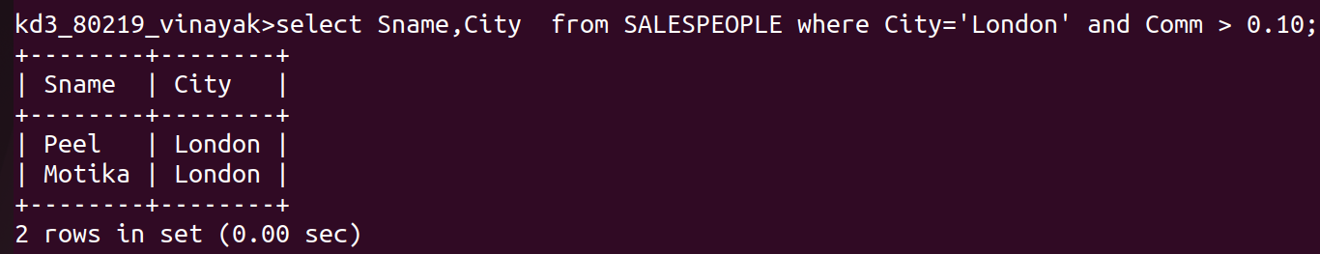
Q3) Write a query on the Customers table whose output ill exclude all customers with a rating < 100, unless hey are located in Rome.

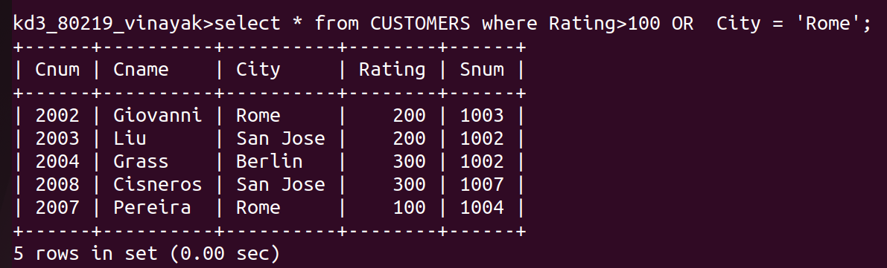

Q4) What will be the output from the following quer,

Select from Orders
where (amt < 1000 OR NOT (odate = ‘1990-10-03'
AND cnum > 2003));

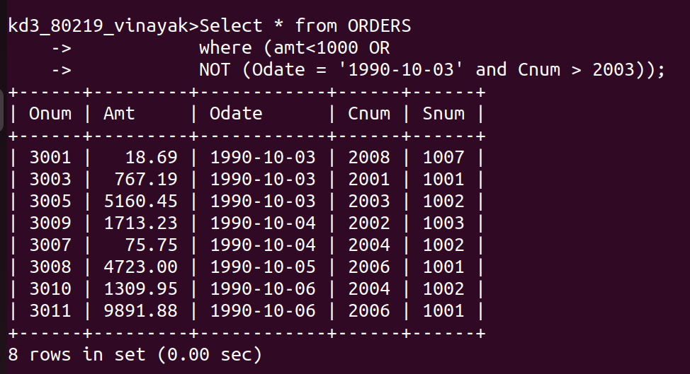

Q5) What will be the output of the following query?

Select from Orders
NOT ((odate = '1990-10-03 OR
snum>1006) AND amt >= 1500);
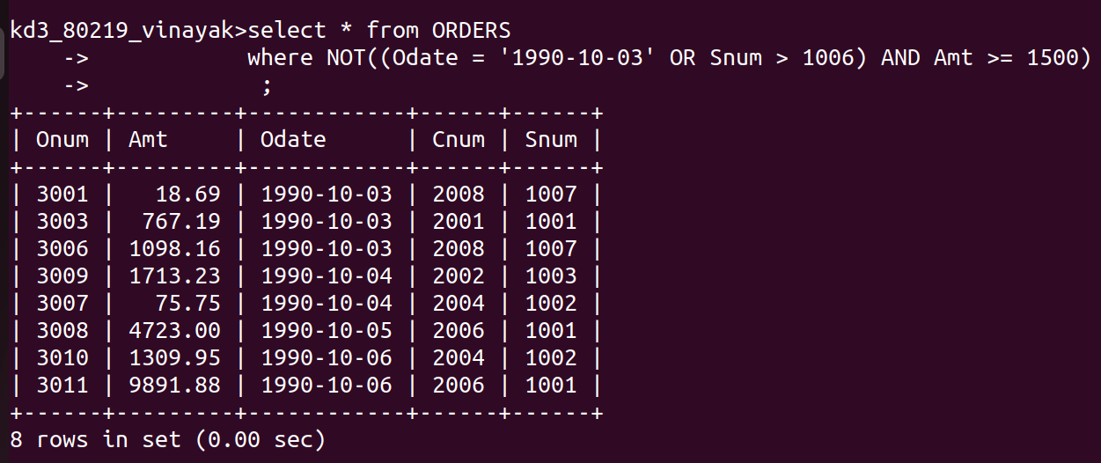

Q6) What is a simpler way to write this query?

Select snum, sname, city, comm From Salespeople
where (comm>.12 OR comm <.14);
