SQL ASSIGNMENT – 6

Using Special Operators in Conditions.

Q1) Write two different queries that would produce all orders taken on October 3rd or 4th ,1990.
Ans :

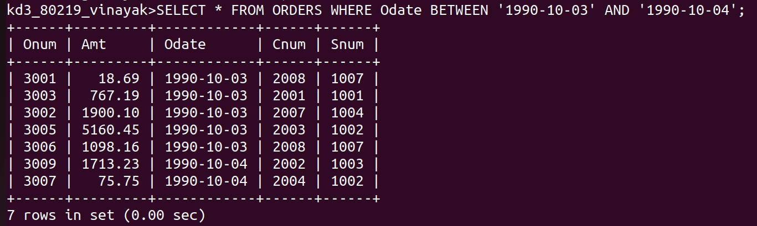

Q2) Write a query that selects all of the customers serviced by Peel or Motika.(Hint : the snum field relates the two tables to one another).
Ans :
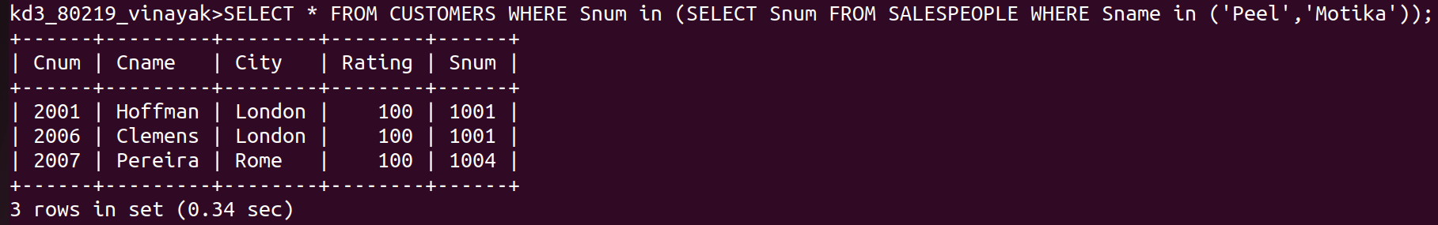

Q3) Write a query that will produce all the Customers whose names begin with a letter from ‘A’ to ‘G’.
Ans :

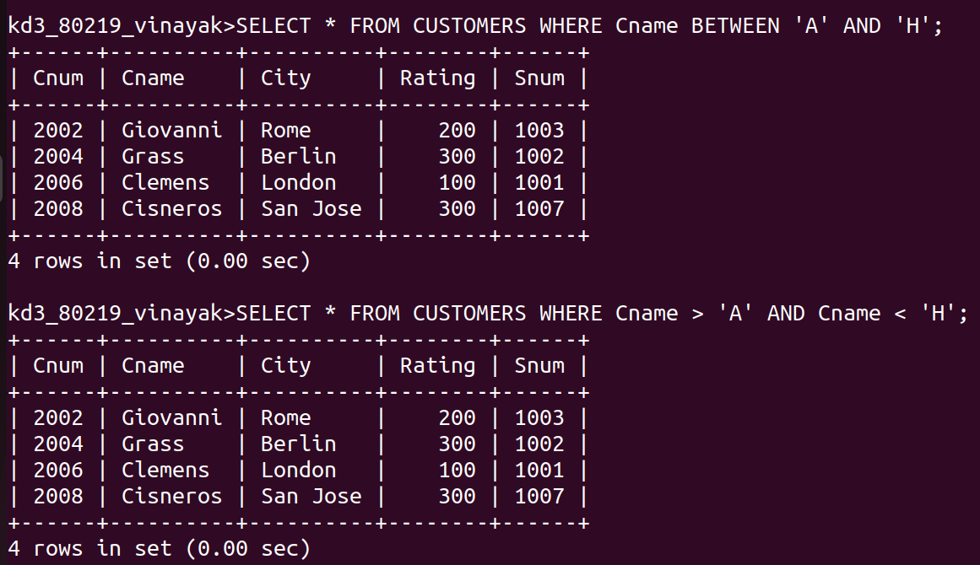

Q4) Write a query that selects all Customers whose names begin with the letter ‘C’ .
Ans :
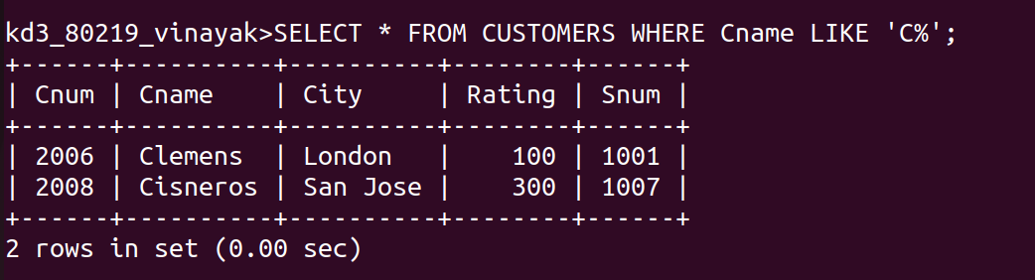

Q5) Write a query that selects all orders except those with zeros or NULLs in the Amt field .
Ans :

