NAME : VINAYAK TANAJI SHIPEKAR
ROLL NO : 80219
BATCH : KD3

Q. Create the following tables with the given structures and insert sample data as specified .

A) SALESPEOPLE :

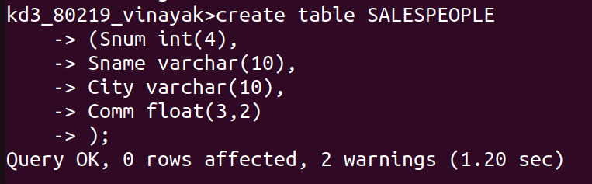

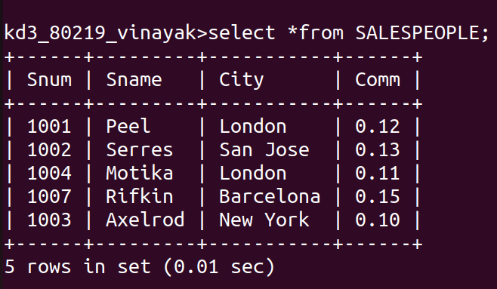

B) CUSTOMERS :

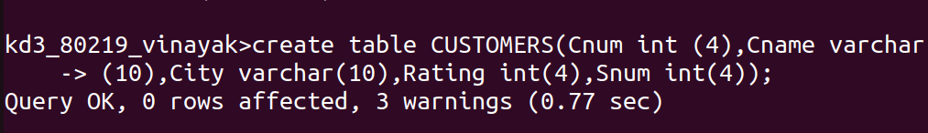

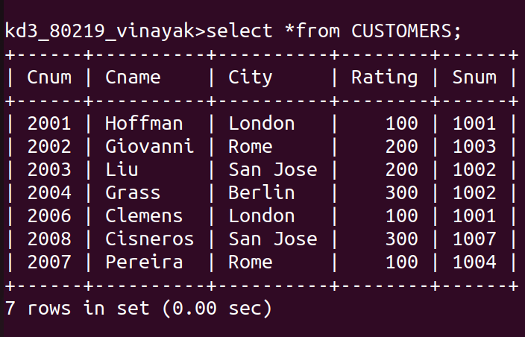

C) ORDERS :

