ROLL NUMBER:80220
BATCH:KD3
NAME:SHIVSHANKAR YASHWANT PATIL

Create the following tables with given structures and insert sample data as specified:
Table A)SALEPEOPLE:
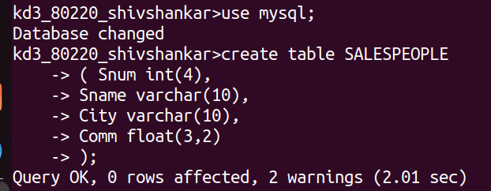

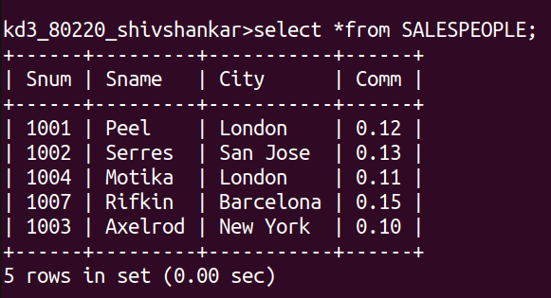

B)CUSTOMERS:
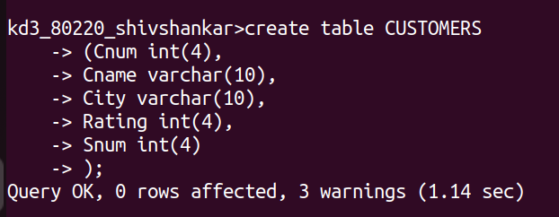
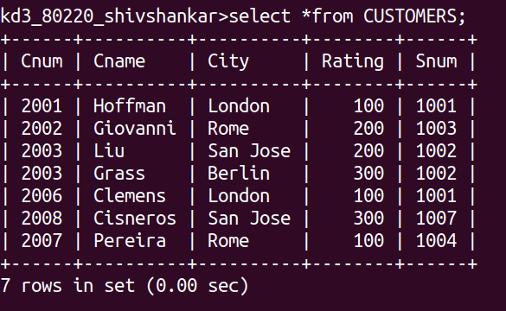

C)ORDERS:
