Assignment No 8

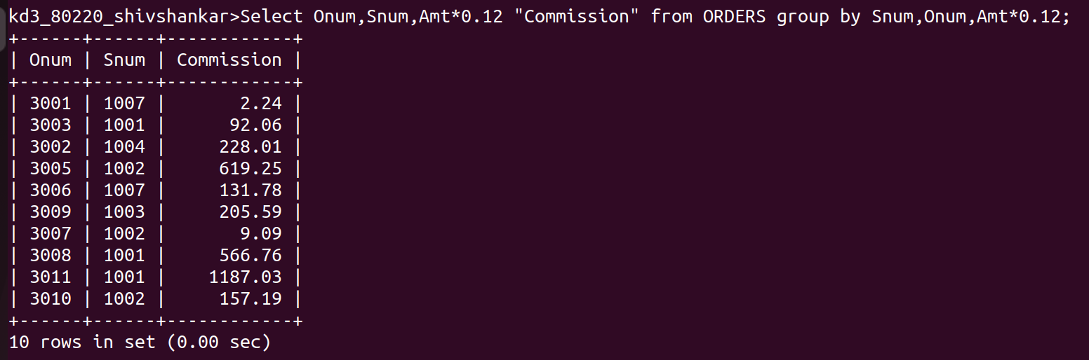
1) Assume each salesperson has a 12% commision. Write a query on the orders table that will produce the order number, the salesperson number, and the amount of the salesperson’s commision for that order.

2) Write a query on the customers table that will find the highest rating in each city. Put the output in this form:
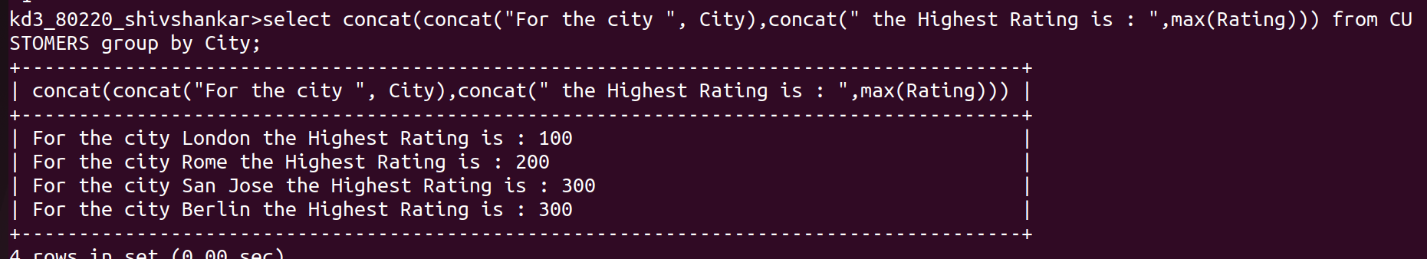
For the city (city) , the highest rating is:(rating);

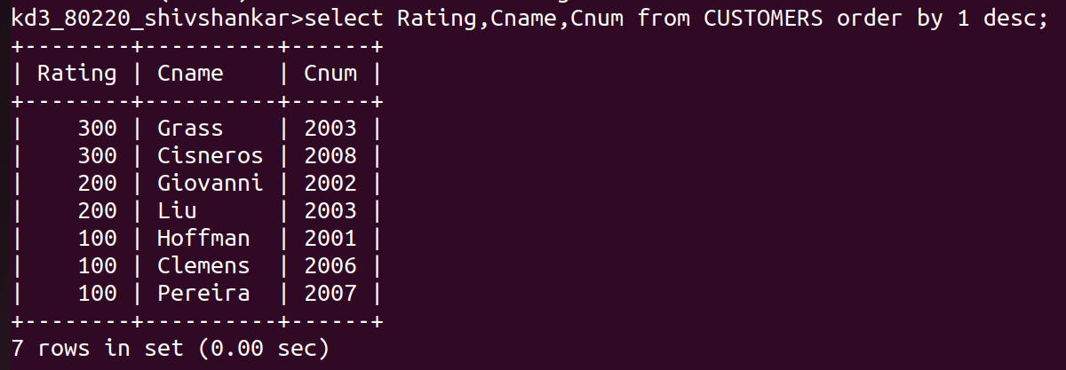
3) Write a query that lists customers in descending order of rating. Output the rating field first, folled by the customer’s name and number.

10) Write a query that orders for each day and places the results in the descending order.
