SQL Assignment 6

1) Write two different quries that would produce all orders taken on October 3rd or 4th ,1990.
Ans: 1st Query

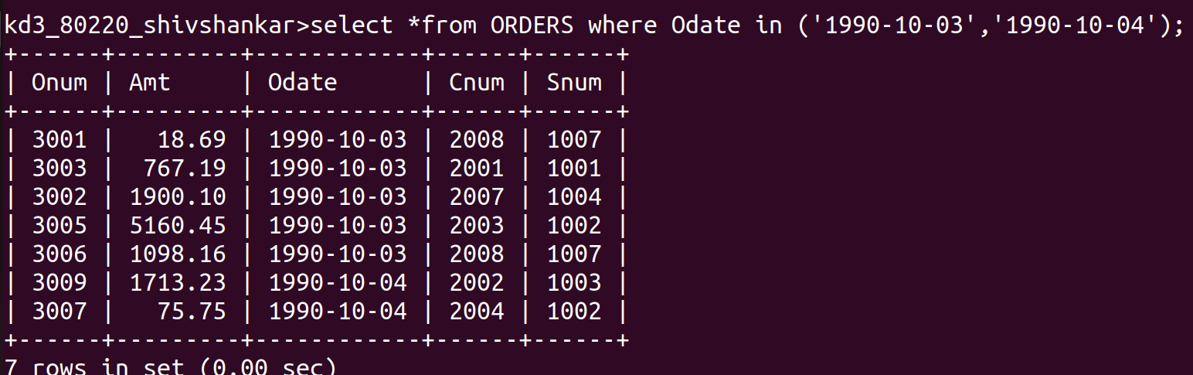
Ans: 2nd Query
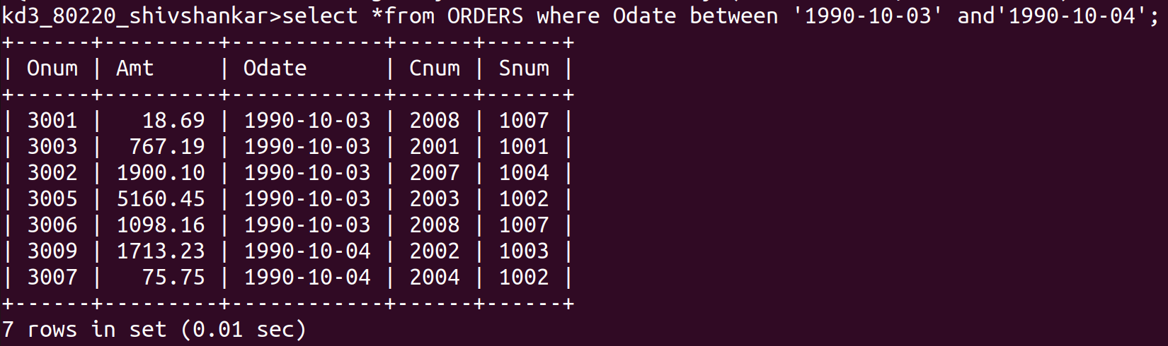

2)Write a query that selects all of the customers serviced by Peel or Motika.(Hint:the snum field relates the two tables to one another).
Ans:
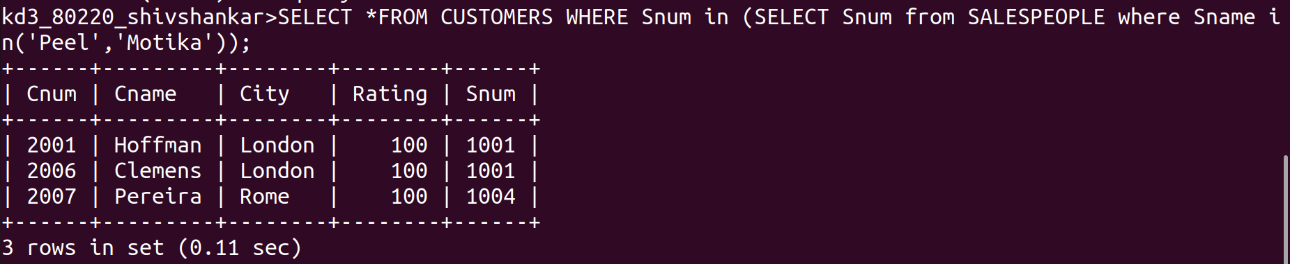

3) Write a query that will produce all the customers whose names begins with a letter from ‘A’ to ‘G’.
Ans:
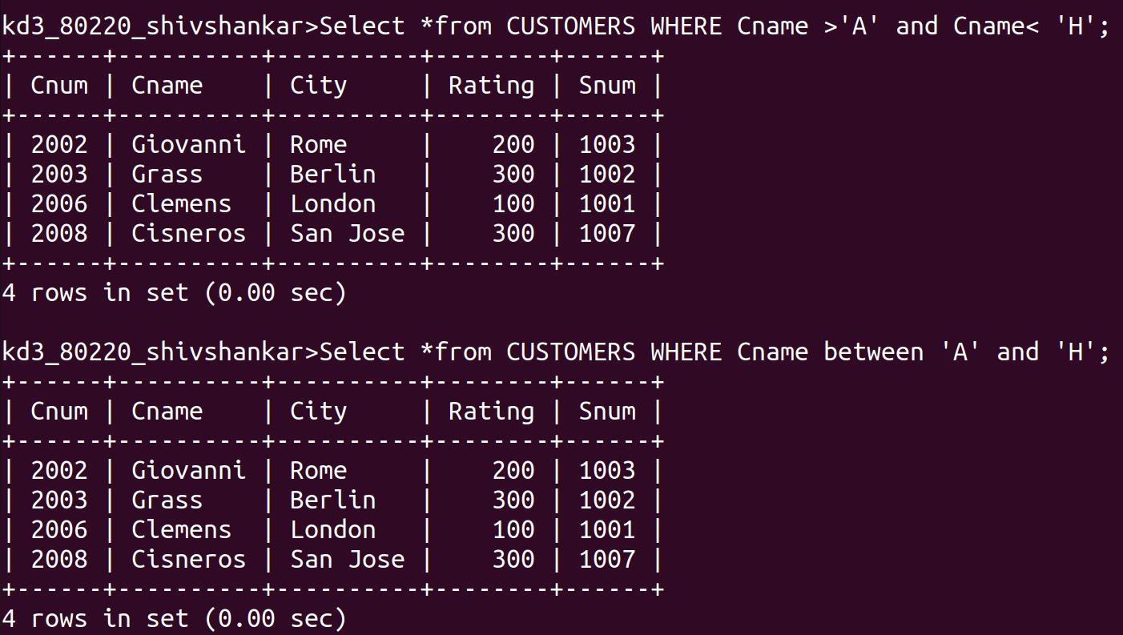

4) Write a query that selects all customers whose names begin with the letter ‘C’;
Ans:

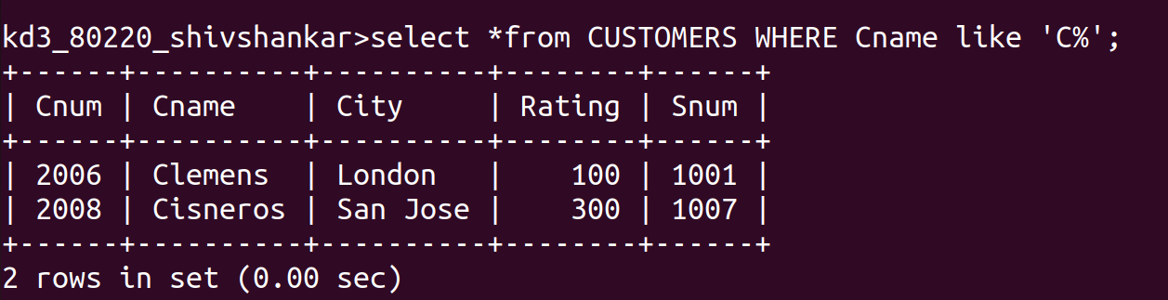

5)Write a query that selects all orders except those with zeroes or NULLs in the Amt field.
Ans:
