SQL Assignment 4

1)Write a select command that produce the order number, amount, and date for all rows in order table.
Ans:-
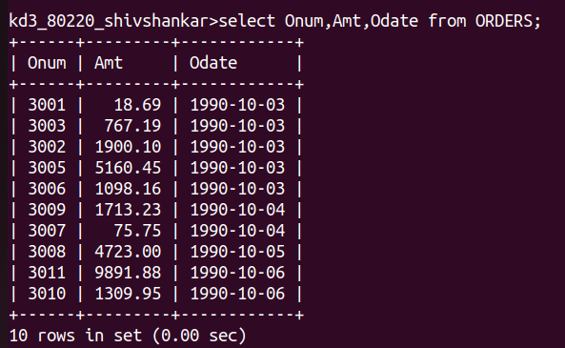

2) Write a query that produces all rows from the Customers table for which the salesperson's number is 1001.
Ans:-
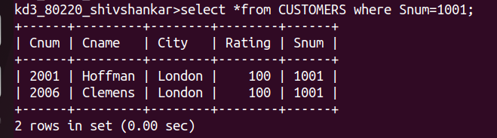

3) Write a query that displays the Salespeople table with the columns in the following order:
city, sname, snum, comm.
Ans:-
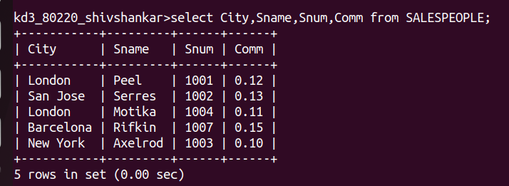
4) Write a select command that produces the rating followed by the name of each customer in San Jose.
Ans:-

