SQL Assignment 5

1) Write a query that will give you all orders for more Rs. 1,000.
Ans:-

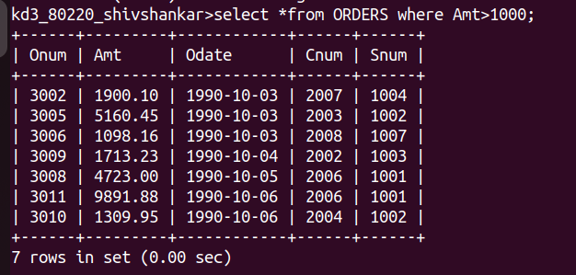

2) Write a query that will give you the names and cities of all salespeople in London with a commission above 0.10.
Ans:-
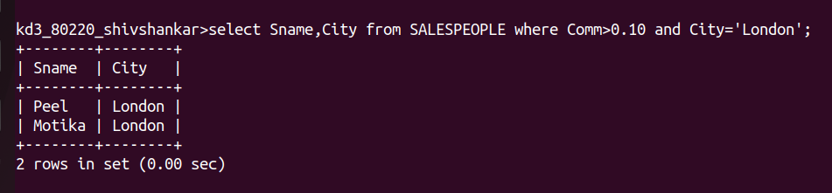

3) Write a query on the Customers table whose output wiIl exclude all customers with a rating <= 100, unless they are located in Rome.
Ans:-

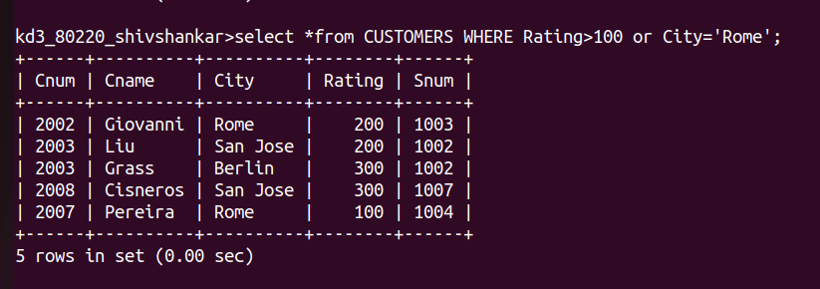

4) What will be the output from the following query
Select
* from Orders
where (amt < 1000 OR NOT (odate = '1990-10-03'
AND enum 2003));
Ans:-
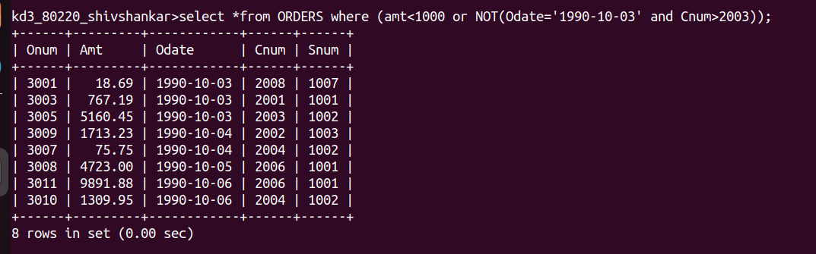

5) What will be the output of the following query?
Select from Orders where NOT ((odate = '1990-10-03' OR snum>1006) AND amt >= 1500);

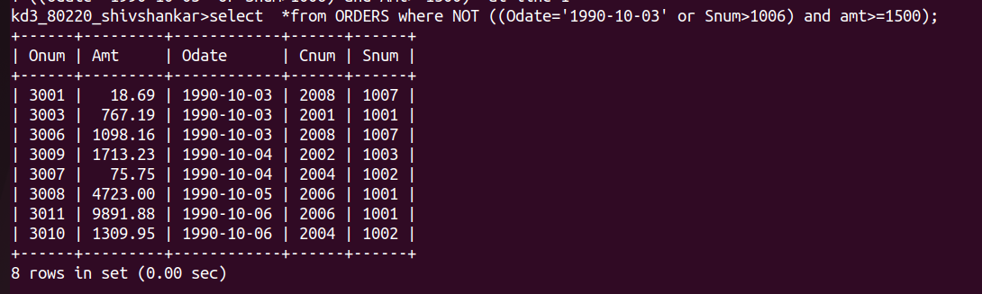

6)What is a simpler way to write this query?
Select snum, sname, city, comm From Salespeople where comm0.12 OR comm <0.14);
