Assignment No 7

1)Write a Query that counts all orders for October 3.
Ans:
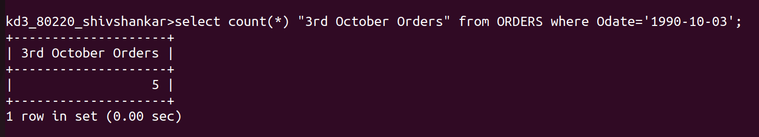
2)Write a query that counts the number o fdifferent non-NULL city values in the Customers table.
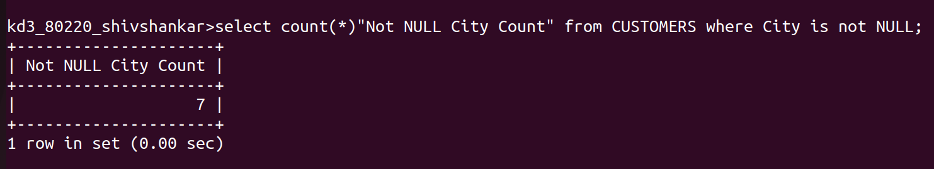
Ans:

3)Write a query that select each customers smallest order.
Ans:
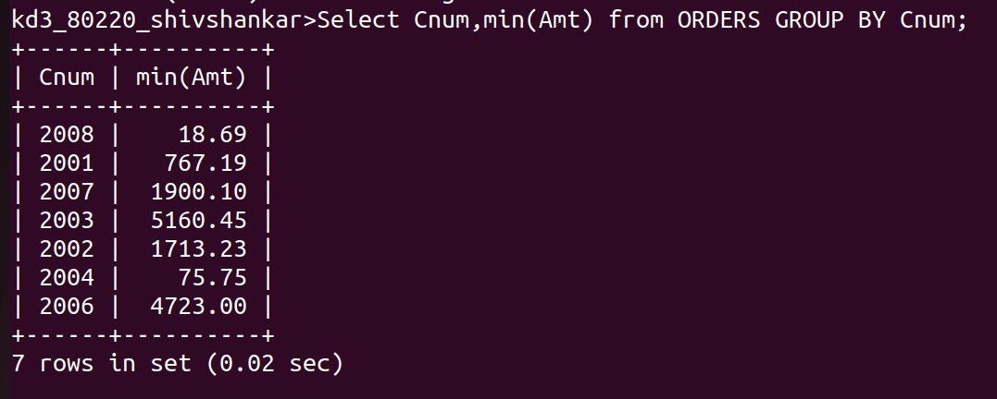

4)Write a query that selects the first customer, in alphabetical order,whose name begins with G.
Ans:
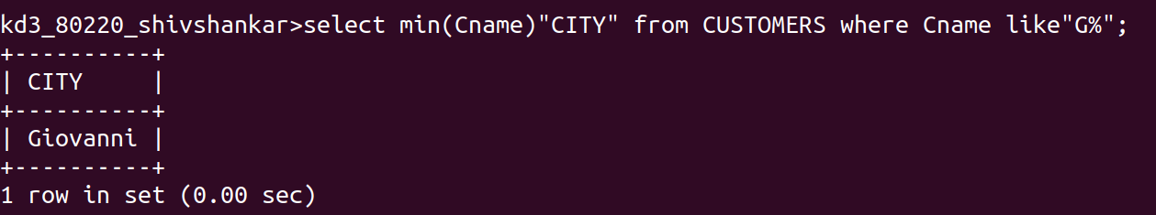

5)Write a query that selects the highest rating in each city.
Ans:
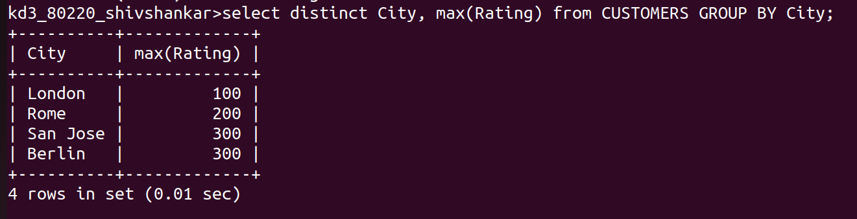
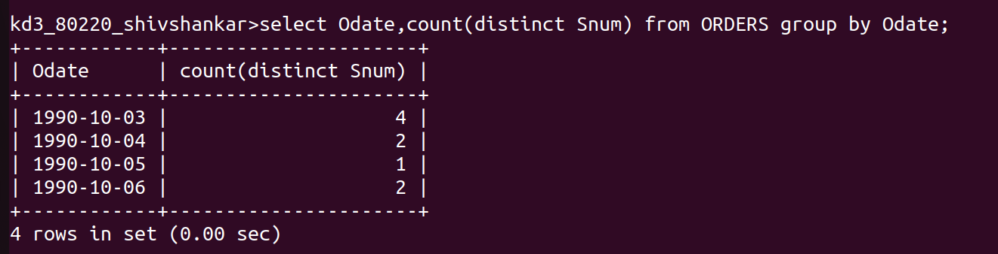
6)Write a query that counts the number of salespeople registering orders for each day(if a salesperson has more than one order on a givenday he or she would only counted once).

