Assignment No 11
Subqueries

1) Write a query that uses a subquery to obtain ll orders for the customer named Cisneros. Assume You do not know his customer number (cnum)

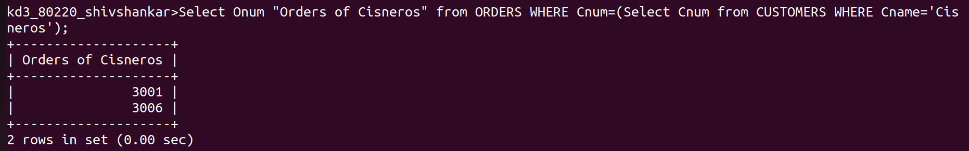
.

2) Write a query that produces the names an Ratings of all customers who have above-average orders.
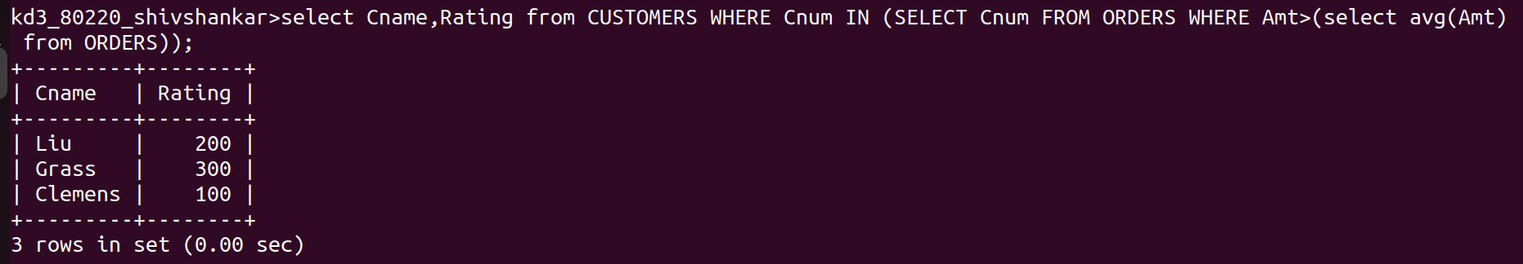

3) Write a query that selects the total amount in orders for each salesperson for whom this total is greater than the amount of the largest order in the table.

