Assignment No 12

Using the operators IN, ANY, and ALL.

1) Write a query that selects all customers whose ratings are equal to or greater than ANY of Serres.

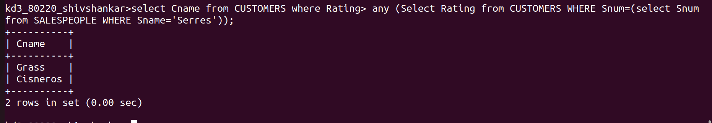

2) Write a query using ANY or ALL that will find all salespeople who have no customers located in their city.

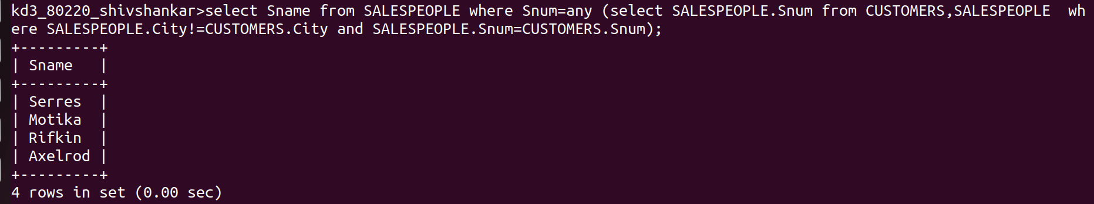

3) Write a query that selects all orders for amounts greater than any for the customers in London.
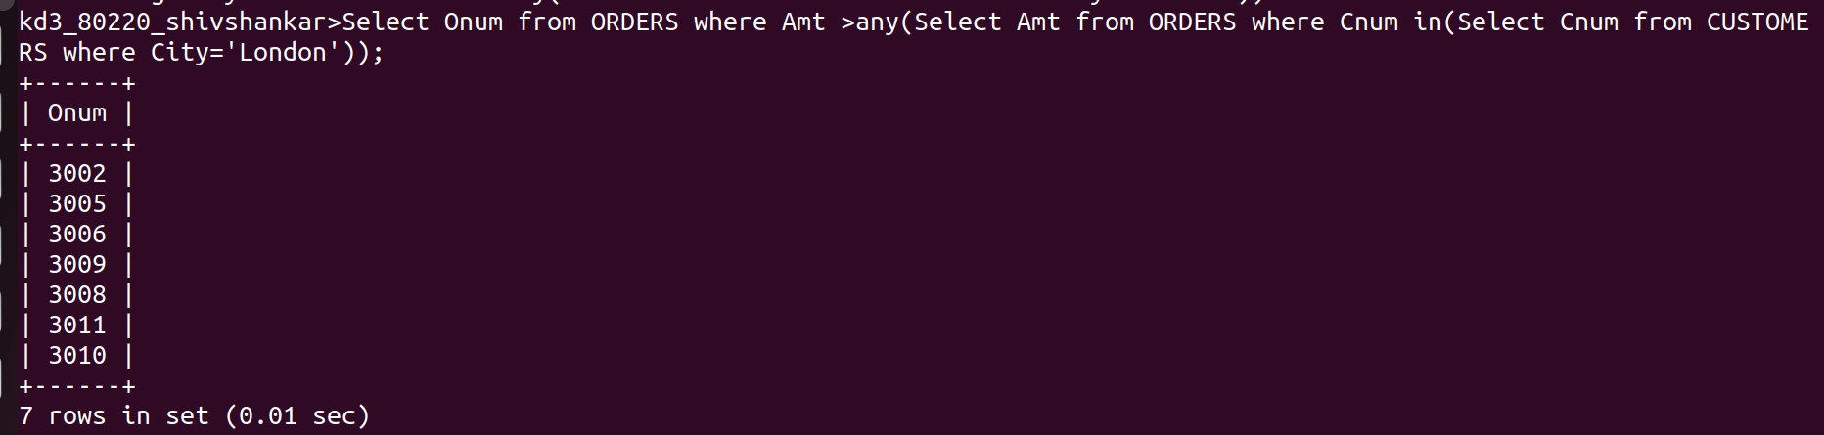


4) Write the above query using MIN or MAX.

