Assignment No 14

Entering, Deleting, and Changing Field Values.

1) Write a command that puts the following values In their given order, into the salespeople table: ity San Jose, name 1100. Blanco, comm- NULL, cnum
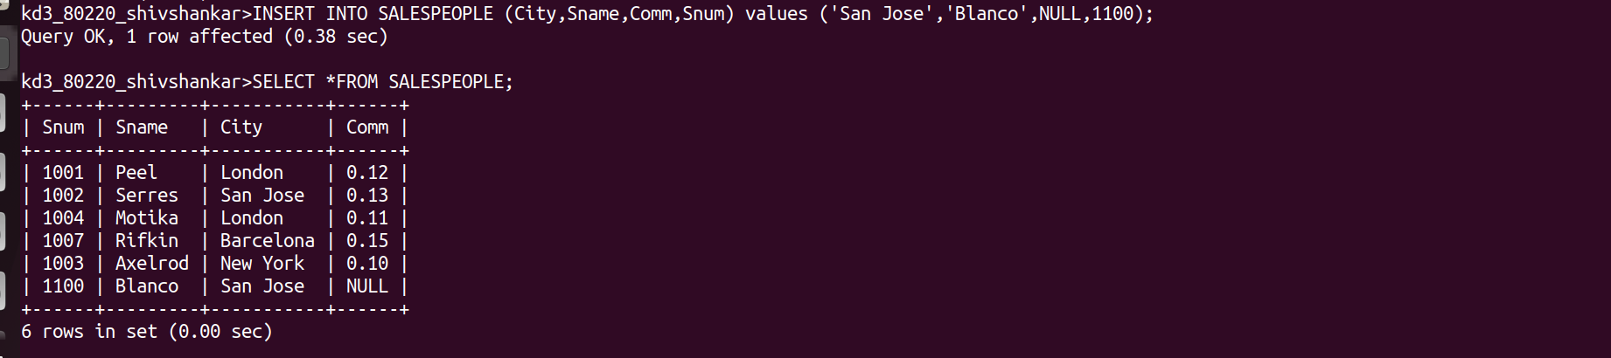

2) Write a command that removes all orders from ustomer Clemens from the Orders table.
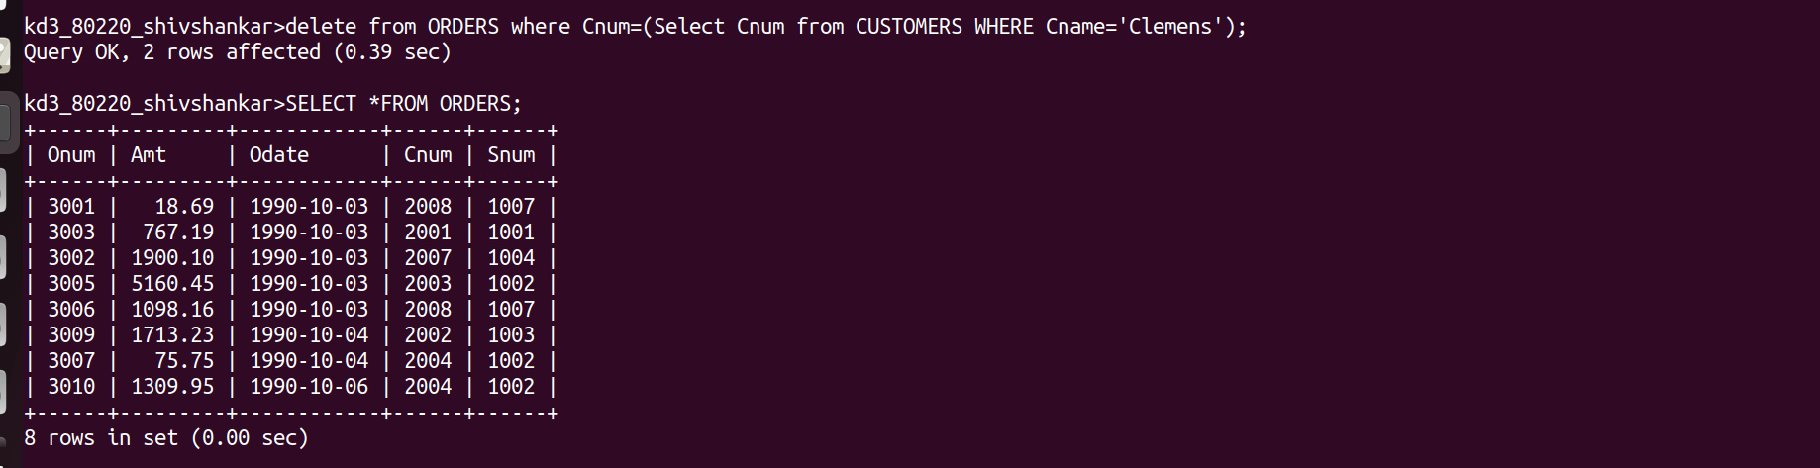

3) Write a command that increases the rating of all customers in Rome by 100.
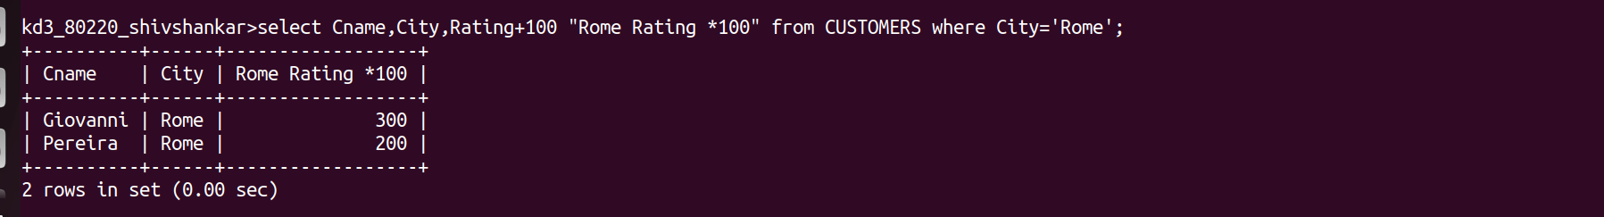

4) Salesperson Serres has left the company. Assign her customers to Motika.
