Assignment No 15

Using Subqueries with DML Commands.

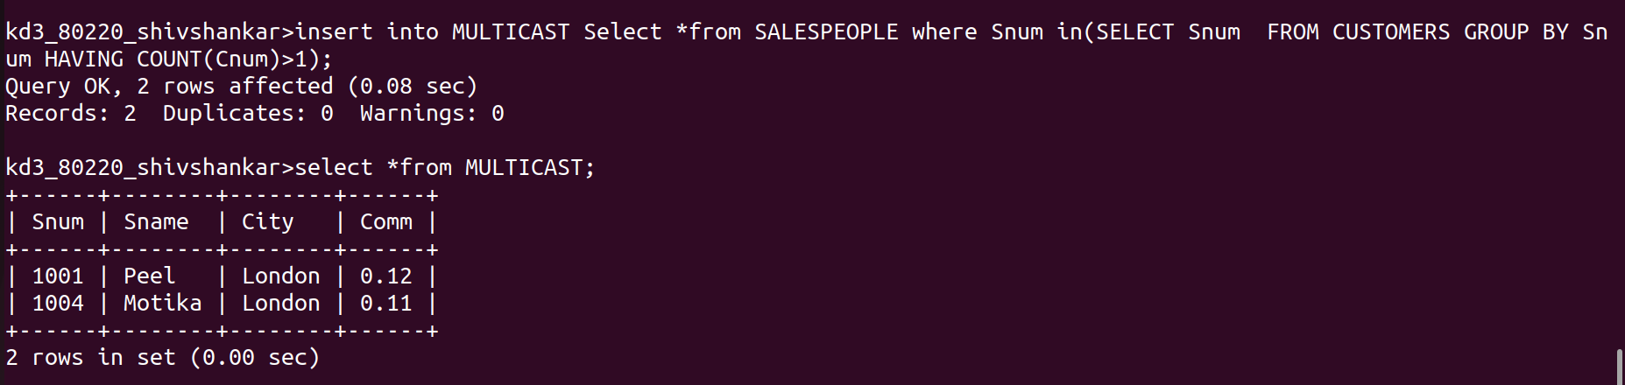
1) Assume there is a table called Multicust, with). all of the same column definitions as Salespeople. Write a command that inserts all salespeople with S ore than one customer into this table.

2) Write a command that deletes all customers with no current orders.

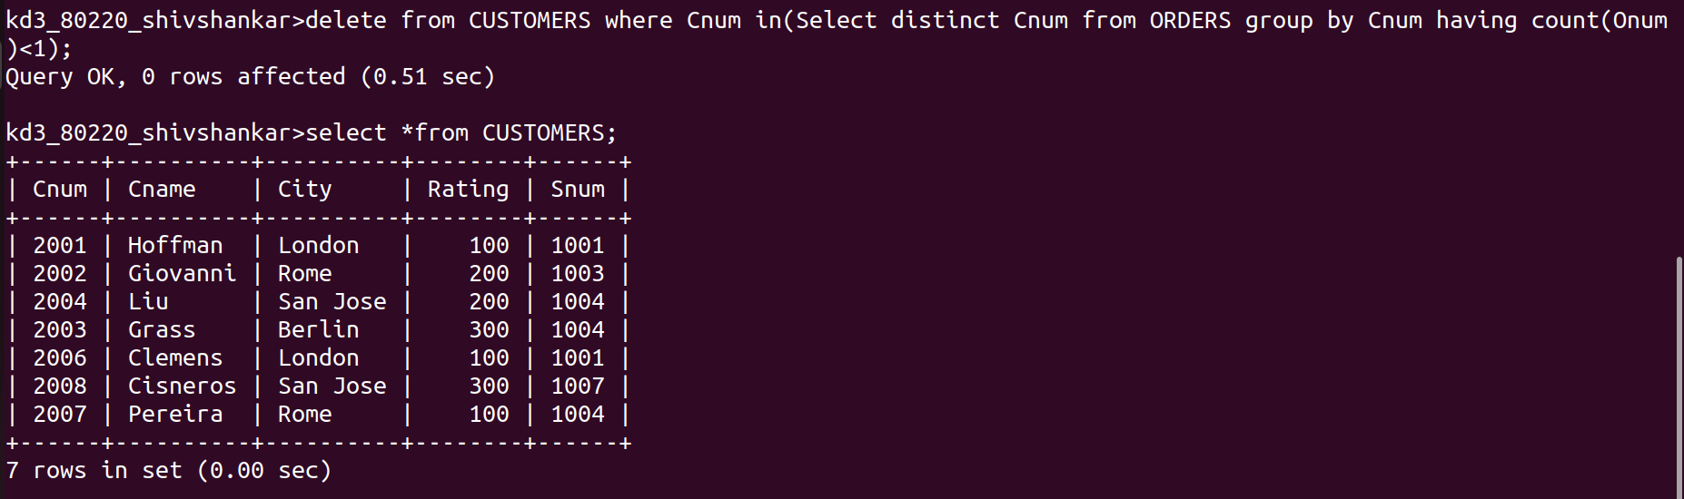

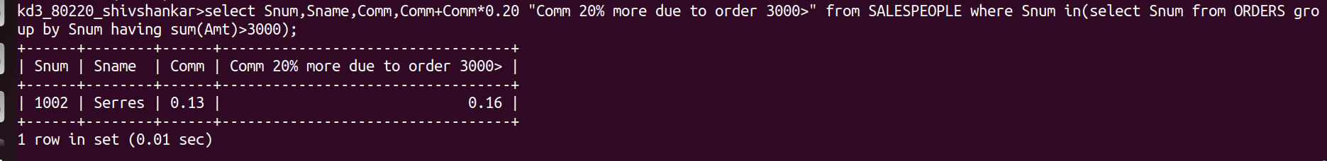
3) Write a command that increases by twenty percent the commissions of all salespeople with total orders above Rs. 3,000.

