SQL Assignment 14
Question1:Write a command that puts the following values, in their given order, into the salespeople table: city – San Jose, name – Blanco, comm – NULL, snum – 1100.
Answer:

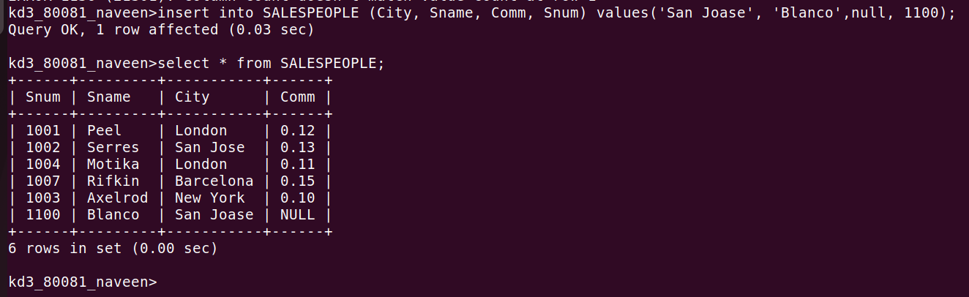

Question2:Write a command that removes all orders from customer Clemens from the Orders table?
Answer:

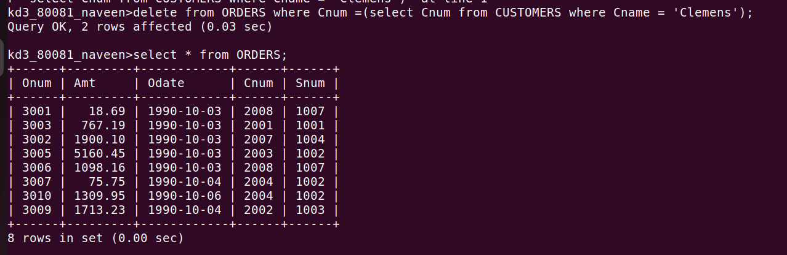

Question3:Write a command that increases the rating of all customers in Rome by 100?
Answer:

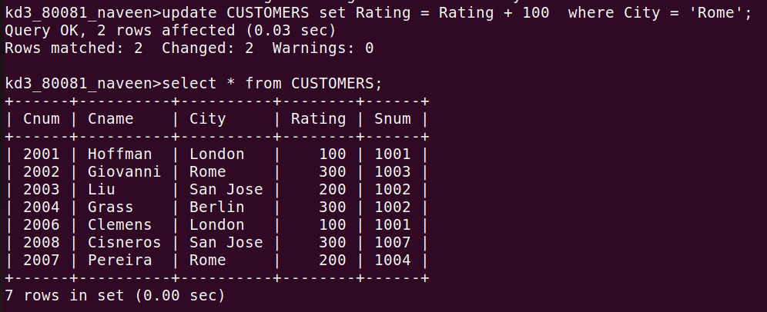

Question4:Salesperson Serres has left the company. Assign her customers to Motika?
Answer:

