SQL Assignment 15
Question 1:Assume there is a table called Multicust, with all of the same column definitions as Salespeople. Write a command that inserts all salespeople with more than one customer into this table
Answer:

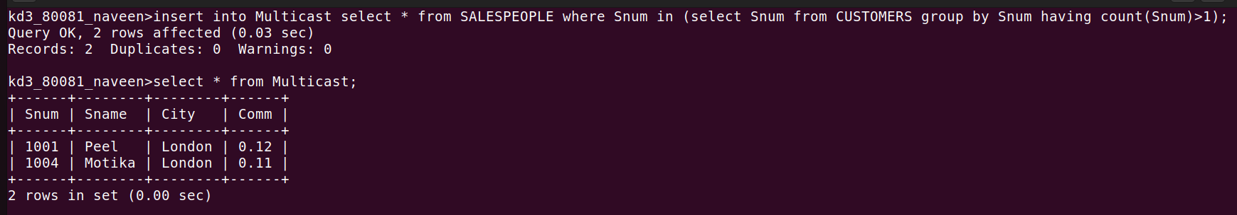

Question 2:Write a command that deletes all customers with no current orders?
Answer:
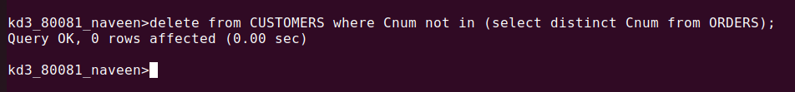

Question 3: Write a command that increases by twenty percent the commissions of all
salespeople with total current orders above Rs. 3,000.
Answer:

