SQL Assignment -7

Question 1: Write a query that counts all orders for October 3?
Answer:

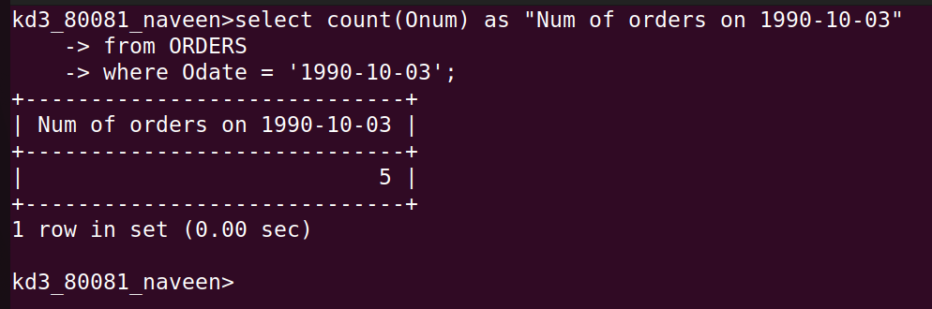
Question 2: Wrte a query that counts the number of different non-Null city values int the customers table?
Answer:
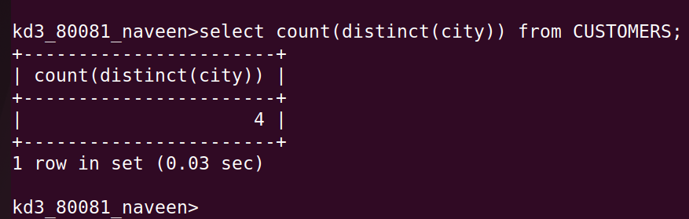

Question 3: Write a query that selects each customer’s smallest order?
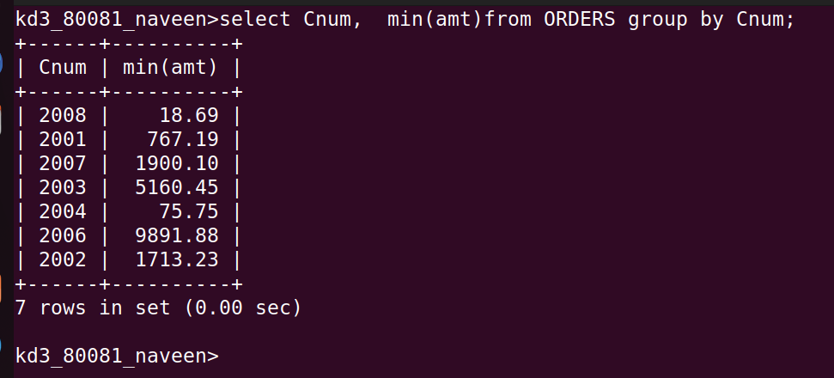
Answer:

Question 4: Write a query that selects the first customer in alphabetical order, whose name begins with G?
Answer:
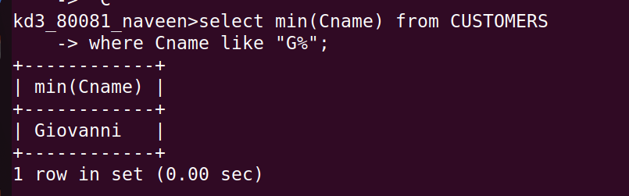

Question 5: Write a query that selects the highest rating each city?
Answer:
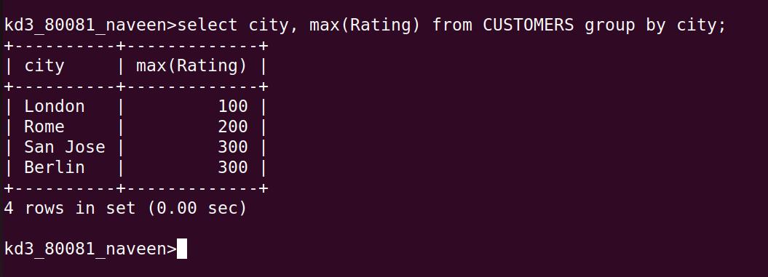

Question 6: Write a query that counts the number of SALESPEOPLE registering orders for each day.(If a salesperson has more than one order on a givenday he or she should be counted only once)?
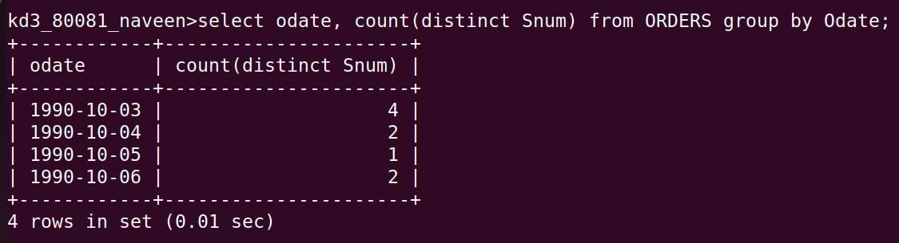
Answer:

