SQL assignment -9

Question 1: write a query that lists each order number followed by the name of the customers who made the order?
Answer:
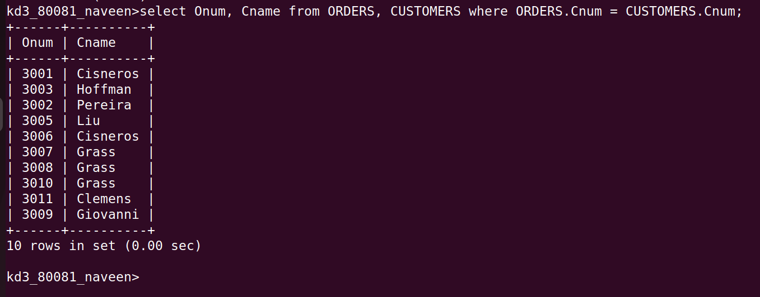
Question 2:Write a query that gives the names of both the salesperson and the customer for each order along with the order number?
Answer:
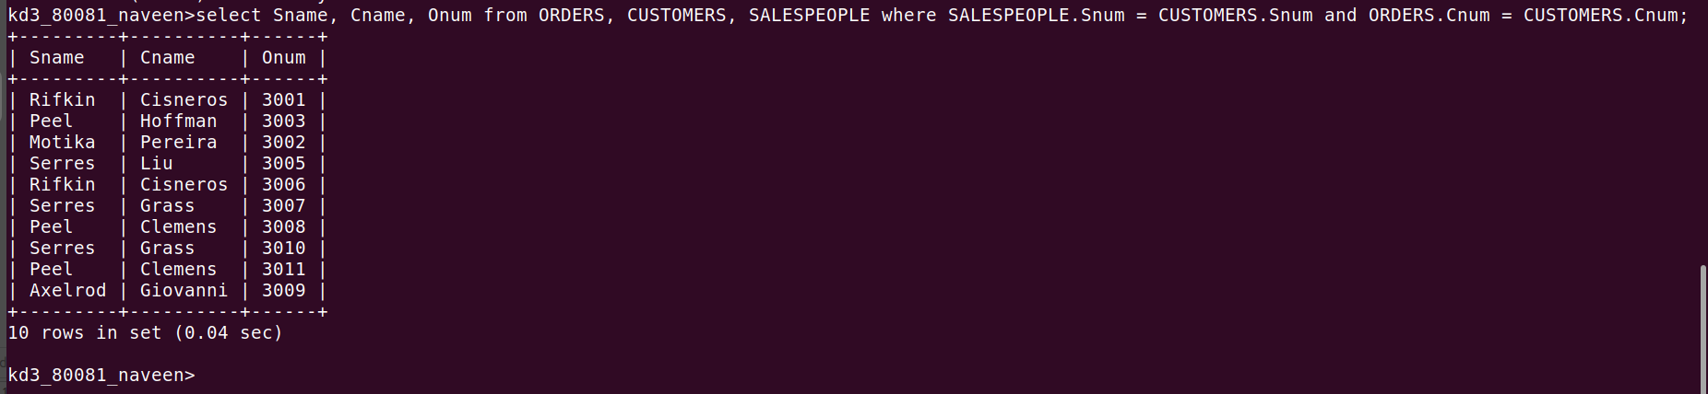
Question 3: Write a query that produces all customers serviced by salespeople with a commission above 12%.Ouput the customers name ,the salesperson name,and the salespersons rate of commission?
Answer:
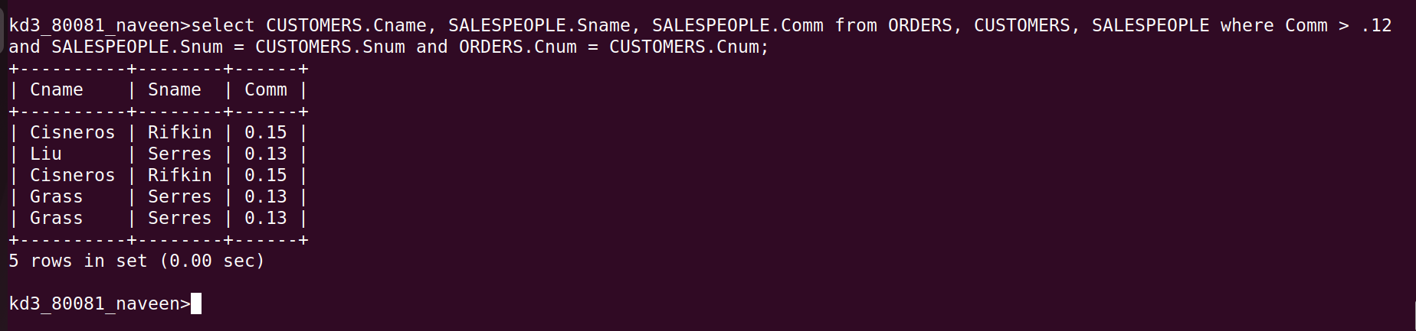

Question 4: Write a query that calculates the amount of the salesperson commission on each order by a customer with a rating above 100?
Answer:
