SQL Assignment 11

Question 1: Write a query that uses a subquery to obtain all orders for the customer named Cisneros.Assume you do not know his customer number (cnum)?
Answer:
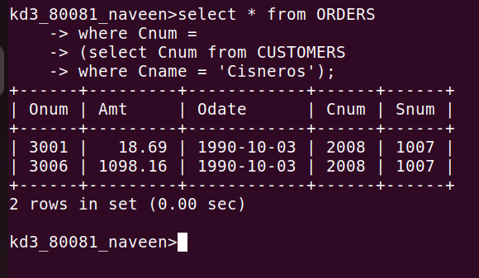
Question 2: Write a query that produces the names and ratings of all customers who have above-average orders?
Answer: AVG of AMT
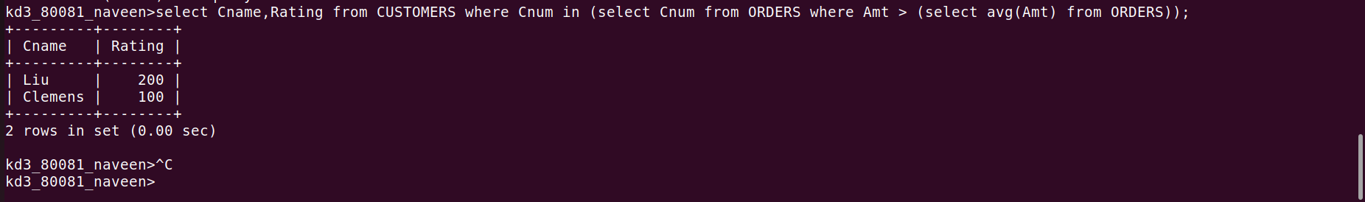
AVG of ORDERS
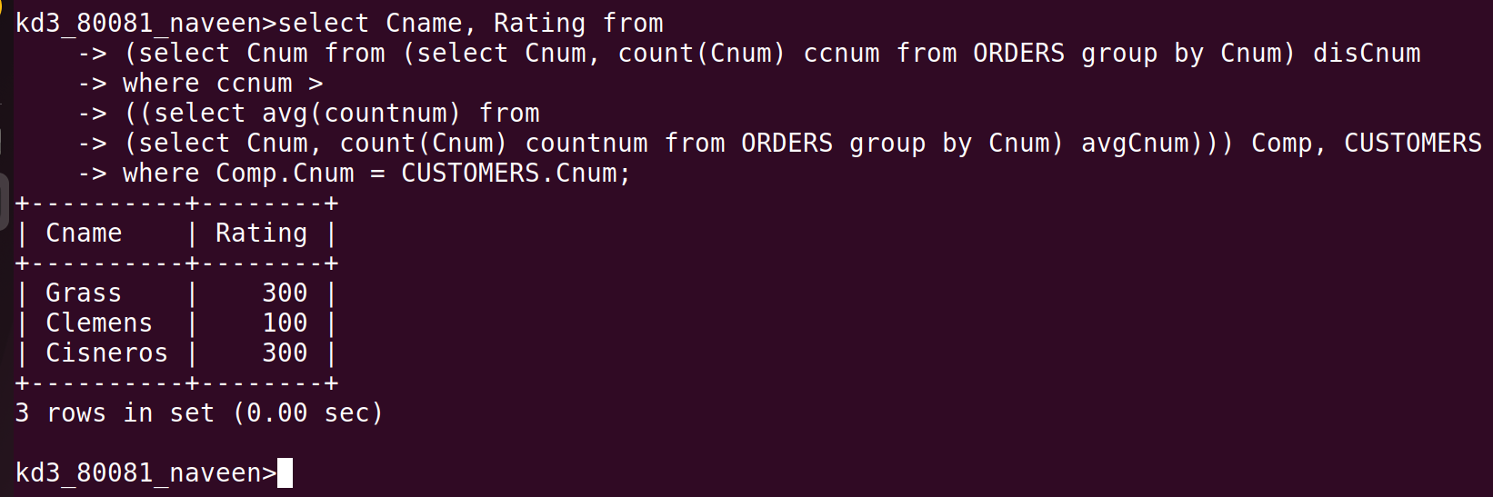
Question 3: Write a query that selects the total amount in orders for each salesperson for who this total is greater than the amount of the largest order in the table?
Answer:
