SQL Assignment 6

Ques1: Write two different queries that would produce all orders taken on October 3rd or 4th,1990?
Answer:

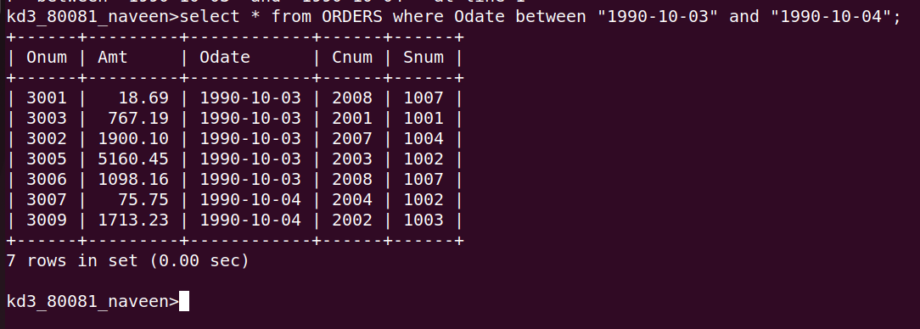

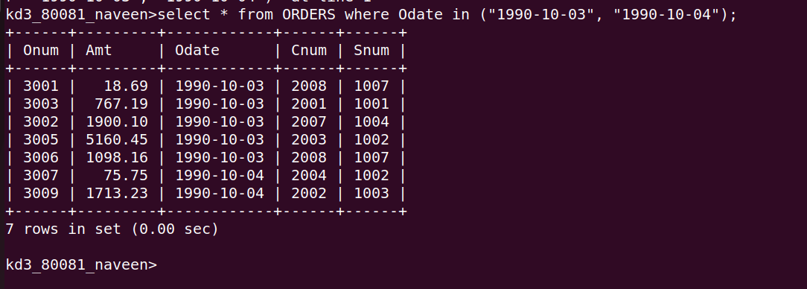

Ques2: Write a query that selects all of the customers serviced by Peel or Motika?
Answer:
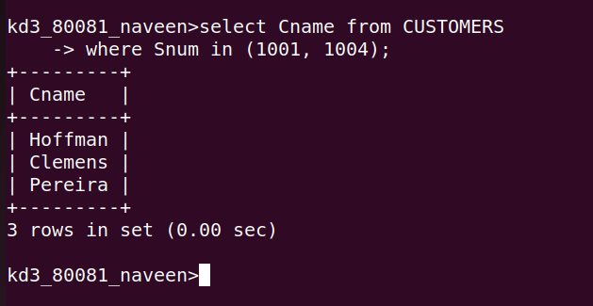

Ques3: Write a query that will produce all the customers whose names begin with a letter from ‘A’ to ‘G’?
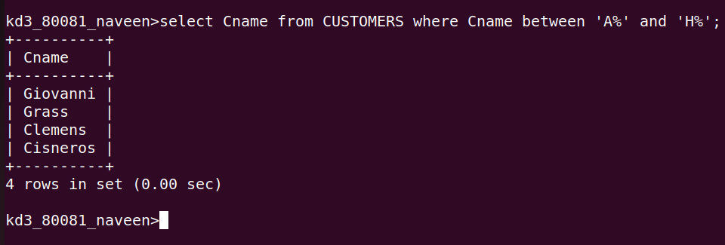
Answer:

Ques4: Write a query that selects all customers whose names begin with letter ‘C’?
Answer :
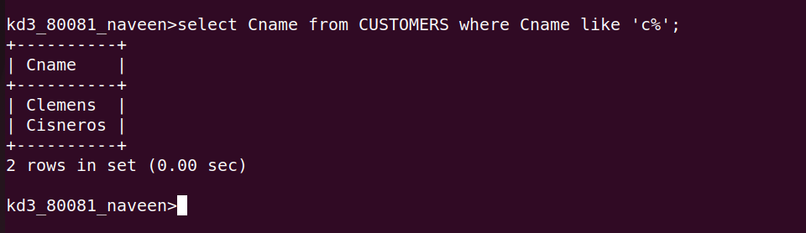

Ques5: Write a query that selects all orders except those with zeroes or NULLs in the amt field?
Answer:

