MongoDB Assignement

6: View list of available databases?
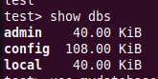

7: Create a new database named CDAC and connect to it?
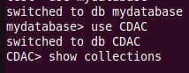

8: View list of available collections in CDAC Database?

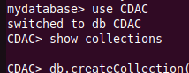

9: Create a new collection by the name of LIBRARY?
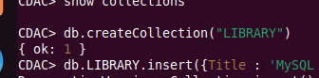

10: Insert the following document in the LIBRARY collection:
title:”Mongo programming”,
author:”Sameer”,likes:”100”?
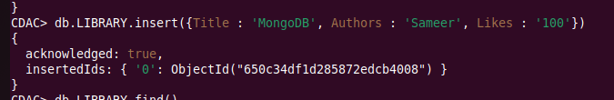

11: View the recently inserte document and note the id field?
-->ObjectId:(“650c333d69bfd86b5ab64f00”)

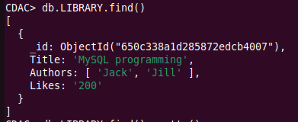

12: Insert another document in the library collection as follows:
title:”MySQL Programming”,
authors:[‘Jack’,’Jill’],likes:”100”?

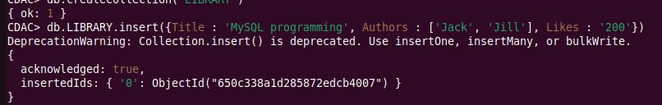

13: View the inserted documents?

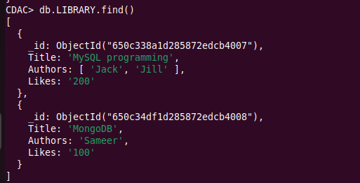

14: View only the first inserted document?

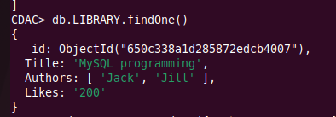

15: View the documents using the pretty() method?

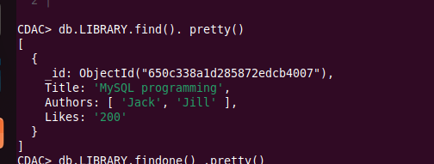

16: Update the document where author name Sameer and change it to Sameer Dehadrai?
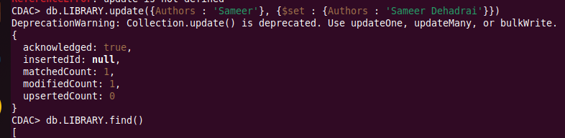

17: Delete all documents that have 100 likes?
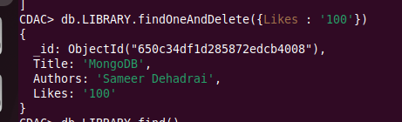

18: Drop the LIBRARY collection?

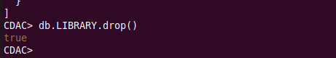

19: Drop the CDAC database?

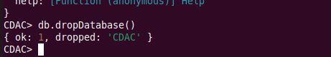

20: Exit from MongoDB shell?

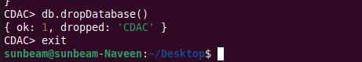

21: Stop MongoDB server?

