ASSIGNMENT NO. 8

Formating query output

Q.1. Assume each salesperson has a 12% commission. Write a query on the orders table table will produce the order number, the sales person number, and the amount of salesperson’s commission for that order.

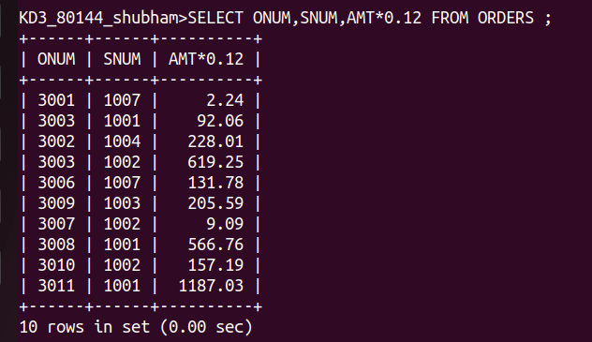

Q.2. Write a query on the customer’s table that will find the highest rating in each city.

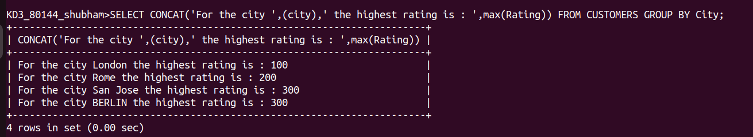

Q.3. Write a query thats lists customers in descending order of rating. Output the rating field first,follwed by customer’s name and number.

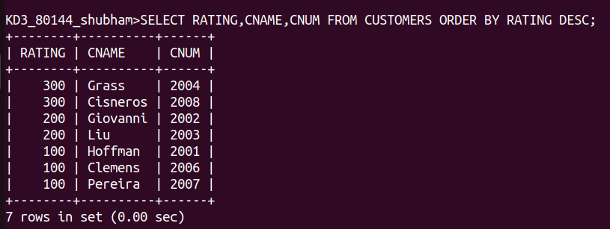

Q.4. Write a query that toals the orders for each day and places the results in the descending order.

