ASSIGNMENT N0. 7

Summarizing Data with Aggregate Function.

Q.1. Write a query that counts all orders for october 3.

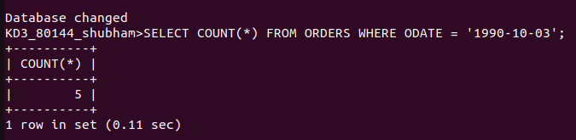

Q.2. Write a query that counts the number of different non-NULL values in the customers table.

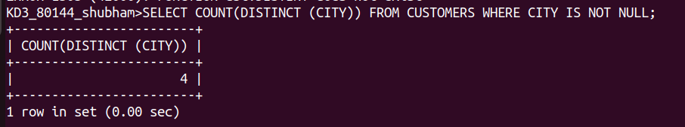

Q.3. Write a query that selects each customer’s smallest order.

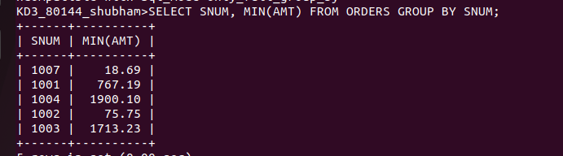

Q.4. Write a query that selects the first customer,in alphabetical order, whose name begins with G.

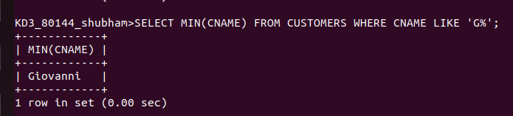

Q.5. Write a query that orders the highest rating in each city.

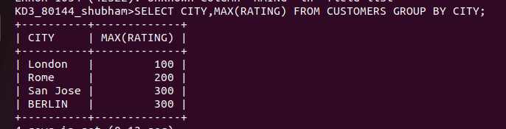

Q.6. Write a query that counts the number of salespeople registering orders for each day.

