ASSIGNMENT NO . 6

Using Special Operators in conditions.
Q.1. Write two different queries that would produce all orders taken on OCTOBER 3rd or 4th ,1990.
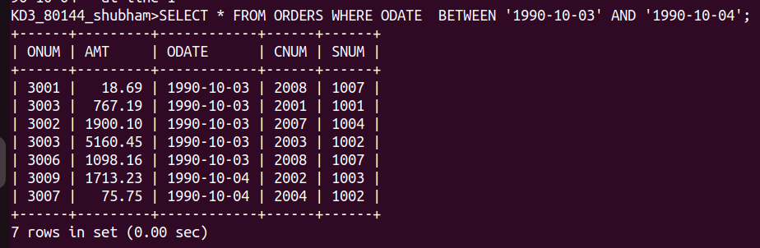

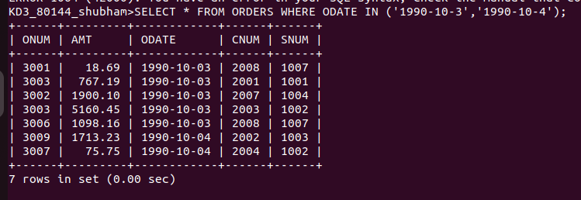

Q.2. Write a query that selects all of the customers serviced by Peel or Motika.

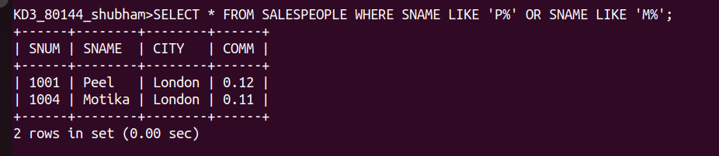

Q.3. Write a query that will produce all the customers whose names begins with a letter from ‘A’ to ‘G’.

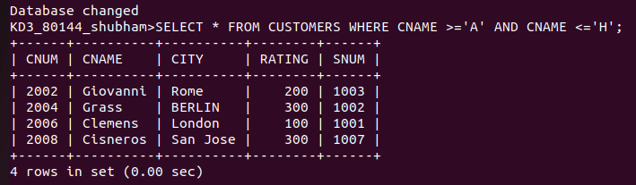

Q.4. Write q query that selects all customers whose same names begin with letter ‘C’

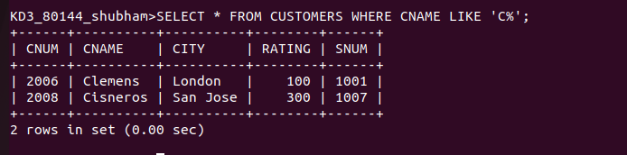

Q.5. Write a query thats selects all orders except those with zeroes or NULL in the amt field.

