ASSIGNMENT NO. 9

Querying Multiple Tables at Once

Q.1. Write a query that lists each order number followed by the name of the customer who made the order.

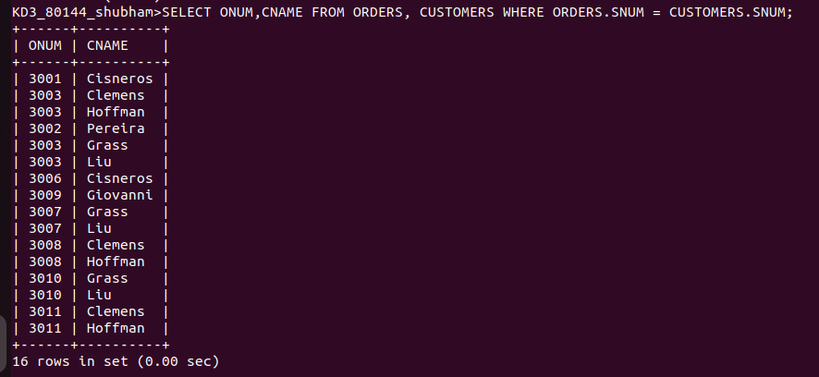

Q.2. Write a query that gives the namesof both the salesperson and the customers for each order along with order number.

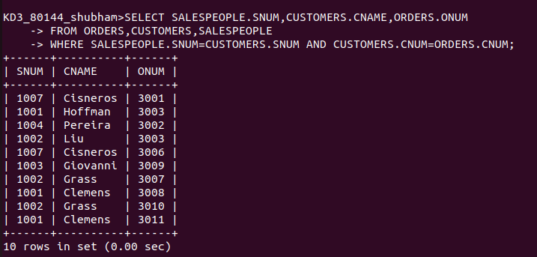

Q.3. Write a query that produces all customers serviced by salespeople with a commission above 12%. Output the customer’s name, the salesperson’n name, and the salesperson’s rate of commission.

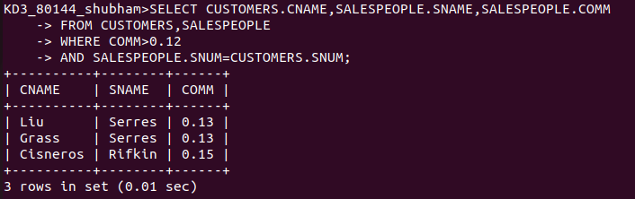

Q.4. Write a query that calculates the amount of the salesperson’s commission on each order by a customers with a rating above 100.
