ASSIGNMENT NO. 4

Retrieving Information from table.

Q.1. Write a select command that produces the other number,amount and date for all rows in the orders tables.

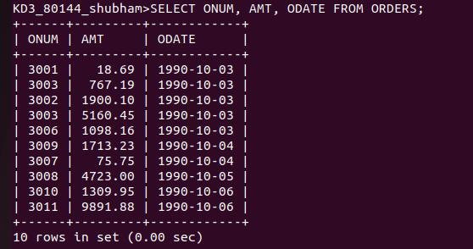
Q.2. Write a query that produces all rows from the CUSTOMERS table for which the Salesperson’s number is 1001.

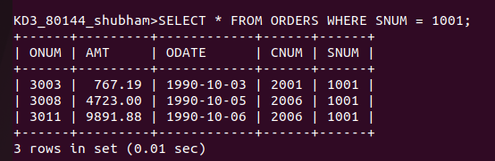

Q.3. Write a query that displays the SALESPEOPLE table with the columns in the following order : CITY, SNAME, SNUM, COMM.

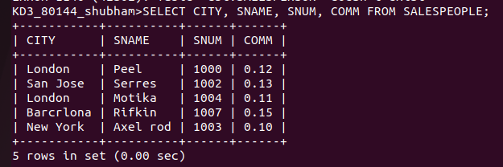

Q.4. Write a select command that produces the rating followed by the name of each customer in SAN JOSE.

