ASSIGNMENT NO. 5

Relational and Logical Operators.

Q.1. Write a query that will give you all orders for more than Rs.1000.

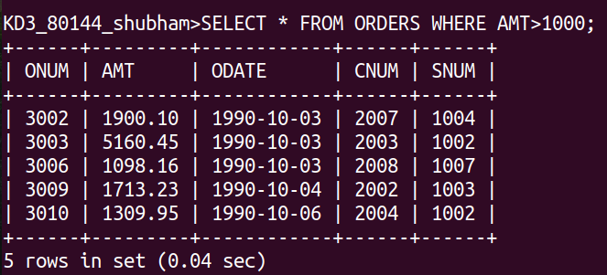

Q.2. Write a query that will give you the names and cities of all salespeople in London with a comission above 0.10

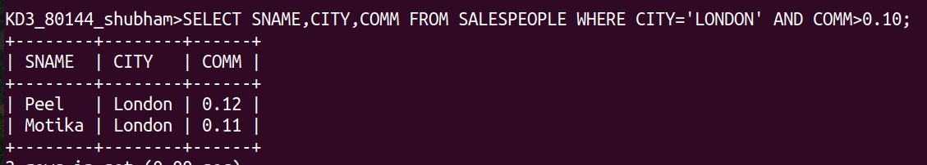
Q.3. Write a query on the customers table whose output will exclude all customers with a rating <= 100, unless they are located in Rome.

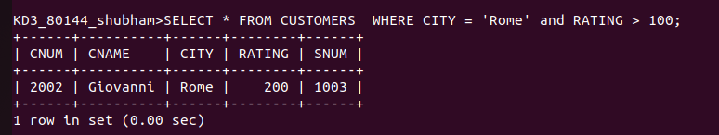
Q.4. What will be output from the following query.

Select * from Orders
where (amt <1000 OR
NOT (ODATE = ‘1990-10-03’ AND cnum >2003));

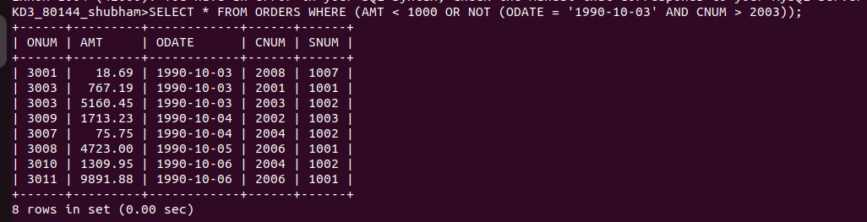

Q.5.What will be the ouput of the following query ?

Select * from Orders
where NOT ((ODATE = ‘1990-10-03’ OR snum >1006) AND amt >=1500);

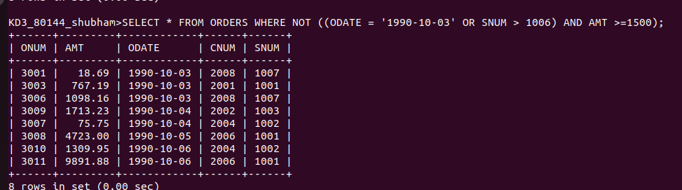
Q,6. What is a simpler way to to write this query?

Select snum, sname, city, comm From Salesperson where (comm >0.12 OR comm <0.14);

