ASSIGNMENT NO. 1

1. Creating sample tables and inserting values.

A) SALESPEOPLE

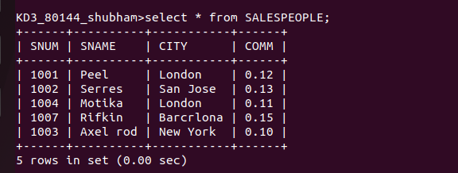

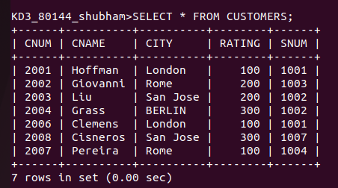
B) CUSTOMERS

C) ORDERS
