ASSIGNMENT NO . 11

Subquerries

Q.1. Write a query that uses a subquery to obtain all orders for the custmores named Cisneros. Assume you do not know his customer name.

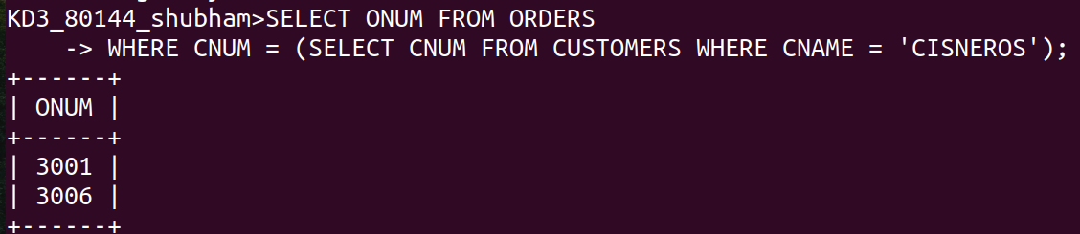

Q.2. Write a query that produces produces the names and rating of all customers who have above average orders.

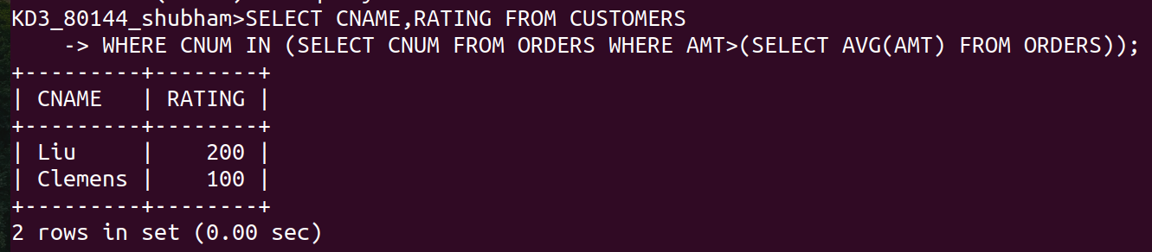

Q.3. Write a query that selects the total amount in orrdes for each salesperson for whom this total is greater than the amount of the largest order in the table.
