ASSIGNMENT NO. 10

Joining a table to itself.

Q.1. Write a query that produces all pairs of salespeople who are are living in the same city. Exclude combination of salespeople with themselves as well as duplicate rows with the orders reversed.
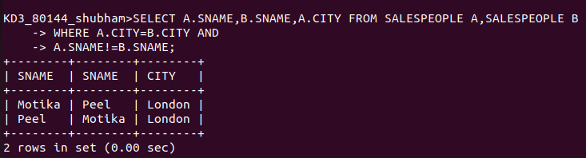

Q.2. Write a query that produces the names and cities of all customers with the same rating as HOFFMAN.

