1)Write a query that produces all pairs of salespeople who are living in same city.Exclude combinations of salespeople with themselves as well as duplicate rows with the order reversed.
Ans:

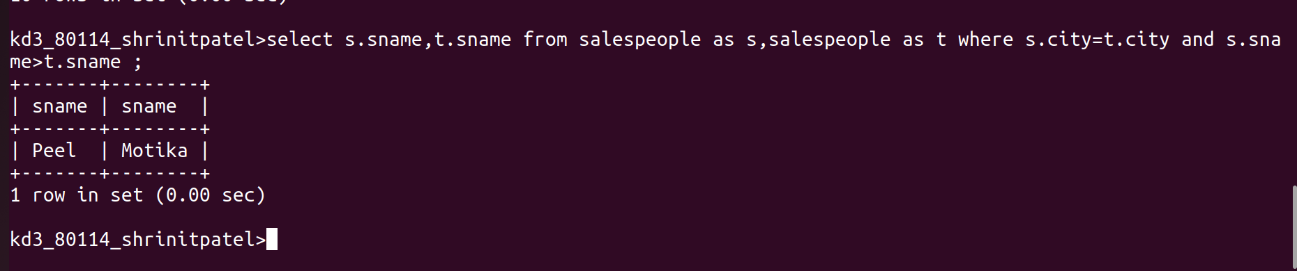
2)Write a query that produces the names and cities of all customers with the same rating as Hoffman.
Ans:
