1)Write a query that uses a subquery to obtain all orders for customers named Cisneros.Assume you do not know his customer number.
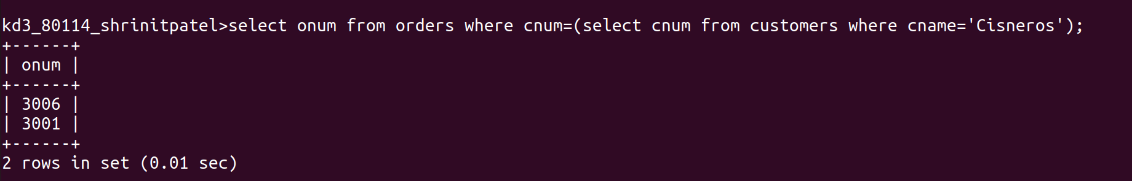
2)Write a query that produces all names and ratings of all customers who have above-average orders.
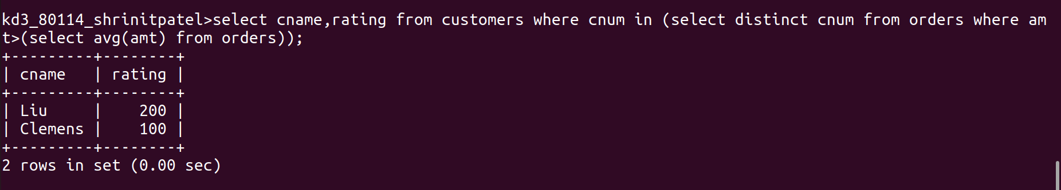
3)Write a query that selects the total amounts in orders for each salesperson for whom this total is greater than the amount of the largest order in the table.
Ans:
