Assignment no 12
1)Write a query that selects all customers whose ratings are equal to or greater than any of ‘Serres’.
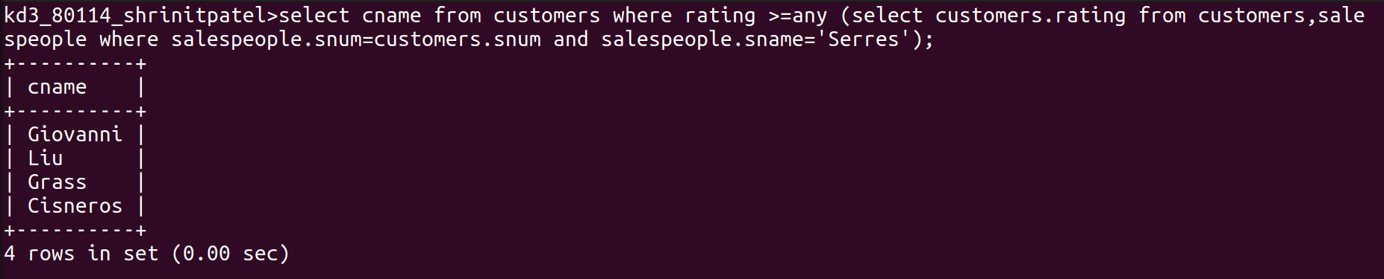
2)Write a query using any or all that will find all salespeople who have no customers located in their city.
Ans:
