1) Assume each salespersonn has 12% Commision.Write a query on the orders table that will produce the order number,the salesperson number,and the amount of the salesperson’s commisson for that order.


2)Write a query on the customers table that will find the highest rating in each city.Put the output in this form:
For the city (city),the highest rating is :(rating).

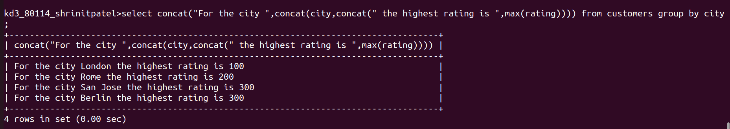

3)Write a query that lists customers in descending order of rating .Output the rating field first, followed by the customers’s name and number.
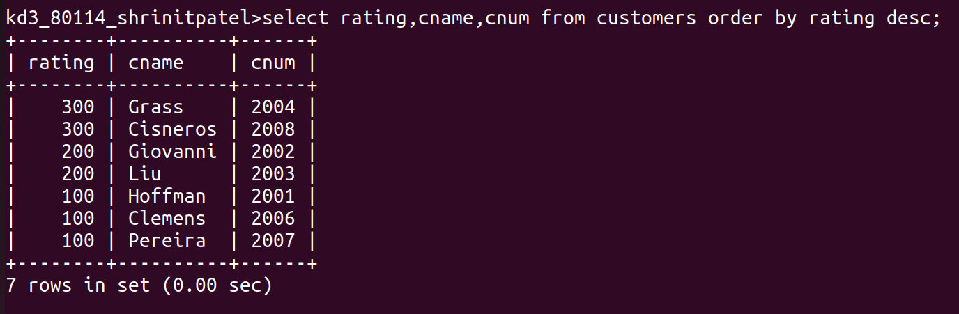
4)Write a query that totals the orders for each day and places the result in descending order.

