1)Write a query that lists each order number followed by the name of the customers who made the order.
Ans:
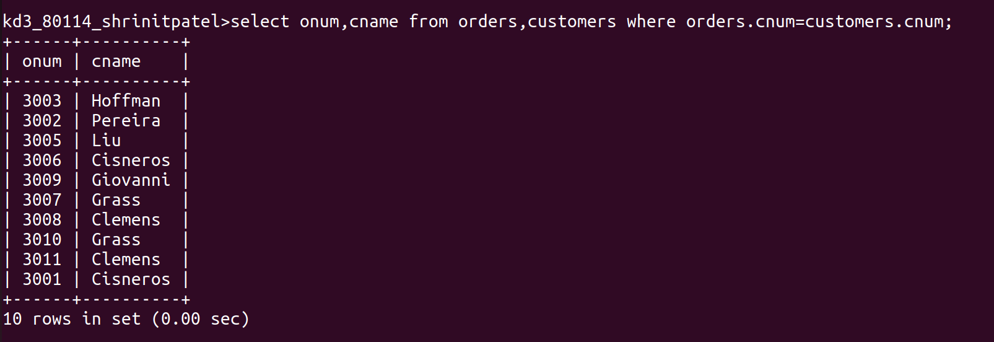

2)Write a query that gives the names of both the salesperson and the customer for each order along with the order number.
Ans:
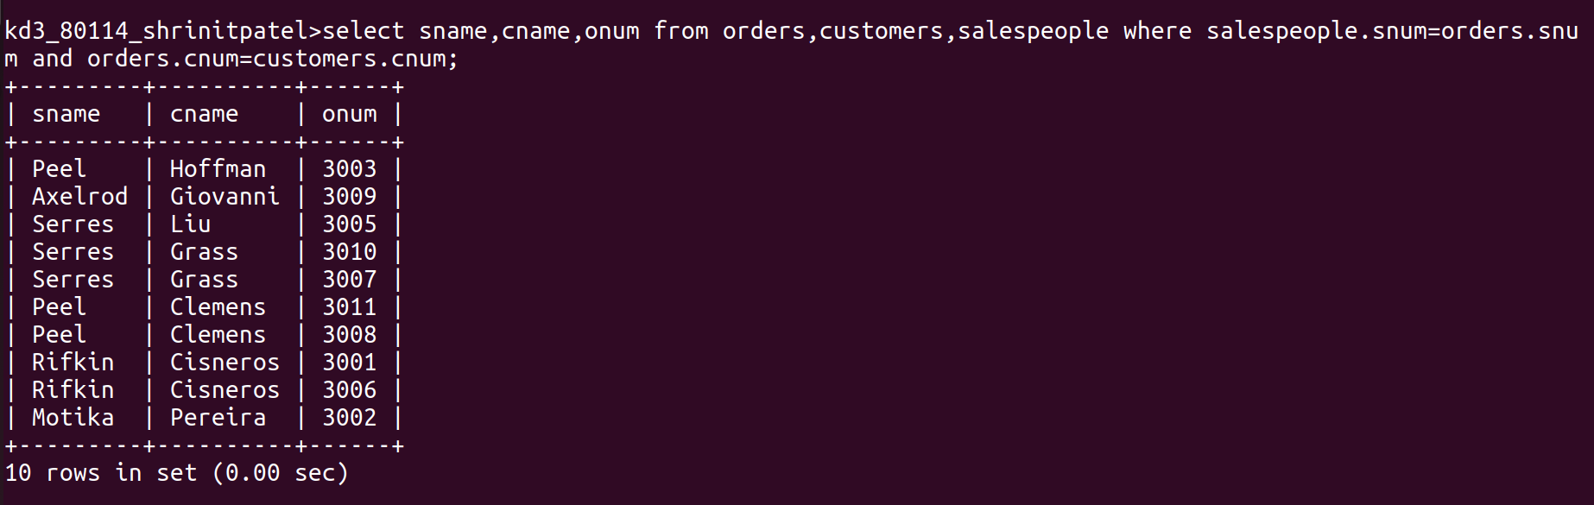

3)Write a query that produces all customers serviced by salespeople with a commission above 12%.Output the customer’s name,the salesperson’s name, and the salespersom’s rate of commission.
Ans:

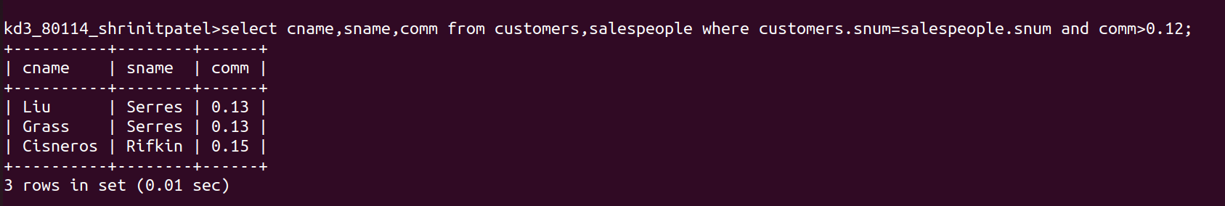
4)Write a query that calculates the amount of the salespeople’s commission on each order by a customer with rating above 100.

