6. View list of available databases.
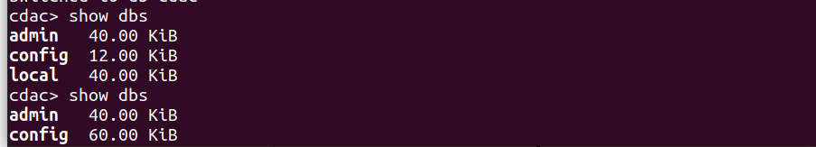

7. Create a new database named CDAC and connect to it.
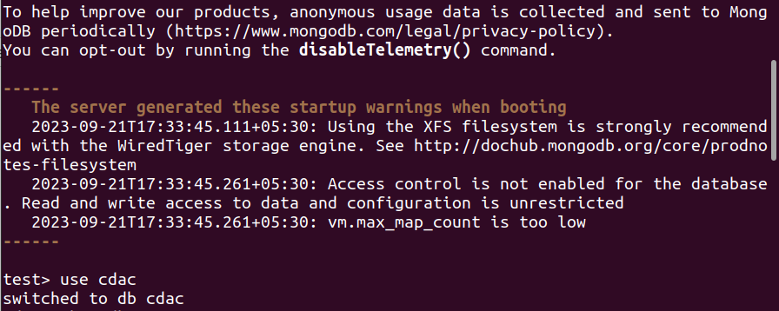
8. View list of available collections in CDAC database
9. Create a new collection by the name of LIBRARY
10. Insert the following document in the LIBRARY collection:-
title:'MongoDB programming', author:'Sameer', likes:100
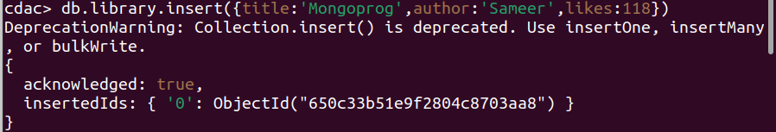
11. View the recently inserted document and note the _id field
12. Insert another document in the LIBRARY collection as follows:-
title:'MySQL programming', authors:['Jack','Jill'], likes:200
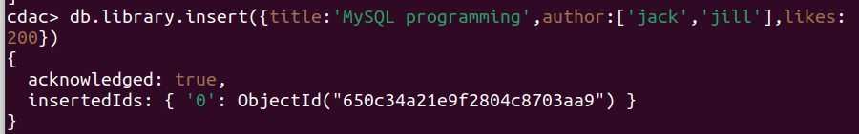
13. View the inserted documents
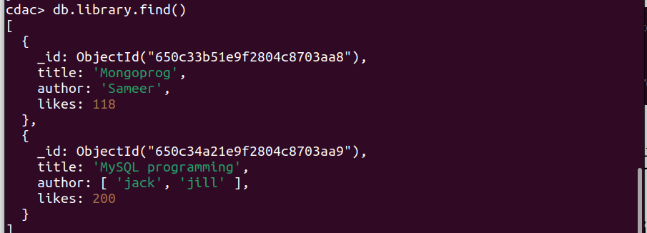

14. View only the first inserted document.
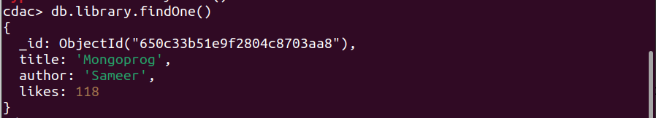
15. View the documents using the pretty() method.
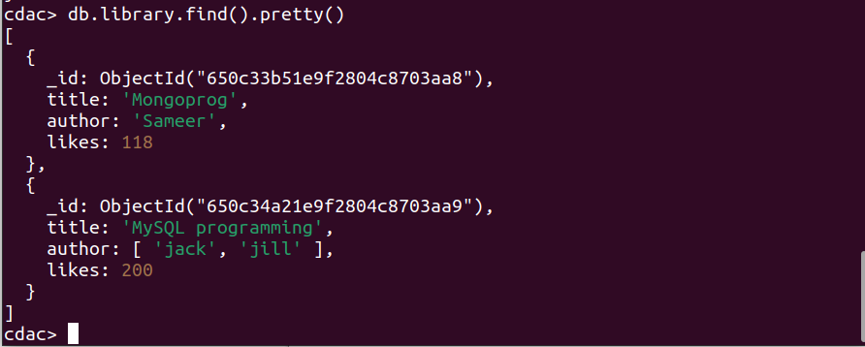

16. Update the document where author name = Sameer and change it to Sameer Dehadrai
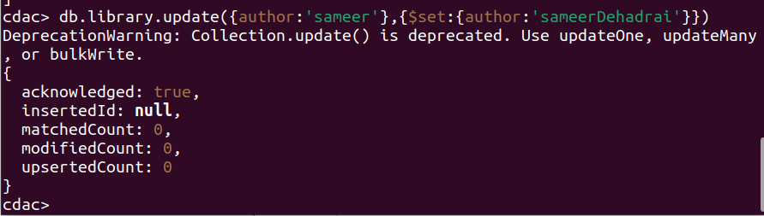
17. Delete all documents that have 100 likes
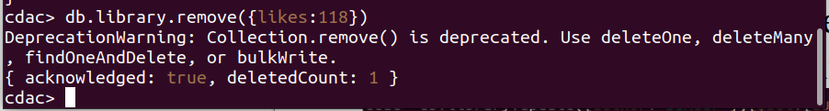
18. Drop the LIBRARY collection
19. Drop the CDAC database
20. Exit from MongoDB shell
21. Stop MongoDB server
