1)Write a query that counts all orders for October 3.

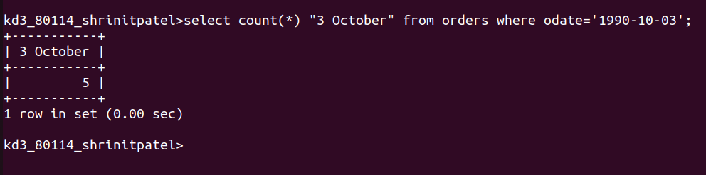
2)Write a query that counts the numbers of different non-NULL city values in the customers table.

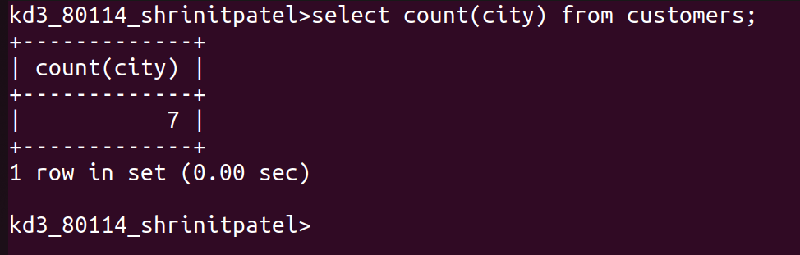
3)Write a query that selects each customer’s smallest order.
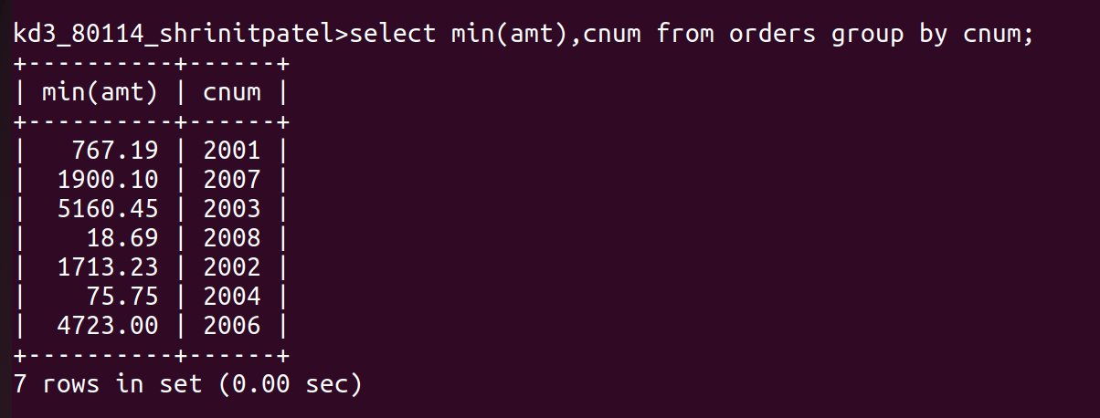
4)Write the query that selects the first customers in alphabetical order,whose name begins with G.


5)Write a query that selects the highest rating in each city.

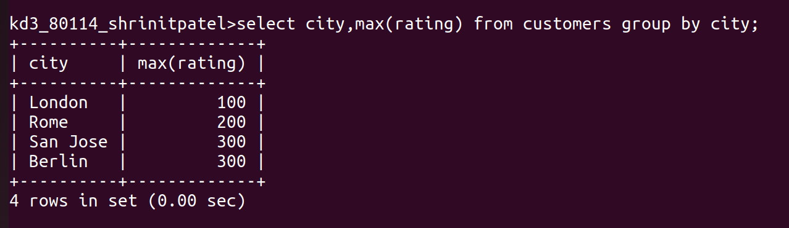

6)Write a query that counts the number of salespeople registering orders for each day.


