1)Write two diffrent queries that would produce all orders taken on Octomber 3rd or 4th ,1990.

Ans:

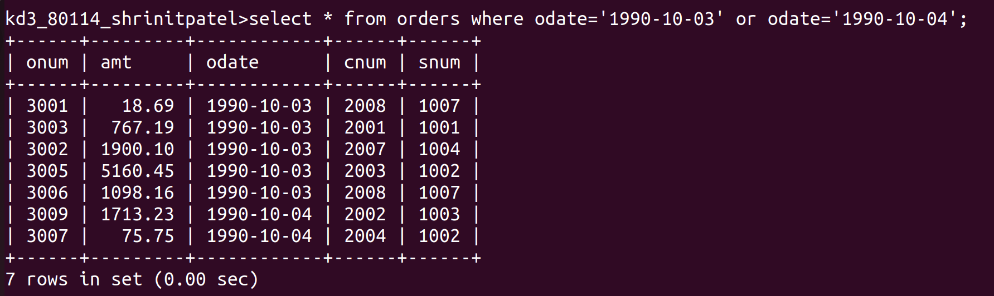
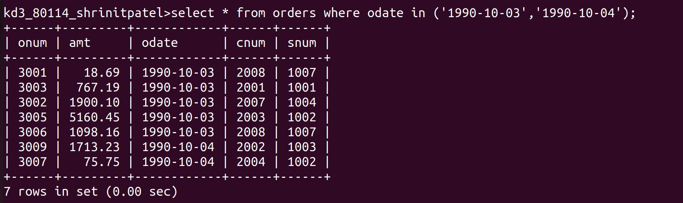
2) Write a query that selects all of the customers serviced by peel or motika.

3)Write a query that selects all customers whose names begin from letter “A” to “G”.

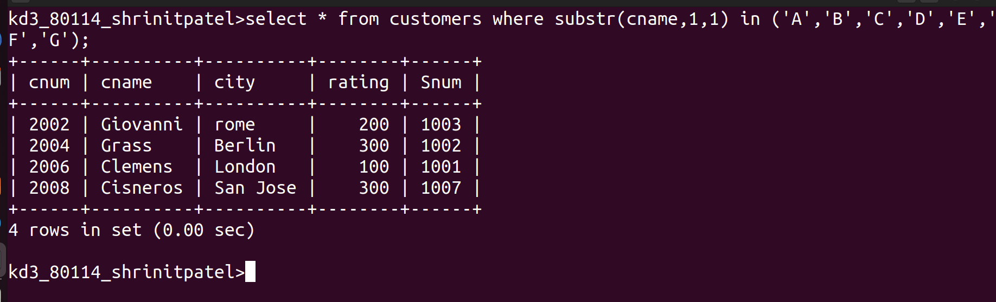
4)Write a query that selects all customers whose names begin from letter “C”.

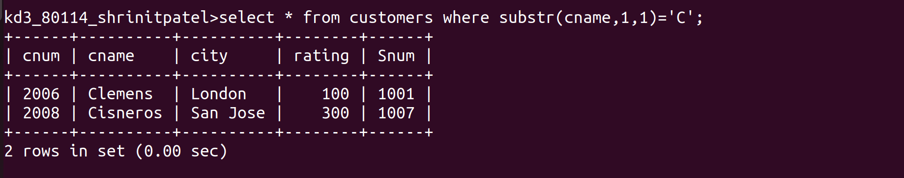

5)Write a query that selects all orders except those with zeroes or nulls in the amt field.

