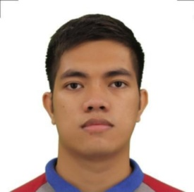**IRVIN MAGIC L. DAHIROC**

Zone 5 Bonbon

9000 Cagayan de Oro, Philippines

irvinmagic51415@gmail.com

+63 975 627 0497

**EDUCATIONAL ATTAINMENT:**

Tertiary:Bachelor of Science in Maritime Transportation

Capitol University

Corrales Osmeña Ext. Cagayan de Oro City

2017

Secondary: Bayabas National High School

Cagayan de Oro City

2010

Elementary: Lila Central Elementary School

Lila, Bohol

2005

**SKILLS**

* Licensed Driver
* Basic Fire fighting
* Elementary First Aid
* Water Survival
* Time management
* Flexible and Adaptable
* Computer literate
* Basic Welding and Carpentry

**TRAINING/S AND SEMINAR/S ATTENDED:**

* **Basic Training**

April 25, 2016

Carcar, Cebu City

* **Stands for Seafarers with Designated Security Duties (SDSD)**

November 11, 2016

MTC, Capitol UUniversity

* **Safety Of Life At Sea (SOLAS)**

April 25, 2016

Carcar, Cebu CCity

* **HIV Awareness**

Capitol University

**WORK EXPERIENCE:**

Provincial Government Office — Misamis Oriental PDRRM Office

March 2022 – Present

* Liaison Officer
* Payroll Officer
* Emergency Responder