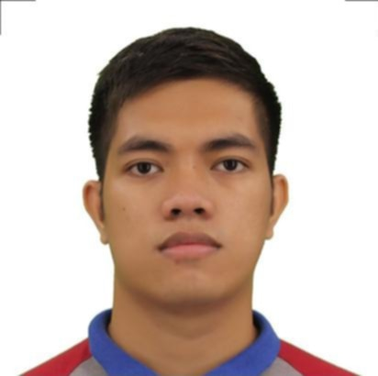IRVIN MAGIC L. DAHIROC

Zone 5 Bonbon, 9000 Cagayan de Oro City, Philippines

📧 irvinmagic51415@gmail.com | 📞 +63 975 627 0497

**OBJECTIVE**

Motivated and service-oriented individual with a Bachelor’s degree in Maritime Transportation, solid emergency response experience, and a strong background in administrative tasks. Seeking opportunities to contribute to dynamic teams with efficiency, reliability, and professionalism.

**EDUCATIONAL ATTAINMENT**

Bachelor of Science in Maritime Transportation

Capitol University, Corrales Osmeña Ext., Cagayan de Oro City

Graduated: 2017

Secondary Education

Bayabas National High School, Cagayan de Oro City

Graduated: 2010

Elementary Education

Lila Central Elementary School, Lila, Bohol

Graduated: 2005

**SKILLS**

• Licensed Driver  
• Basic Firefighting  
• Elementary First Aid  
• Water Survival  
• Time Management  
• Flexible and Adaptable  
• Computer Literate  
• Basic Welding and Carpentry

**TRAININGS AND SEMINARS ATTENDED**

Basic Training — Carcar, Cebu City

April 25, 2016

Standards for Seafarers with Designated Security Duties (SDSD) — MTC, Capitol University

November 11, 2016

Safety of Life at Sea (SOLAS) — Carcar, Cebu City

April 25, 2016

HIV Awareness Seminar — Capitol University

Date not specified

**WORK EXPERIENCE**

Provincial Government of Misamis Oriental

Provincial Disaster Risk Reduction and Management Office (PDRRMO)

March 2022 – Present

• Liaison Officer  
• Payroll Officer  
• Emergency Responder