Gephi Upload Protocol

The following is a guide for how to upload files to Gephi from the excel adjacency matrices for our networks.

1. Upload the desired excel file to GRNsight
2. 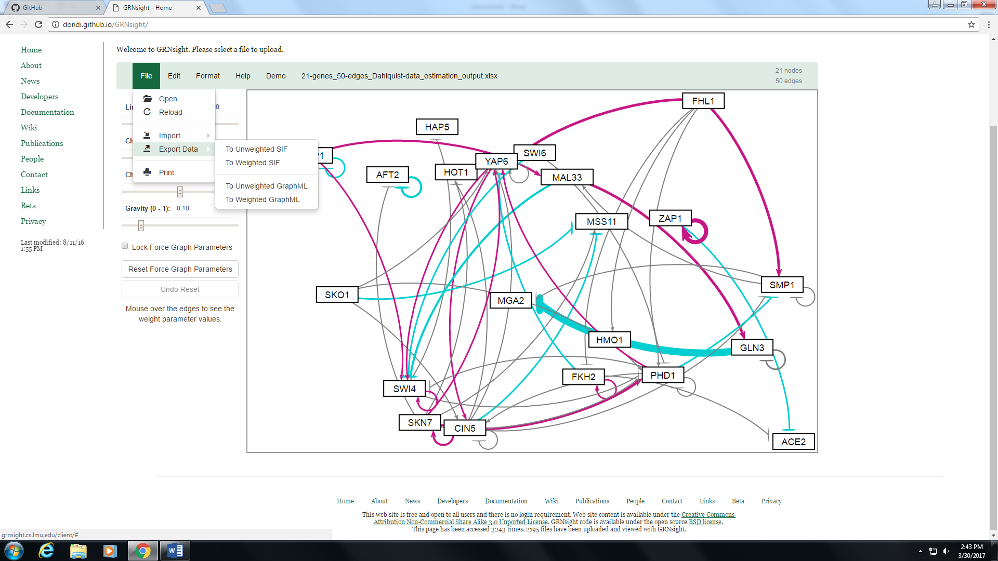Export the file to a weighted GraphML format using the file-> export data tab in GRNsight. Save the file in an easily accessibly location, such as the desktop
3. 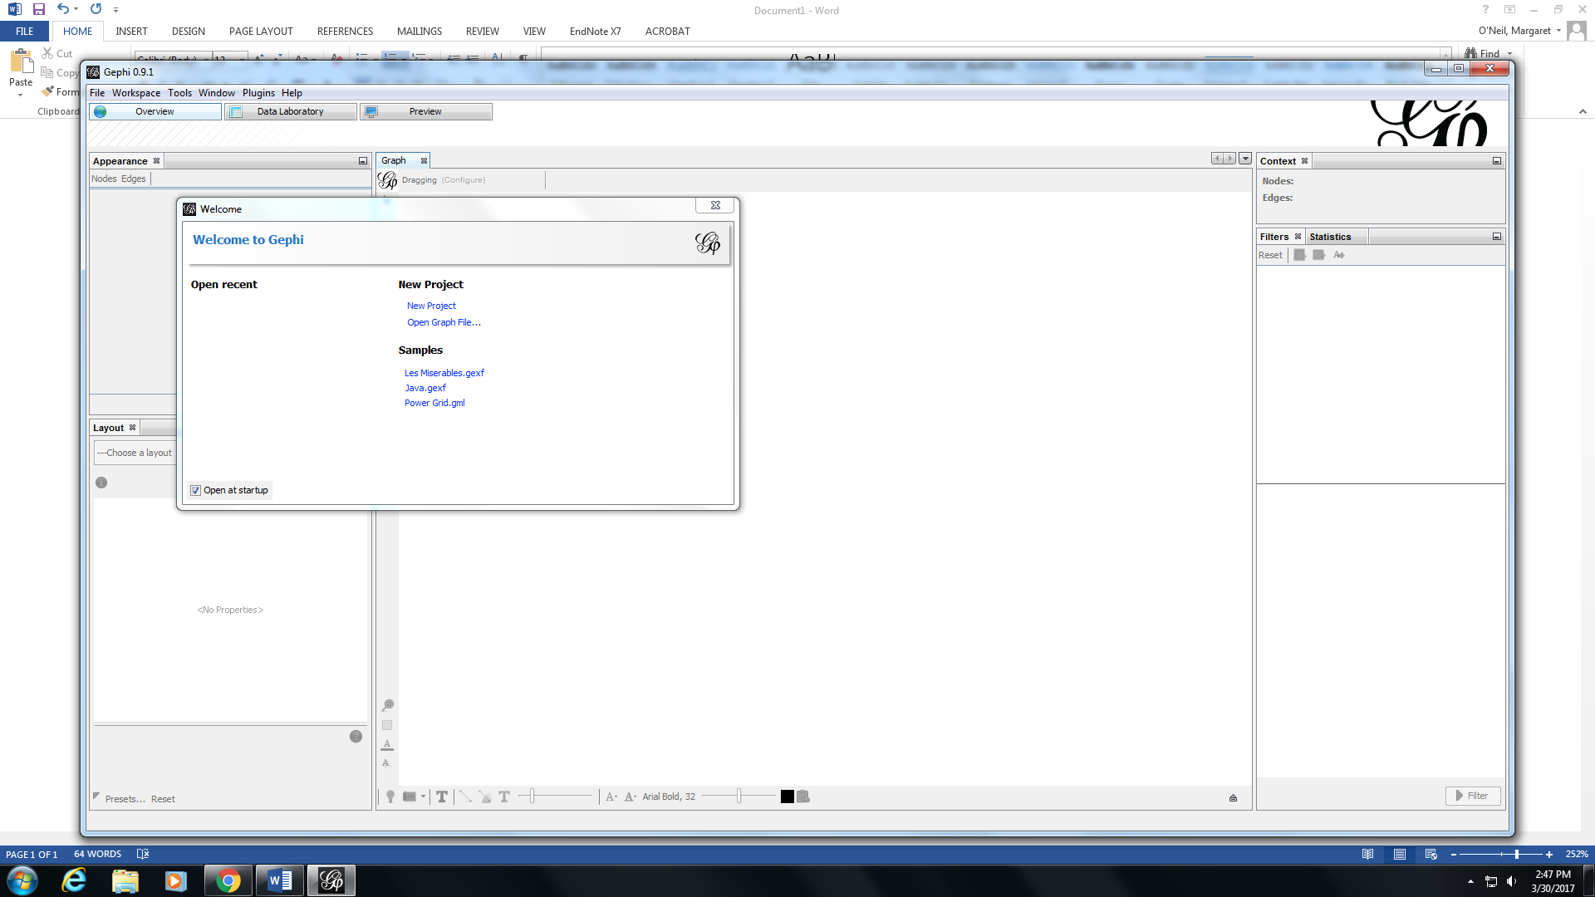Open Gephi and select “open graph file”
4. Select your file, and the graph should appear on the main page

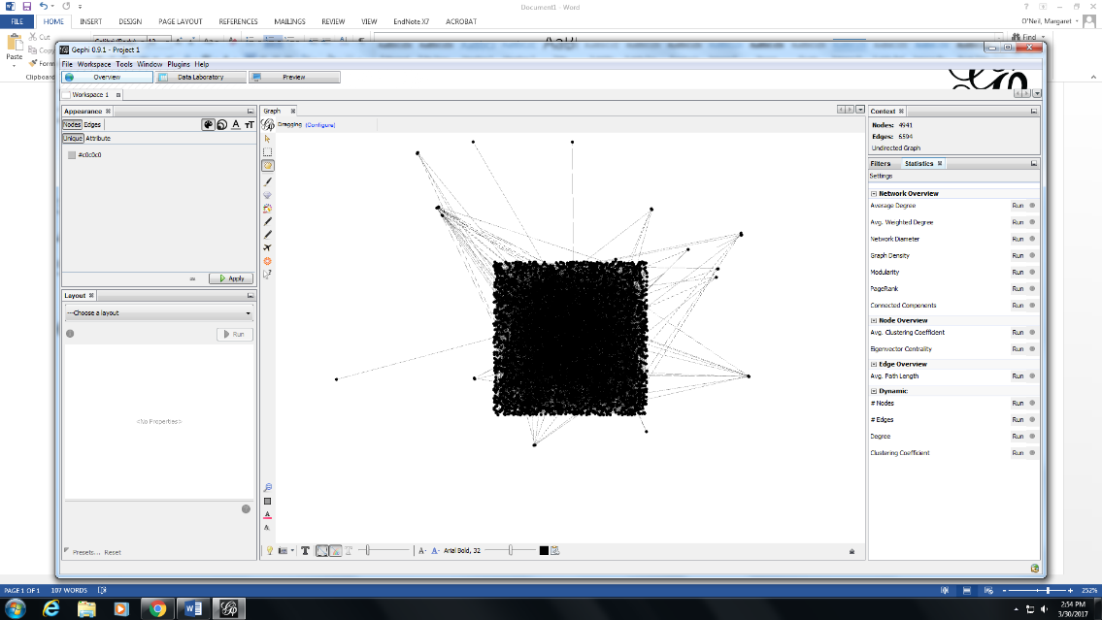

1. On the right-hand column of the Gephi window, select the desired graph statistics you wish to run
2. To view the output of these statistics, select the “Data laboratory” at the top of the screen
3. 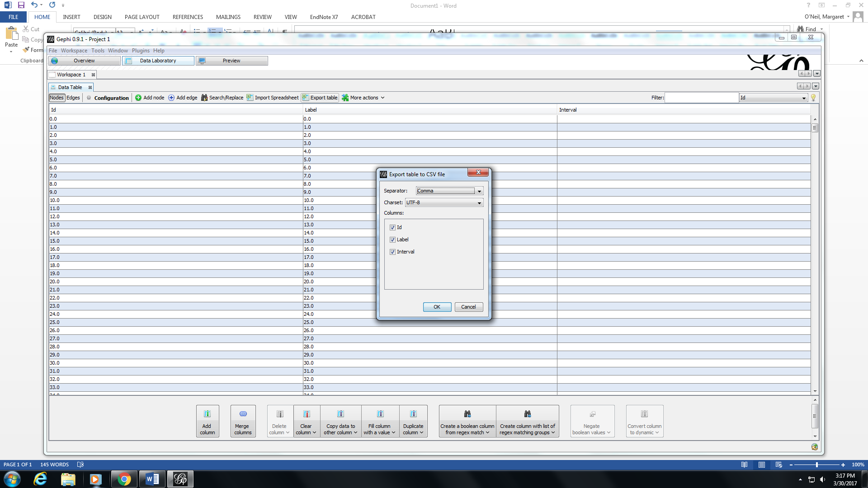To export the table, hit the “export table” button on the menu bar for the data laboratory 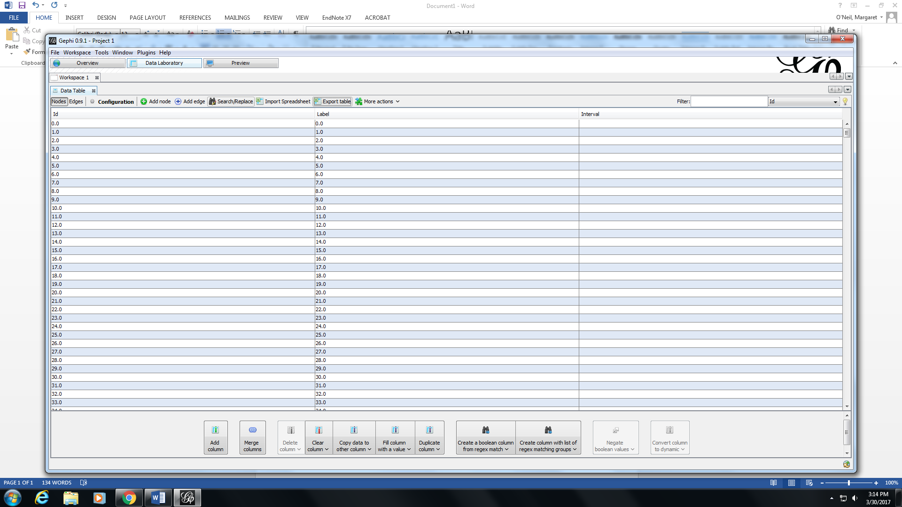
4. Select the data columns you want to export, hit “Ok”, save the file and then view the data in excel