**Analysis of each node in db5 using graph statistics**

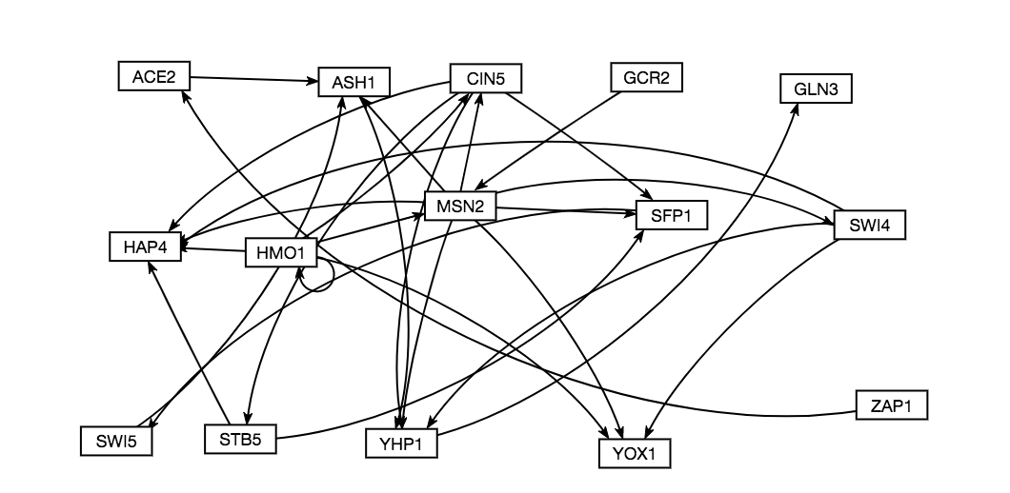

Table 1. Compilation of graph statistics as computed by Gephi for the network db5

|  |  |  |  |  |
| --- | --- | --- | --- | --- |
| Gene | Closeness Centrality | Betweeness Centrality | Eigencentrality | Eccentricity |
| ACE2 | 0.5 | 3 | 0.008418 | 3 |
| ASH1 | 0.666667 | 10 | 0.575118 | 2 |
| CIN5 | 0.636364 | 5 | 0.249597 | 3 |
| GCR2 | 0.458333 | 0 | 0 | 3 |
| GLN3 | 0 | 0 | 0.8377 | 0 |
| HAP4 | 0 | 0 | 0.861994 | 0 |
| HMO1 | 0.55 | 0 | 0.11352 | 3 |
| MSN2 | 0.769231 | 14 | 0.121938 | 2 |
| SFP1 | 0.4 | 9 | 0.605438 | 4 |
| STB5 | 0.375 | 0 | 0.248138 | 5 |
| SWI4 | 0.8 | 0 | 0.136077 | 2 |
| SWI5 | 0.5 | 7 | 0.52969 | 3 |
| YHP1 | 1 | 11 | 1 | 1 |
| YOX1 | 0 | 0 | 0.392633 | 0 |
| ZAP1 | 0.4 | 0 | 0 | 4 |

**ACE2**

* Betweeness Centrality: 3
  + A Betweeness of 3 means that ACE2 is contained in 3 shortest paths on the network, so it is being used as a hub for a small number of nodes to reach other nodes in the graph.
* Closeness Centrality: 0.5
  + A Closeness of 0.5 is relatively high, which means many nodes have paths going to, or going through ACE2, which makes sense in that it acts as a hub for several nodes.
* Eccentricity: 3
  + An eccentricity of 3 means that compared to other nodes in the graph, ACE2 has a similar “reach” or influence. This moderate influence indicates that the hub nature of the node is of moderate importance to the network.
* Eigenvector Centrality: 0.008418
  + An eigenvector centrality of 0.008418 is incredibly low, and indicates that because the node is deemed central by other measures, and because the in:out degree ratio is 1:1, the eigenvector statistic is labeling the node as unimportant.

**ASH1**

* Betweeness Centrality: 10
  + With a Betweeness of 10, ASH1 is shown to be acting like a large hub for the network, with many shortest paths having to pass through ASH1
* Closeness Centrality: 0.666667
  + A closeness centrality of 0.666667 is relatively high, which makes sense in conjunction with the high Betweeness measure, as many paths in the network have to pass through or go to ASH1
* Eccentricity: 2
  + An eccentricity of 2 means that ASH1 has slightly less influence on the graph than the majority of the nodes, which would indicate that in acting as a hub, it is more of a way station than a command center in sending out activating or suppressing influences across the network.
* Eigenvector Centrality: 0.575118
  + With a relatively high eigenvector centrality of 0.575118 and a Betweeness value also so high, this means that ASH1 has more in degrees than out degrees, and that more nodes are trying to regulate it than it is regulating other nodes.

**CIN5**

* Betweeness Centrality: 5
  + With a Betweeness centrality of 5, CIN5 is operating as a moderately sized hub in the network, with several shortest paths passing through the node.
* Closeness Centrality: 0.636364
  + A closeness of 0.636364 makes sense in this node, as it means it is highly central to the network, which further confirms the hub nature of the node.
* Eccentricity: 3
  + An eccentricity of 3 indicates that CIN5 has a moderate level of influence over the network, as an eccentricity of 3 is about average for the network.
* Eigenvector Centrality: 0.249597
  + An eigenvector centrality of 0.249597 means that the node has more out degrees than in degrees, and is having more influence on other nodes in the network than nodes are having on it.

**GCR2**

* Betweeness Centrality: 0
  + With a Betweeness centrality of 0, and looking at the network, GCR2 is at the start of a regulatory chain, and not a hub in the network.
* Closeness Centrality: 0.458333
  + With a closeness centrality of 0.45833, this means that GCR2 is moderately connected to the rest of the network, and through it’s connection to MSN2, it has many shortest paths connecting it to other nodes.
* Eccentricity: 3
  + With an eccentricity of 3, it can be determined that while at the start of a regulatory pathway, GCR2 has an average level of influence over the rest of the network, which when compared to other nodes at the start of regulatory pathways, might help determine the importance of GCR2.
* Eigenvector Centrality: 0
  + GCR2 has an eigenvector centrality of 2, which means nothing is influencing the node (no in degrees), which makes sense seeing as how the node only has one out degree.

**GLN3:**

* Betweeness Centrality: 0
  + With a Betweeness centrality of 0 and looking at the graph, it can be determined that GLN3 is at the end of a regulatory pathway.
* Closeness Centrality: 0
  + A closeness centrality of 0 makes sense, as there are no out degrees for GLN3, and therefore no edges are emanating from it that form a shortest path.
* Eccentricity: 0
  + An eccentricity of 0 makes sense for GLN3, as there are no nodes for it to influence, since there is no out degree for this node.
* Eigenvector Centrality: 0.8377
  + As the in:out degree ratio for GLN3 is 1:0, it makes sense for this node to have a very high eigenvector centrality at 0.8377, as nodes are regulating it, and it is regulating no nodes.

**HAP4:**

* Betweeness Centrality: 0
  + With a Betweeness centrality of 0 and looking at the network, HAP4 is at the end of a regulatory pathway, which makes sense why no shortest paths are passing through the node.
* Closeness Centrality: 0
  + With a closeness centrality also at 0, this makes sense as there are no edges emanating out from the node.
* Eccentricity: 0
  + With an eccentricity of 0, it makes sense that HAP4 has no influence over other nodes in the network.
* Eigenvector Centrality: 0.861994
  + HAP4 has a high eigenvector centrality at 0.861994 because the ratio of in degree:out degree is 5:0, which shows many nodes are influencing HAP4.

**HMO1:**

* Betweeness Centrality: 0
  + With a Betweeness centrality of 0, it can be determined that the Gephi measure for Betweeness does not take self-regulation into account as an in degree. Therefore, HMO1 does not act as a hub, and there are no shortest paths that go through HMO1, making it the start of a regulatory pathway.
* Closeness Centrality: 0.55
  + With a closeness centrality of 0.55, HMO1 is moderately connected to the rest of the network, with many shortest paths emanating from HM01.
* Eccentricity: 3
  + With an eccentricity value at 3, HMO1 has the same level of influence as the majority of the genes in the network, indicating that while it is the start of a regulatory pathway, it is not necessarily of the most importance.
* Eigenvector Centrality: 0.11352
  + With a low eigenvector centrality, HMO1 is influencing more nodes than are influencing it, which makes sense with the other centrality measures calculated for this node/network.

**MSN2:**

* Betweeness Centrality: 14
  + With a Betweeness centrality of 14, MSN2 is shown to be the biggest hub in the network, with many nodes containing MSN2 on a shortest path. This means it is a highly important node in that it acts as a step stone that is incredibly central to the structure of the network.
* Closeness Centrality: 0.769231
  + With a very high closeness centrality, it is clear that not only do shortest paths go through MSN2, but it also has a number of shortest paths emanating from it, further showing the importance of this node as a hub for many edges in the network.
* Eccentricity: 2
  + With an eccentricity of 2, MSN2 might not have the farthest reach across the graph, but in being incredibly central to the graph, it is also possible that this number is lower than average because MSN2 does not have to reach as far as other nodes to get to the furthest node from it.
* Eigenvector Centrality: 0.121938
  + With many in and out degrees, it makes sense that MSN2 has a very low eigenvector centrality, as the number of nodes regulating it, as it is regulating is fairly similar.

**SFP1:**

* Betweeness Centrality: 9
  + With a Betweeness of 9, SFP1 is acting as a moderate sized hub for the network, with several shortest paths going through the node.
* Closeness Centrality: 0.4
  + With a closeness centrality of 0.4, SFP1 has a moderate
* Eccentricity: 4
* Eigenvector Centrality: 0.605438

**STB5:**

* Betweeness Centrality: 0
* Closeness Centrality: 0.375
* Eccentricity: 5
* Eigenvector Centrality: 0.248138

**SWI4:**

* Betweeness Centrality: 0
* Closeness Centrality: 0.8
* Eccentricity: 2
* Eigenvector Centrality: 0.136077

**SWI5:**

* Betweeness Centrality: 7
* Closeness Centrality: 0.5
* Eccentricity: 3
* Eigenvector Centrality: 0.52969

**YHP1:**

* Betweeness Centrality: 11
* Closeness Centrality: 1
* Eccentricity: 1
* Eigenvector Centrality: 1

**YOX1:**

* Betweeness Centrality: 0
* Closeness Centrality: 0
* Eccentricity: 0
* Eigenvector Centrality: 0.392633

**ZAP1**:

* Betweeness Centrality: 0
* Closeness Centrality: 0.4
* Eccentricity: 4
* Eigenvector Centrality: 0