Results
As a result of the systematic edge deletions, 28 deletion networks were generated form the intact network. The LSE:minLSE ratios, MSE:minMSE ratios, and network parameters (w, p, and b) allowed for each of the deletion networks to be compared to the intact network (Dahlquist et al., 2015).
The LSE:minLSE ratio describes how well the GRN was modeled by GRNmap and allows for the comparison of the intact network to each of the edge deletion networks. A lower LSE:minLSE ratio (a ratio closer to one) means that the GRN that resulted from the edge deletion is a better fit to the experimental data. The LSE:minLSE ratio increased for 18 networks in the collection (dSTB5HAP4, dMSN2SWI4, dCIN5HAP4, dCIN5YHP1, dACE2ASH1, dGCR2MSN2, dMSN2ASH1, dYHP1GLN3, dSTB5SFP1, dHMO1HMO1, dMSN2SFP1, dHMO1HAP4, dCIN5STB5, dSFP1SWI5, dCIN5SFP1, dASH1YHP1, dHMO1MSN2, and dSWI5ASH1) (Figure 1).
Figure 1. Intact network and deletion networks arranged in order from lowest to highest LSE:minLSE ratio. Edge deletions that resulted in a lower LSE:minLSE improved the fit of the model and are likely not important to the network. Those that resulted in a higher LSE:minLSE are likely important to the network.

Deletion network dSWI5ASH1 experienced a 2.37% increase in LSE:minLSE ratio, which is the greatest increase out of all of the deletion networks. This increase indicates that this edge is important to the network. Five edge deletions, on the other hand, improved the fit of the model. The LSE:minLSE ratio decreased for deletion networks dMSN2YOX1, dHMO1CIN5, dMSN2CIN5, dHMO1YOX1, and dZAP1ACE2, suggesting that these edges are not crucial edges in the network. dZAP1ACE2 exhibited a 2.41% decrease in LSE:minLSE ratio, which is the largest drop out of all the deletion networks. This edge, therefore, is likely not an important edge in the intact network. Other edge deletions, however, did not have an effect on the LSE:minLSE ratio. Deletion networks dSWI4YHP1, dMSN2YHP1, dSWI4YOX1, and dSWI4HAP4 did not have an altered LSE:minLSE ratio and appear to be neutral deletions.
Changes in the LSE:minLSE ratio also correlated with downstream regulatory weight changes in the remaining edges. One example can be seen when comparing the intact network to deletion network dHMO1CIN5 (Figure 2).
Intact Network | dHMO1CIN5
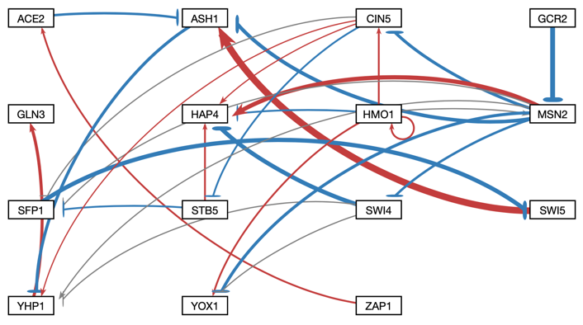
Figure 2. Comparison of the intact network to deletion network dHMO1CIN5. Asterisks denote edges that changed as a result of the edge deletion. These edges flipped from up-regulating to down-regulating, and vice versa.

Regulatory edges flipped from upregulating to down regulating, and vice versa. HMO1 is a central gene in the network, as it has high in- and out-degrees (Dahlquist et al., 2016). The regulatory weight changes suggest that the deleted edge was involved in long regulatory chains. For further analysis, the networks were arranged in a heatmap from lowest to highest LSE:minLSE ratio. This arrangement revealed patterns in the regulatory weight changes (Figure 3).
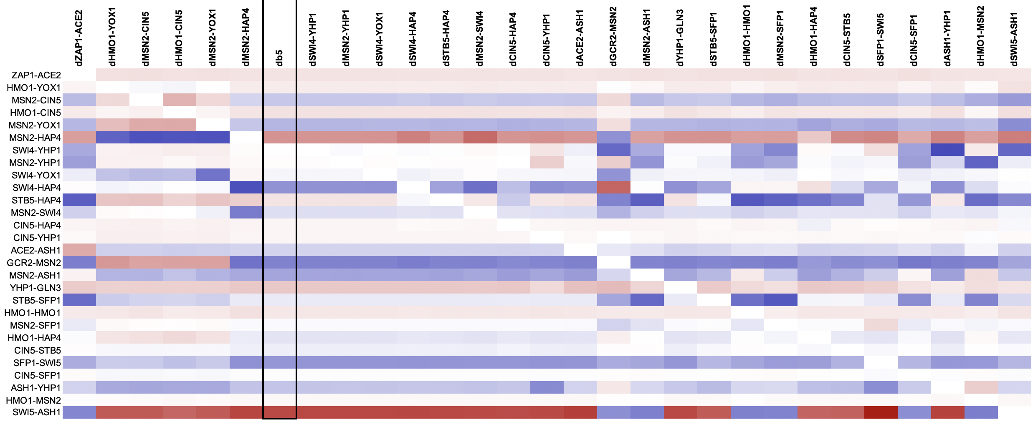Figure 3. Heatmap illustrated the regulatory edge weight changes as a result of certain edge deletions, organized
from lowest to highest LSE:minLSE ratio. Edge deletions that resulted in a higher or lower LSE:minLSE ratio also displayed a variety of downstream edge weight changes.

The regulatory weight changes are clustered around the higher and lower ends of the LSE:minMSE spectrum. These changes can be interpreted as the network compensating for the loss of an edge. These changes, in turn, make the network a better or worse fit to the experimental data, depending on the LSE:minLSE ratio. Interestingly, dHMO1YOX1, dMSN2CIN5, dHMO1CIN5, and dMSN2YOX1 exhibited the same regulatory weight changes. These 4 edges are very closely connected in the intact network, which may explain why their deletions cause the network to change in similar ways. These four deletion networks also have very similar LSE:minLSE ratios (Figure 1). The deletion networks that resulted in greater LSE:minLSE ratios also exhibited many regulatory changes, especially dGCR2MSN2. Furthermore, changes in the regulatory weights only occurred where there was a change in LSE:minLSE ratio. Deletion networks dSWI4YHP1, dMSN2YHP1, dSWI4YOX1, and dSWI4HAP4 exhibited no changes in the LSE:minLSE ratio and no regulatory weight changes. These observations suggest that the edge weights and the LSE:minLSE ratio are closely related.
The production rates of each gene in each deletion network were compared by normalizing each value to the intact network. The production rates for the intact network were compared to a selection of deletion networks with higher, lower, or the same LSE:minLSE ratio. This selection consisted of the intact network, dZAP1ACE2, dHMO1CIN5, dMSN2YHP1, dGCR2MSN1, and dSWI5ASH1 (Figure 4).
Figure 4. The production rates of all of the genes in the network were comparted for the intact network and a selection of deletion networks. Large changes in production rate occurred for ACE2, CIN5, STB5, SWI4, and YHP1.

In the case of the deletion networks with higher or lower LSE:minLSE ratios, the production rates of certain genes were altered. The most notable differences occurred in ACE2, CIN5, STB5, SWI4, and YHP1. In the intact network, most of these genes have very low in-degree, with only one to two nodes regulating them. In the case of ACE2, which has an in-degree of 1, the production rate spiked when ZAP1ACE2 was deleted. YHP1, on the other hand, has an in-degree of 4; four different nodes are either up-regulating or down-regulating this gene. The production rate of YHP1 spiked drastically when SWI5ASH1 was deleted. In the intact network, SWI5 strongly up-regulates ASH1, which down-regulates YHP1. The absence of the up-regulation of ASH1, which then down-regulates the expression of YHP1, may be why the production rate increased. Another notable change in production rate occurred in STB5 when ZAP1ACE2 was deleted. Unlike the previous example, ZAP1ACE2 is not part of a regulatory chain that includes STB5. Other factors within the network that were altered by this edge deletion may be the reason for the spike in the production of STB5. While there does not appear to be a direct pattern between the in-degrees and the production rates, in many cases the production rates of genes are altered when a close connection is deleted.
The optimized expression rates of ACE2, CIN5, STB5, SWI4, and YHP1 were also assessed within the previously mentioned selection of networks. Graphs compare the optimized expression of genes as modeled by GRNmap as a result of certain edge deletions compared to the intact network (Figure 5). The log2 optimized expression rates were plotted against time to reveal changes in expression that may relate to the changes in production rates. ACE2, STB5, and SWI4 all had changes in production rate that may be related to changes in optimized expression. While the production rate of ACE2 spiked when ZAP1ACE2 was deleted, the optimized expression over time decreased. However, the deletion of SWI5ASH1 caused increases in both the production rate of ACE2 and the optimized expression. STB5 had an extremely large increase in production rate when ZAP1-ACE2 was deleted, as well as a change in the optimized expression trend. The optimized expression changed from a steady decrease over time. This change may be related to the increase in production rate; higher expression would logically necessitate a higher production rate. The production rate of STB5 also increased in the dSWI5ASH1 network, which resulted in initially higher optimized expression that decreased over time and followed a trend similar to the intact network. Finally, the production rate of SWI4 increased when GCR2MSN2 was deleted, which corresponds with an initial spice in optimized expression that decreases over time. The deletion of ZAP1ACE2, while it did not cause a large change in the SWI4 production rate, caused the optimized expression to initially plummet and subsequently increase. While in many cases changes in production rate were paired with changes in optimized expression, CIN5 and YHP1 displayed no change in optimized expression, despite their production rate changes.
 | 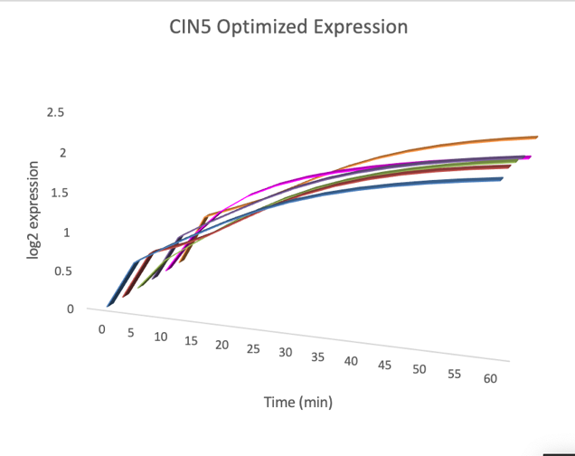
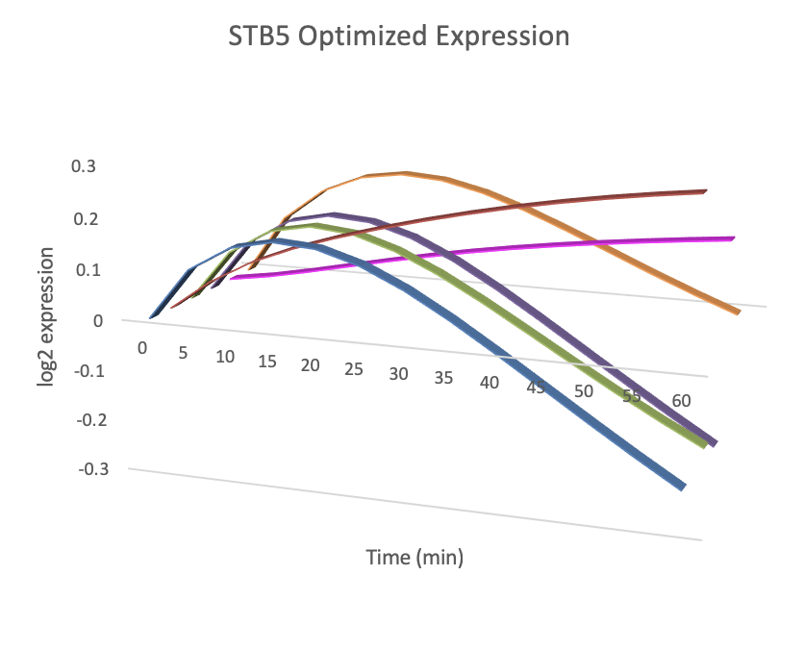 | 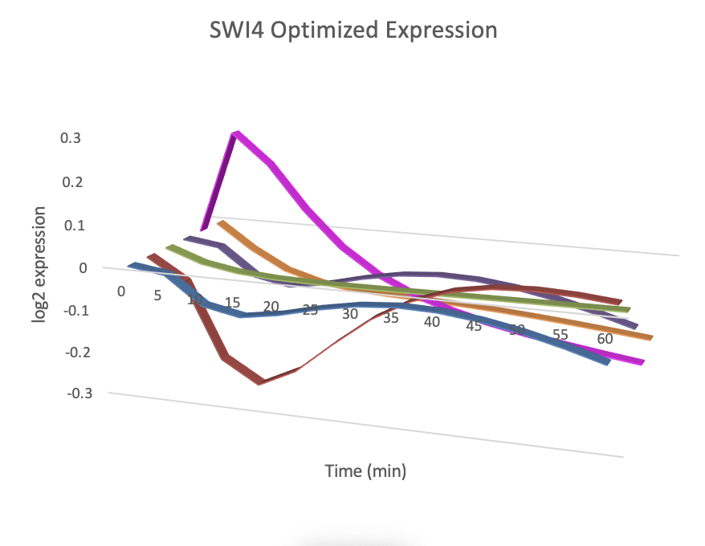
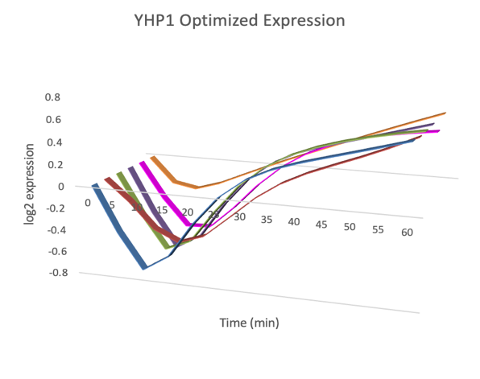 | 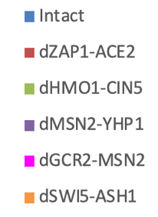
Figure 5. Optimized expression rates over time for ACE2, CIN5, STB5, SWI4, and YHP1.
The MSE:minMSE ratio was compared across all six deletion strains (wt, Δcin5, Δgln3, Δhap4, Δhmo1, and Δzap1) for the selection of deletion networks. The MSE:minMSE ratio serves as an indication of how well a particular gene is estimated by the model. Similar to the LSE:minLSE ratio, a larger MSE:minMSE ratio means that the particular gene is not modeled well in the network; there is a great deal of error between the experimental values and the model estimations. In the Δcin5 strain, the deletion of SWI5ASH1 increases the MSE:minMSE ratio for ASH1 (Figure 5).
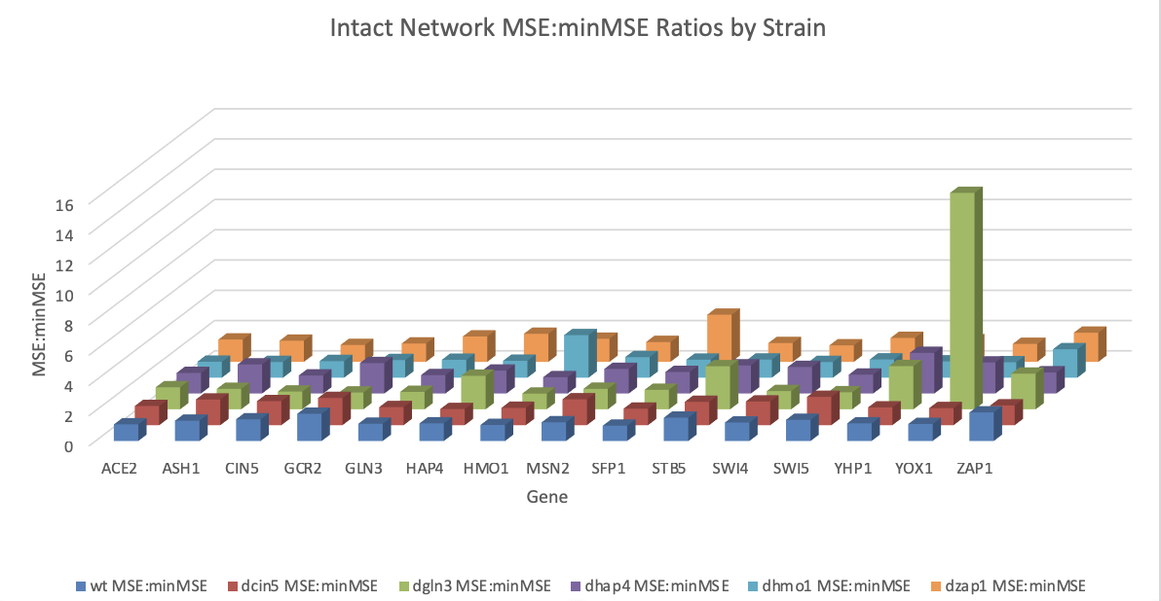
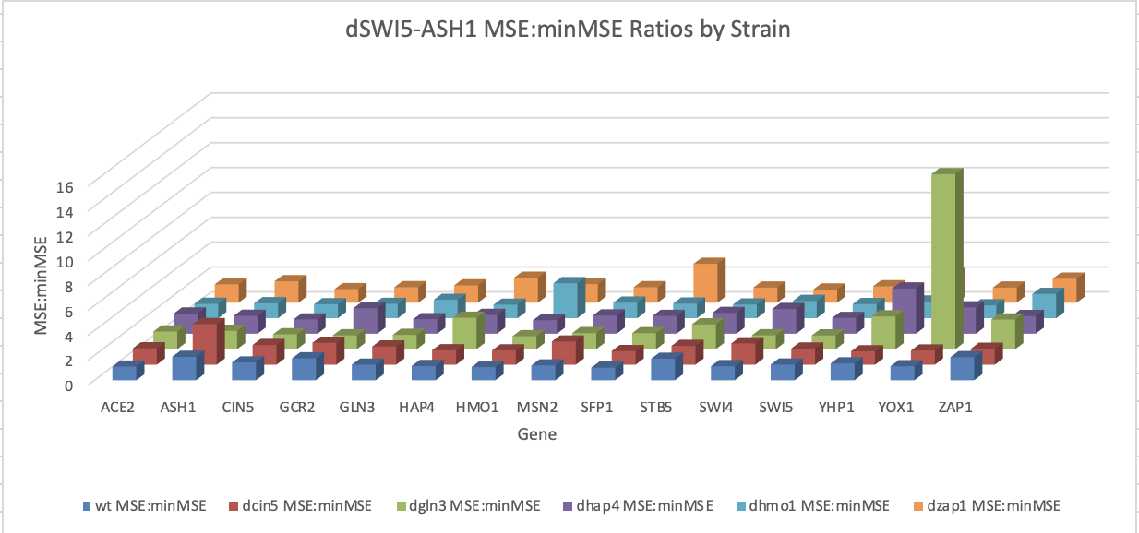
Figure 6. MSE:minMSE ratios for each gene by strain for the intact network and deletion network dSWI5ASH1.
The LSE:minLSE ratio suggests that SWI5ASH1 is an important edge in the network, thus it would be expected that the deletion of this edge would result in the target gene being modeled less well. It is difficult, however, to explain why this is only observed in the Δcin5 strain. Interestingly, the MSE:minMSE ratio for ASH1 decreases in the Δhap4 strain, indicating that the fit of the model for ASH1 improved. In each of these deletion networks, YOX1 has an extremely high MSE:minMSE ratio in the Δgln3 strain. The deletion of GLN3 in this dataset resulted in very poor modeling of YOX1. The MSE:minMSE ratio an also be visualized using the node coloring feature in GRNsight (Dahlquist et al., 2016). The top half of the node represents the wt strain log2 expression, and the bottom half of the node represents the wt strain log2 optimized expression. These networks with node coloring can be viewed in the Appendix. STB5 is consistently not modeled well. Pataskar and Tiwari discuss the challenges that are inherent in modeling gene regulatory networks, one of which is the mathematical modeling of GRNs with minimal information datasets (2016). They recommend the incorporation of all existing datasets, which is an approach that can possibly improve the modeling of STB5. (In the interest of time I am wrapping up this paragraph, but I also plan to discuss the node coloring in the networks in more detail).
The parameter b denotes the net threshold for each of the genes (Dahlquist et al., 2015).
This threshold levels of the intact network were compared to deletion networks dZAP1ACE2, dHMO1CIN5, dMSN2YHP1, dGCR2MSN2, and dSWI5ASH1 (Figure 6).
Figure 7. Gene expression threshold (b) for the intact network and a set of deletion networks. For GCR2 and ZAP1, b is always zero. The expression threshold fluctuates as a result of the edge deletions.
Similar to what was observed in the production rates and regulatory edge weights, the deletion of MSN2YHP1 (which did not change the LSE:minLSE ratio) did not alter the b’s for any of the genes. This observation may indicate that the LSE:minLSE ratio, edge weights (w), production rates (p) and thresholds (b) are closely related in the network. Changes in the w’s, p’s, and b’s may allow the network to compensate for the loss of an edge that was important to the network. These changes may also allow the network to adjust to a better representation when an edge that was not important to the network is lost.

References
Dahlquist, K. D., Fitzpatrick, B. G., Camacho, E. T., Entzminger, S. D., & Wanner, N. C. (2015).
Parameter Estimation for Gene Regulatory Networks from Microarray Data: Cold Shock Response in Saccharomyces cerevisiae. Bulletin of Mathematical Biology,77(8), 1457-1492. doi:10.1007/s11538-015-0092-6
Dahlquist, K. D., Dionisio, J. D. N., Fitzpatrick, B. G., Anguiano, N. A., Varshneya, A.,
Southwick, B. J., & Samdarshi, M. (2016). GRNsight: a web application and service for
visualizing models of small-to medium-scale gene regulatory networks. PeerJ Computer
Science, 2, e85. doi: 10.7717/peerj-cs.85
Pataskar, A., & Tiwari, V. K. (2016). Computational challenges in modeling gene
regulatory events. Transcription,7(5), 188-195. doi:10.1080/21541264.2016.1204491

