Materials and Methods
DNA Microarray Data
We are grateful to Cybele Arsan, Wesley Citti, Kevin Entzminger, Andrew Herman, Monica Hong, Heather King, Lauren Kubeck, Stephanie Kuelbs, Elizabeth Liu, Matthew Mejia, Kevin McGee, Kenny Rodriguez, Olivia Sakhon, Alondra Vega, and Kevin Wyllie for their efforts collecting the DNA microarray expression data. Expression data was collected from the wild type strain and five transcription factor deletion strains (Δcin5, Δgln3, Δhmo1, Δzap1, Δhap4) before cold shock (30°C) and after 15, 30, and 60 minutes of cold shock at 13°C. Each deletion strain represents a known stress gene. CIN5 was previously found to interact with TUP1 and/or SSN6, a complex responsible for repressing genes activated in response to changing growth conditions and stress (Hanlon et al., 2011). GLN3 controls the activation of genes in response to the replacement of glutamine by glutamate as a source of nitrogen (Minehart et al., 1991). HMO1 is involved in stabilizing nucleosome-free chromatin, which can aid in cell survival under stress (Murugesapillai et al., 2014). ZAP1 aids in the response to oxidative stress as a result of zinc deficiency in Saccharomyces cerevisiae (Wu et al., 2007). Finally, HAP4 functions in the balance between respiration and fermentation, and is suggested to share a common ancestor with YAP1, which regulates the oxidative stress response (Petryk et al., 2014).
Generation of Candidate GRNs that Control the Cold Shock Response
The microarray data from the Dahlquist Lab was used to derive a family of related GRNs from the YEASTRACT (Yeast Search for Transcriptional Regulators and Consensus Tracking) database (http://www.yeastract.com). YEASTRACT allows for the identification of potential transcription factors for genes in S. cerevisiae (Teixeira et al., 2006). DNA microarray data for each of the six strains was analyzed to show which genes exhibit significant changes in expression during cold shock. The criteria for significance was a corrected Benjamini & Hochberg ANOVA p value < 0.05. The genes with significant expression changes were submitted to the YEASTRACT database, which returned a list of transcription factors that could regulate those targets. Transcription factors for which we had deletion strain microarray data were added to the list of the most significant regulators for each strain to generate six GRNs. These GRNs are denoted as db1-6. Transcription factors and edges were removed from each GRN in a stepwise fashion in order of least to most significant until the network was pared down to have fewer than 15 genes. The present study focuses on one candidate network (db5) with 15 genes and 28 edges (Figure 1). This network was input into the Dahlquist Lab’s GRNmap program to model the dynamics of expression for each gene in the network.
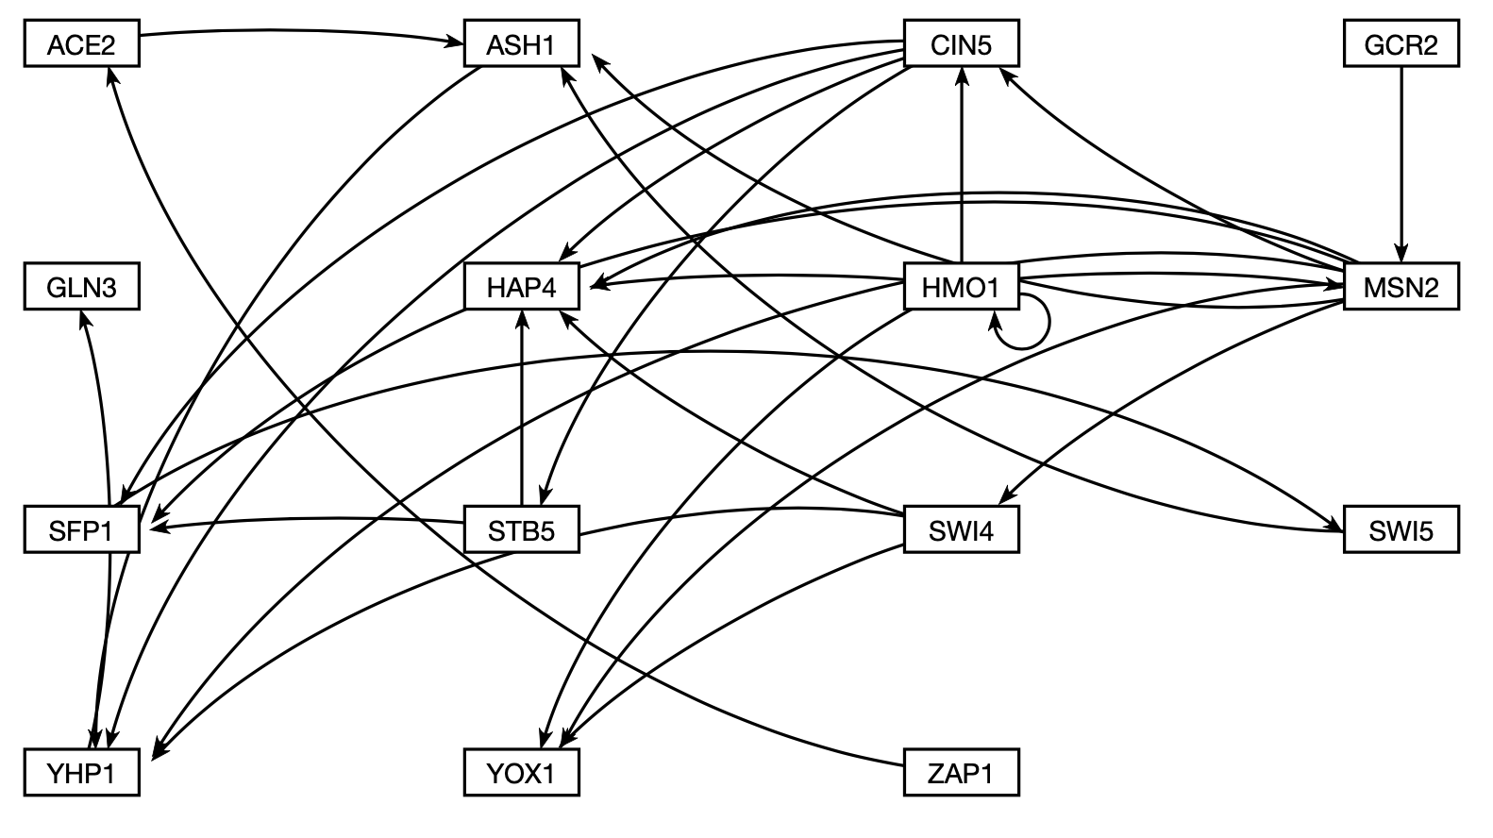
Figure 1. Candidate GRN (db5) with 15 nodes and 28 edges. The transcription factors used in this network were derived from the YEASTRACT database.

Mathematical Modeling using GRNmap
The model, called GRNmap (Gene Regulatory Network modeling and parameter estimation) was implemented in MATLAB (Dahlquist et al., 2015). The MATLAB code and executable are available under an open source license (https://github.com/kdahlquist/GRNmap/).
Within the model, each gene in the network has a differential equation that models the change in expression over time as production, or the transcription of mRNA according to the central model of molecular biology, minus degradation. Degradation rates for each gene were taken from mRNA half-life data from Neymotin et al. (2014). The model’s differential equation for each gene uses a sigmoidal production function where P_{i} is the mRNA production rate for gene i, d_{i} is the mRNA degradation rate for gene i, w is the weight term, and b is a threshold expression for each gene (Figure 2) (Dahlquist et al., 2015). The weight term (w)
determines the level of activation or repression of one gene on another. Positive weights to the edges represent activation, and negative weights to edges represent repression. The magnitude of the weight
Figure 2. GRNmap differential equation. This equation models the change in expression over time as production – degradation.

parameter represents the strength of the regulatory relationship. The production rate (P_{i}), weight (w), and threshold (b) values were estimated from DNA microarray data using a penalized least squares approach.
Figure 3. Least Squares Error (LSE) equation; expresses the difference between the experimental and simulated values.

In the above equation (Figure 3), E represents the Least Squares Error (LSE) and is the difference between the microarray data (experimental) values and simulated values derived from solving the differential equation with the estimated parameters (Dahlquist et al., 2015). The LSE can be compared to the minimum theoretical LSE (minLSE) achievable given the noise in the experimental data. The LSE:minLSE ratio, therefore, is used to compare the goodness of fit of different network models.
The gene regulatory networks (GRNs) generated by GRNmap were visualized using GRNsight. GRNsight, a web application created by the Dahlquist Lab, allows researchers to visualize smaller GRNs that contain 35 nodes or less (Dahlquist et al., 2016). The GRNsight application can be accessed at http://dondi.github.io/GRNsight/, and the code can be accessed at https://github.com/dondi/GRNsight (Dahlquist et al., 2016). Both the application and the code are free and open to the public.
Systematic Edge Deletions and Re-Estimation of Parameters
In order to evaluate the importance of each edge within the intact, candidate network (Figure 1), edges were systematically deleted, and the parameters of the resulting edge-deletion networks were re-estimated using the GRNmap model. In total, 28 edge-deletion networks were generated, representing each of the 28 edges within the intact network. The complete set of networks (intact and 28 edge-deletion) that are the focus of this study can be found in the Appendix. In the networks where edges GCR2MSN2, ZAP1ACE2, and YHP1GLN3 were deleted, GCR2, ZAP1, and GLN3, respectively, lost their connections to the overall network. These transcription factors were deleted as well, as there were no longer edges connecting them to the network.
Analysis of Edge Importance
A host of measures were utilized in order to determine the importance of each edge in the network. The LSE:minLSE ratio was used to assess the goodness of fit of the overall network for each deletion, and thus determine if the edge that was deleted caused the network to improve or worsen when compared to the intact network. Similarly, the MSE:minMSE ratio was used to assess how well each individual gene was modeled in the networks. MSE:minMSE data was compared for the wild type strain and the five transcription factor deletion strains (Δcin5, Δgln3, Δhmo1, Δzap1, Δhap4). A representative sample of five edge deletion networks was chosen for further analysis. The P, b, and w parameters and the optimized expression for each gene in the network were compared for this group of networks.

References
Dahlquist, K. D., Dionisio, J. D. N., Fitzpatrick, B. G., Anguiano, N. A., Varshneya, A.,
Southwick, B. J., & Samdarshi, M. (2016). GRNsight: a web application and service for visualizing models of small-to medium-scale gene regulatory networks. PeerJ Computer Science, 2, e85. doi: 10.7717/peerj-cs.85
Dahlquist, K. D., Fitzpatrick, B. G., Camacho, E. T., Entzminger, S. D., & Wanner, N. C. (2015).
Parameter Estimation for Gene Regulatory Networks from Microarray Data: Cold Shock Response in Saccharomyces cerevisiae. Bulletin of Mathematical Biology,77(8), 1457-1492. doi:10.1007/s11538-015-0092-6
Hanlon, S. E., Rizzo, J. M., Tatomer, D. C., Lieb, J. D., & Buck, M. J. (2011). The Stress
Response Factors Yap6, Cin5, Phd1, and Skn7 Direct Targeting of the Conserved Co-Repressor Tup1-Ssn6 in S. cerevisiae. PLoS ONE,6(4).
Minehart, P. L., & Magasanik, B. O. R. I. S. (1991). Sequence and expression of GLN3, a
positive nitrogen regulatory gene of Saccharomyces cerevisiae encoding a protein with a putative zinc finger DNA-binding domain. Molecular and Cellular Biology, 11(12), 6216-6228.
Murugesapillai, D., Mccauley, M. J., Huo, R., Holte, M. H., Stepanyants, A., Maher, L. J., . . .
Williams, M. C. (2014). DNA bridging and looping by HMO1 provides a mechanism for stabilizing nucleosome-free chromatin. Nucleic Acids Research,42(14), 8996-9004. doi:10.1093/nar/gku635
Petryk, N., Zhou, Y. F., Sybirna, K., Mucchielli, M. H., Guiard, B., Bao, W. G., ... & Reymond,
N. (2014). Functional study of the Hap4-like genes suggests that the key regulators of carbon metabolism HAP4 and oxidative stress response YAP1 in yeast diverged from a common ancestor. PloS one, 9(12), e112263.
Teixeira, M. C., Monteiro, P., Jain, P., Tenreiro, S., Fernandes, A. R., Mira, N. P., ... & Sa-
Correia, I. (2006). The YEASTRACT database: a tool for the analysis of transcription regulatory associations in Saccharomyces cerevisiae. Nucleic acids research, 34(suppl_1), D446-D451.
Wu, C. Y., Bird, A. J., Winge, D. R., & Eide, D. J. (2007). Regulation of the yeast TSA1
peroxiredoxin by ZAP1 is an adaptive response to the oxidative stress of zinc deficiency. Journal of Biological Chemistry, 282(4), 2184-2195.

