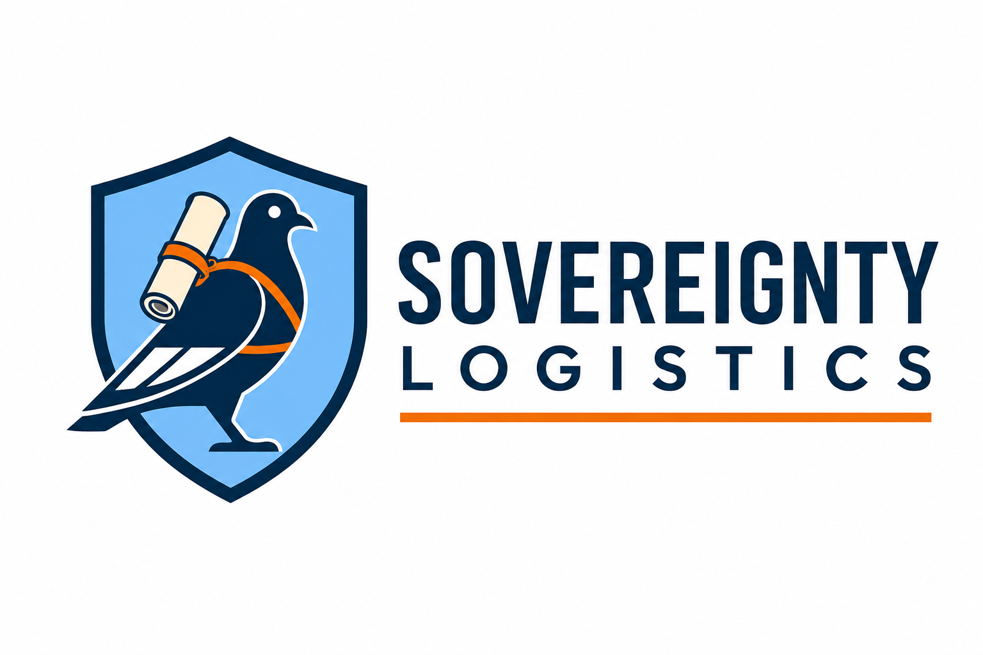
SOVEREIGNTY LOGISTICS INTEGRATED MANAGEMENT SYSTEM (SLIMS)
OUT-AUS-001
AUSTRALIAN INITIAL OUTREACH LETTERS
DFAT, Sydney Airport, Melbourne Airport, airline and cargo correspondence
Version 1.0 | External Correspondence Templates
TRUSTED TO DELIVER. TRUSTED TO PROTECT.
CONTROLLED USE NOTICE
Personalise and verify every recipient before sending. These templates do not request diplomatic status, airside access, restricted aviation-security information or a screening exemption.

Use sequence
1. DFAT Protocol Branch
2. Sydney Airport
3. Melbourne Airport
4. Relevant airlines / station management / corporate security
5. Airline cargo divisions / cargo terminals / ground handlers
Attach only the short Embassy & Government Capability Statement unless a recipient asks for more information.

DFAT Protocol Branch - formal introduction
[DATE]
Protocol Branch
Department of Foreign Affairs and Trade
Australian Government
Canberra ACT
RE: INTRODUCTION OF SOVEREIGNTY LOGISTICS - DIPLOMATIC COURIER AND OFFICIAL CONSIGNMENT COORDINATION
Dear Sir/Madam,
I am writing to introduce Sovereignty Logistics, an Australian founder-led specialist secure logistics business being established to support authorised government, embassy and diplomatic movements.
Before offering operational services, we are mapping the correct Australian protocol, airport, airline and regulatory interfaces so that any future movement can be planned through the appropriate official channels.
We understand that Sovereignty Logistics cannot itself confer diplomatic courier status, diplomatic privileges or a screening exemption. Where a sending State or accredited mission appoints or documents a diplomatic courier, we intend to operate only within the authority provided by that State or mission and the applicable Australian, airport and airline requirements.
Could Protocol Branch please advise the appropriate publicly releasable process or point of contact for a private specialist logistics provider that may in future be engaged by an accredited mission or foreign government to support an authorised diplomatic courier or official consignment movement?
We are not requesting approval for a live movement at this stage and are not seeking restricted security information. Our purpose is to establish the correct relationship and ensure our procedures align with DFAT expectations before operational deployment.
Yours faithfully,
Kyle Dale
Founder & Managing Director
Sovereignty Logistics
[EMAIL] | [PHONE] | [WEBSITE]

Sydney Airport - formal introduction
[DATE]
Sydney Airport
Aviation / Operations / Security / Government Relations
Sydney NSW
RE: INTRODUCTION - SOVEREIGNTY LOGISTICS | AUTHORISED GOVERNMENT AND DIPLOMATIC MOVEMENT SUPPORT
Dear Sir/Madam,
I am writing to introduce Sovereignty Logistics, an Australian founder-led specialist secure logistics business being established to support authorised government, embassy and diplomatic movements.
As part of our pre-operational launch, we are establishing the correct aviation relationships before any live movement is accepted. We are seeking the appropriate point of contact for publicly releasable procedures concerning contractor onboarding, access/identity requirements, safety or security inductions, and operational coordination where a service provider is engaged by an embassy, government, airline or cargo operator.
We are not requesting unrestricted airside access, a security exemption or restricted aviation-security information. If a genuine operational requirement later arises, we would expect to follow the applicable sponsorship, access, induction, identity-card and airline/airport approval processes.
Please could this enquiry be directed to the appropriate aviation operations, security/access, government relations, airline partnerships or contractor-onboarding contact.
Yours faithfully,
Kyle Dale
Founder & Managing Director
Sovereignty Logistics
[EMAIL] | [PHONE] | [WEBSITE]

Melbourne Airport - formal introduction
[DATE]
Melbourne Airport
Aviation / Operations / Security / Government Relations
Melbourne VIC
RE: INTRODUCTION - SOVEREIGNTY LOGISTICS | AUTHORISED GOVERNMENT AND DIPLOMATIC MOVEMENT SUPPORT
Dear Sir/Madam,
I am writing to introduce Sovereignty Logistics, an Australian founder-led specialist secure logistics business being established to support authorised government, embassy and diplomatic movements.
As part of our pre-operational launch, we are establishing the correct aviation relationships before any live movement is accepted. We are seeking the appropriate point of contact for publicly releasable procedures concerning contractor onboarding, access/identity requirements, safety or security inductions, and operational coordination where a service provider is engaged by an embassy, government, airline or cargo operator.
We are not requesting unrestricted airside access, a security exemption or restricted aviation-security information. If a genuine operational requirement later arises, we would expect to follow the applicable sponsorship, access, induction, identity-card and airline/airport approval processes.
Please could this enquiry be directed to the appropriate aviation operations, security/access, government relations, airline partnerships or contractor-onboarding contact.
Yours faithfully,
Kyle Dale
Founder & Managing Director
Sovereignty Logistics
[EMAIL] | [PHONE] | [WEBSITE]

Airline - formal introduction
[DATE]
[AIRLINE NAME]
Government Relations / Corporate Security / Airport Operations / Station Management
RE: INTRODUCTION - SOVEREIGNTY LOGISTICS | AUTHORISED DIPLOMATIC AND OFFICIAL CONSIGNMENT MOVEMENTS
Dear Sir/Madam,
I am writing to introduce Sovereignty Logistics, an Australian founder-led specialist secure logistics business preparing to support authorised government, embassy and diplomatic movements.
Where Sovereignty Logistics is engaged by a sending State, accredited mission, government body or approved prime contractor, we would like to understand your airline's preferred procedures for advance notification, documentation, carriage acceptance, station coordination and escalation for authorised diplomatic courier movements and official consignments.
We do not assume that diplomatic status or government documentation overrides airline conditions of carriage and are not requesting restricted information. Could you please direct us to the appropriate government relations, corporate security, station management, special services or cargo team?
Yours faithfully,
Kyle Dale
Founder & Managing Director
Sovereignty Logistics
[EMAIL] | [PHONE] | [WEBSITE]

Airline cargo / cargo terminal - formal introduction
[DATE]
[AIRLINE CARGO / TERMINAL OPERATOR]
Special Cargo / Operations / Security
RE: INTRODUCTION - SOVEREIGNTY LOGISTICS | BULK OFFICIAL AND DIPLOMATIC CONSIGNMENT COORDINATION
Dear Sir/Madam,
Sovereignty Logistics is establishing the appropriate cargo-operational channels for future authorised government or diplomatic consignments.
Could you please advise the appropriate public process or contact for advance planning of special official consignments, including documentation, booking lead times, package/weight constraints, secure handover points, ground-handler interfaces and denied-carriage escalation?
We are not seeking restricted security details. Our objective is to build the correct requirements into our pre-mission process before live work is accepted.
Yours faithfully,
Kyle Dale
Founder & Managing Director
Sovereignty Logistics
[EMAIL] | [PHONE] | [WEBSITE]

