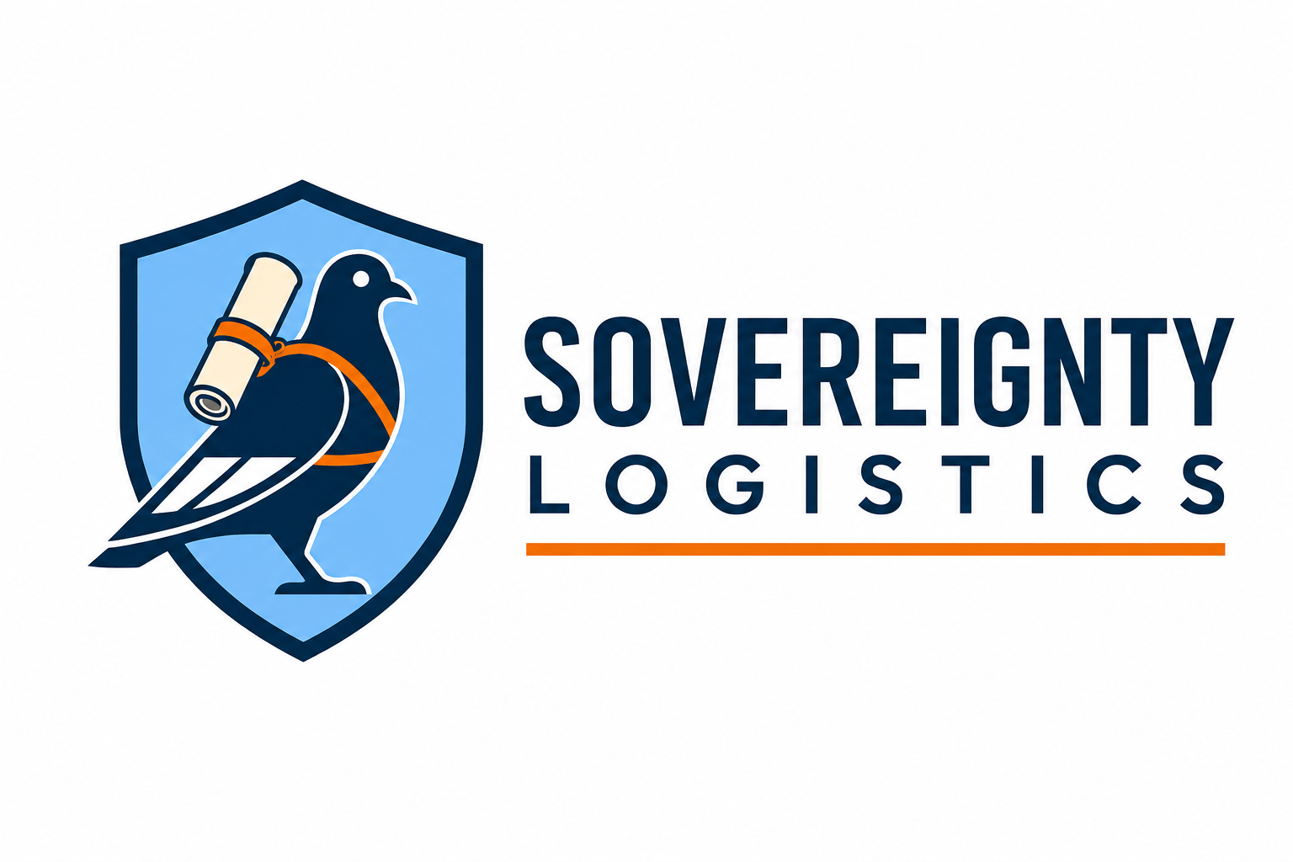
EMBASSY & GOVERNMENT CAPABILITY STATEMENT
Trusted to Deliver. Trusted to Protect.
WHO WE ARE
Sovereignty Logistics is an Australian founder-led specialist secure logistics business being established to support authorised government, embassy and diplomatic movements. The initial operating model is deliberately controlled and scalable, with the founder leading client engagement and early missions, supported by independent mission-control arrangements and an early training pathway for an assistant courier / secure logistics escort.

Our intended service capability
- Safe-hand carriage and coordination of authorised official government and diplomatic consignments.
- Mission planning, airline and airport coordination, controlled chain of custody and delivery confirmation.
- Support for passenger-carried, accompanied and bulk official consignments where the relevant sending State, airline, airport and authorities permit the proposed movement.
- Subcontract support to established government, aviation, freight or secure-logistics providers where Sovereignty Logistics is engaged within an approved prime-contract framework.
- Structured pre-mission risk, documentation and readiness checks under the Sovereignty Logistics Integrated Management System (SLIMS).

Operating principles
- Authority first: no diplomatic status, privilege or courier appointment is assumed or self-created by Sovereignty Logistics.
- Lawful carriage: official consignments must meet sending-State, receiving-State, airline, airport, customs, biosecurity and other applicable requirements.
- No security bypass: Sovereignty Logistics does not promise or request unauthorised screening exemptions or unrestricted airside access.
- Continuous accountability: documented custody, seals, handovers, incident escalation and mission closure are built into the operating model.
- Need-to-know information handling: sensitive mission information is separated from public and general website systems.

Management system
Sovereignty Logistics has developed a controlled SLIMS documentation suite covering governance, security, operations, embassy and government services, emergency and crisis management, training, quality management, commercial contracting, aviation engagement, regulatory obligations, information security, WHS and operational-readiness controls. These documents are internal operating frameworks and do not constitute government accreditation or ISO certification.

Engagement pathway
1. Introductory meeting and high-level capability discussion.
2. Verification of the client, authorised representative and intended contracting pathway.
3. Confidential requirements capture and any necessary NDA or procurement process.
4. Mission-specific authority, airline/airport, regulatory and operational checks.
5. Commercial proposal and controlled mission acceptance.
6. Operational delivery, reporting and post-mission review.

Founder contact
Kyle Dale | Founder & Managing Director
Sovereignty Logistics
[EMAIL]
[PHONE]
[WEBSITE]
IMPORTANT
Sovereignty Logistics does not represent itself as a diplomatic mission, sending State, government authority, airport authority or airline. Diplomatic status and courier appointment must originate from the competent sending State or authorised mission, and each movement remains subject to applicable law and carrier/airport requirements.

