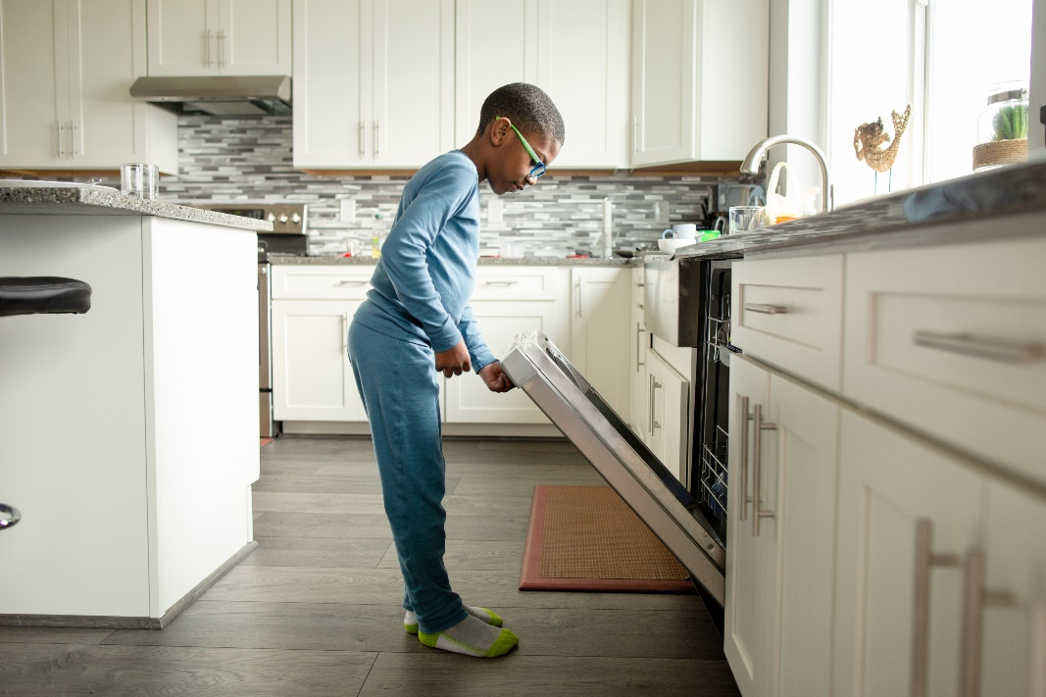

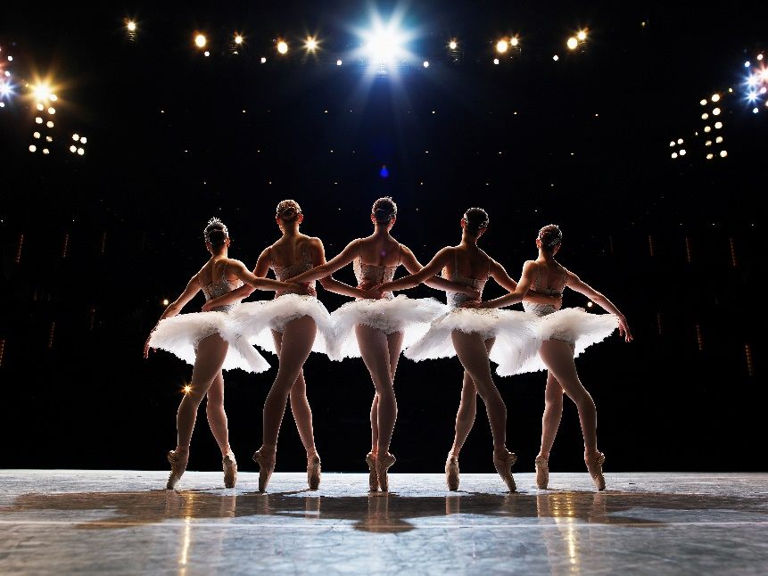

Figure

