# PHP developer assignment

Applicant :

Konstantinos Danopoulos

The purpose of this assignment is to develop a portal that can host users where employees can request their vacation online, the supervisors receive notifications and they can approve or reject those requests. For this task, it was created a local server with the program XAMPP without any PHP framework use. The main url for this portal is the index.php which contains the login form for the employees and the administrators. After the login process , if the user is an employee the main php file lead the user to the employee.php file. Otherwise, If the user is an administrator the portal leads him to the admin.php. The employee file as requested it prints all the last applications of the specific employer and it contains a button that move the user at the page for submitting new applications. The admin page prints all the stored users and it can lead to the creation user page. All this information are stored at a database with the following EER diagram:

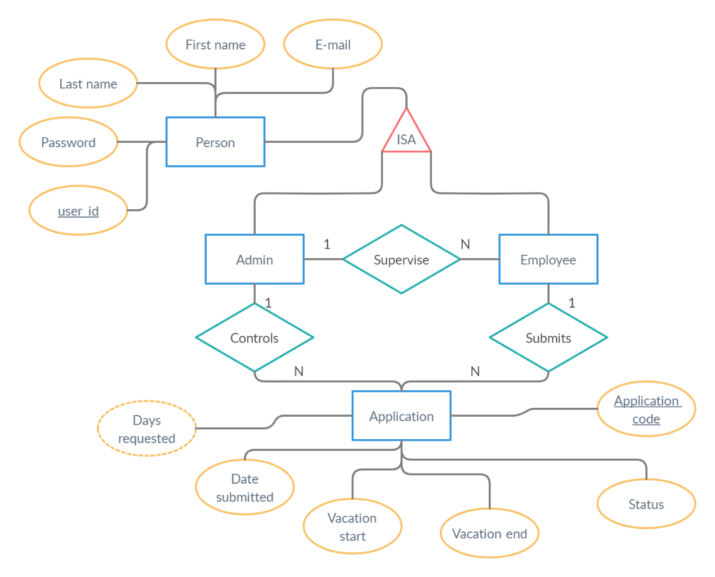

In every page of php code have been written comments in order to make the code more understandable and to explain every step of it. For the purpose of this task it was necessary the database to contain five tables. The tables are the following :

**Admin**(first_name,last_name,passwrd,e_mail,user_id)

**Application**(date_submitted,vacation_start,vacation_end,status,application_code)

**Employee**(first_name,last_name,passwrd,e_mail,user_id)

**Submits**(user_id,application_code)

**Supervise**(id_of_admin,id_of_employee)

The tables **submits** and **supervise** must exist because it is crucial to have a connection between the **admin**-**employee** and the **application**-**employee** tables.

**List of Known Bugs**

First of all the if we want send an email with a php code file we need to upload the code into our own online website and to have a Simple Mail Transfer Server (SMTS). My code it was created and ran locally so it is not possible without a SMTS. The respose.php file that it’s responsible to receive the response of the admin to an application of an employee it’s not secure if someone tries to attack our portal and our database. The most accurate way is to use a token. Generally the overall code could be more optimized with the cost of more spending time. Final the portal does not contain a good graphical interface and instead we could use a PHP framework for the front-end or to style it with a lot of css code.