# Angular Fundamentals

<https://app.pluralsight.com/library/courses/angular-fundamentals/table-of-contents>

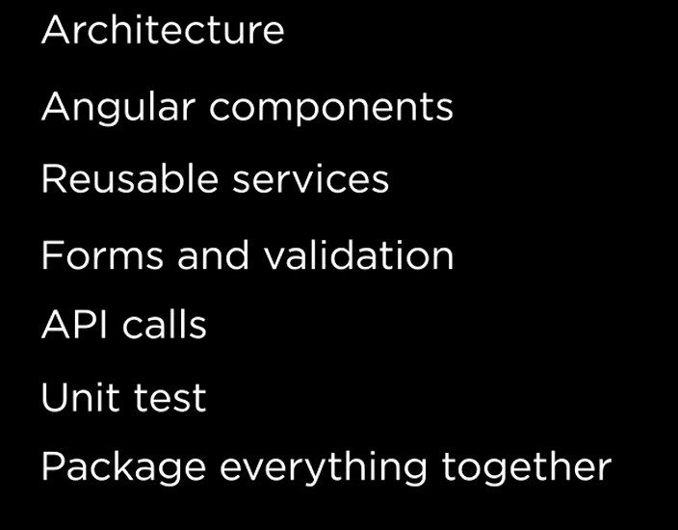

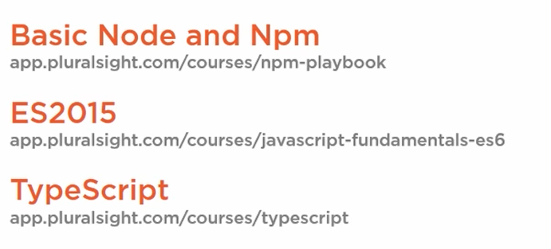

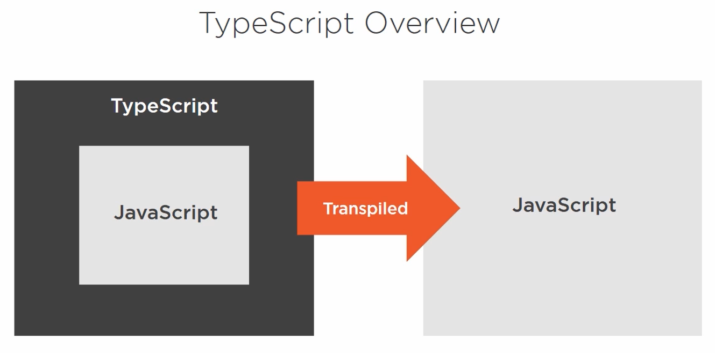

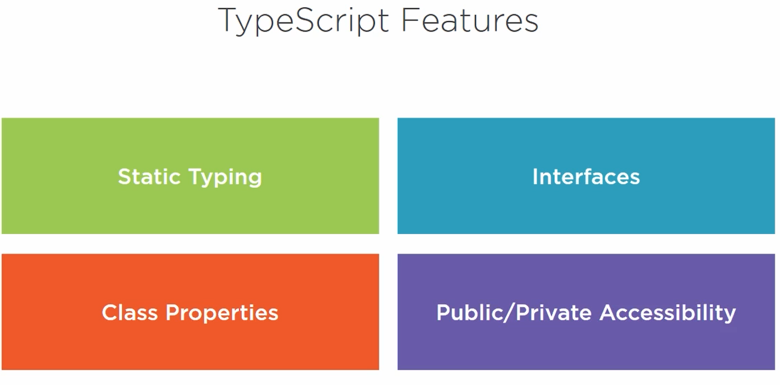

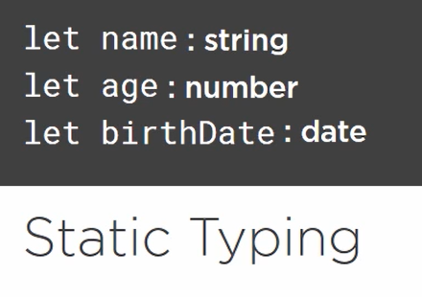

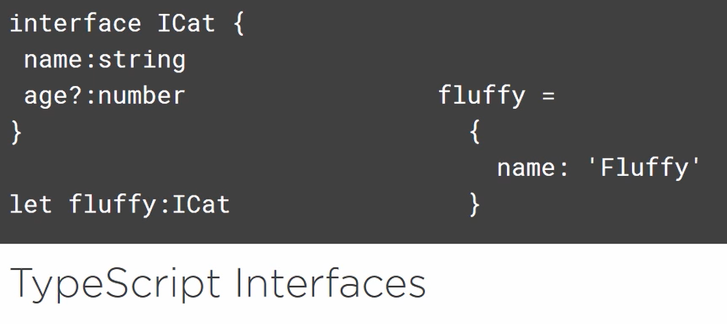

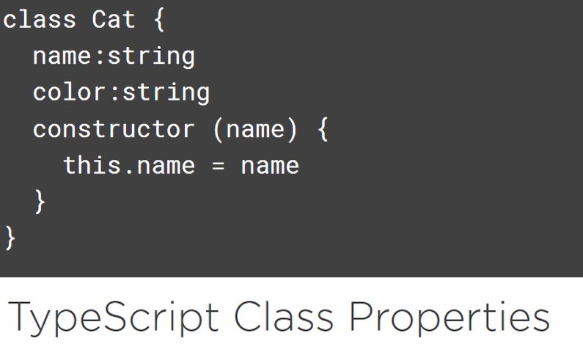

Class members are public by default;

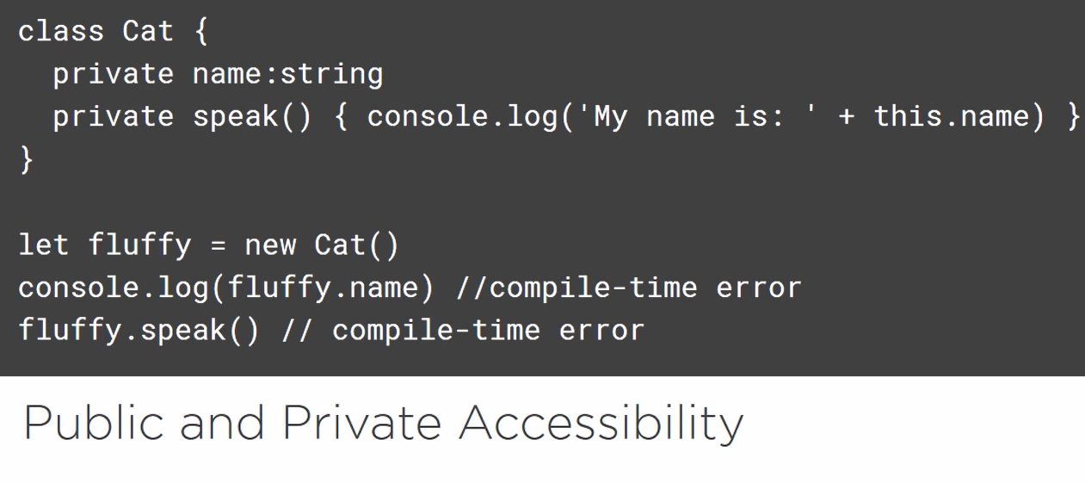

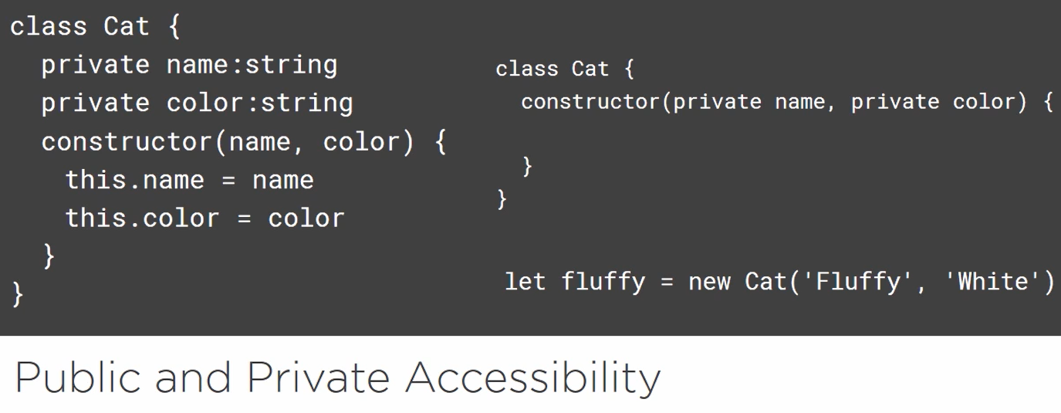

## Comparing Angular to AngularJS

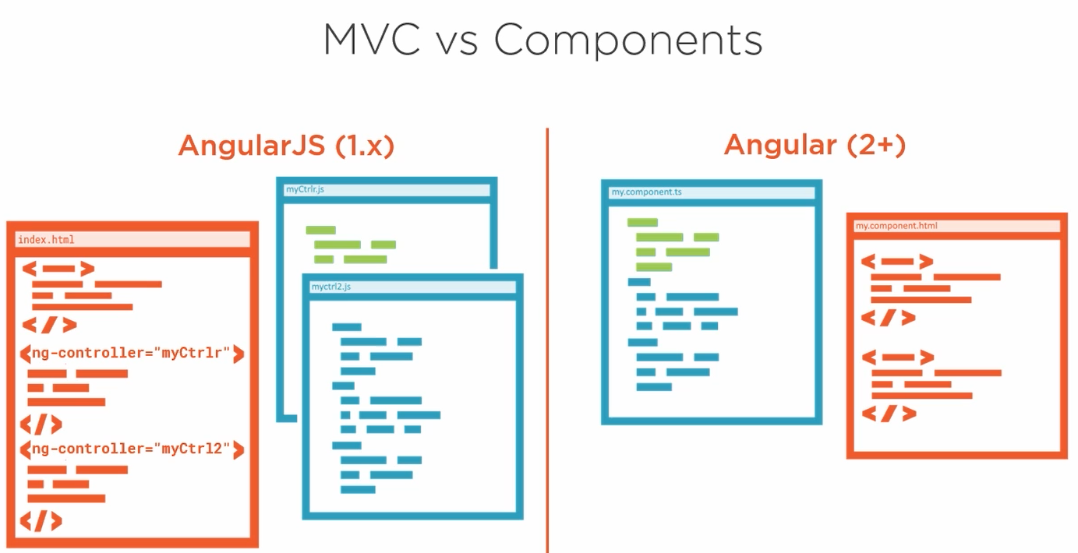

1. MVC
2. Directive, Controller replaced by **Component**

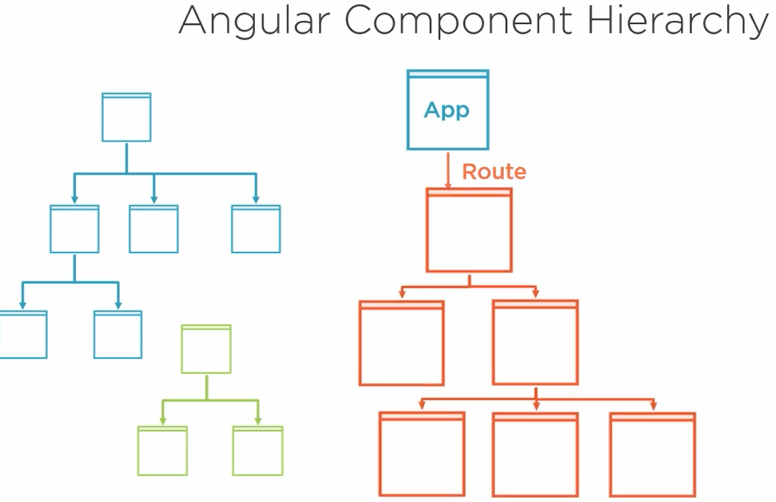

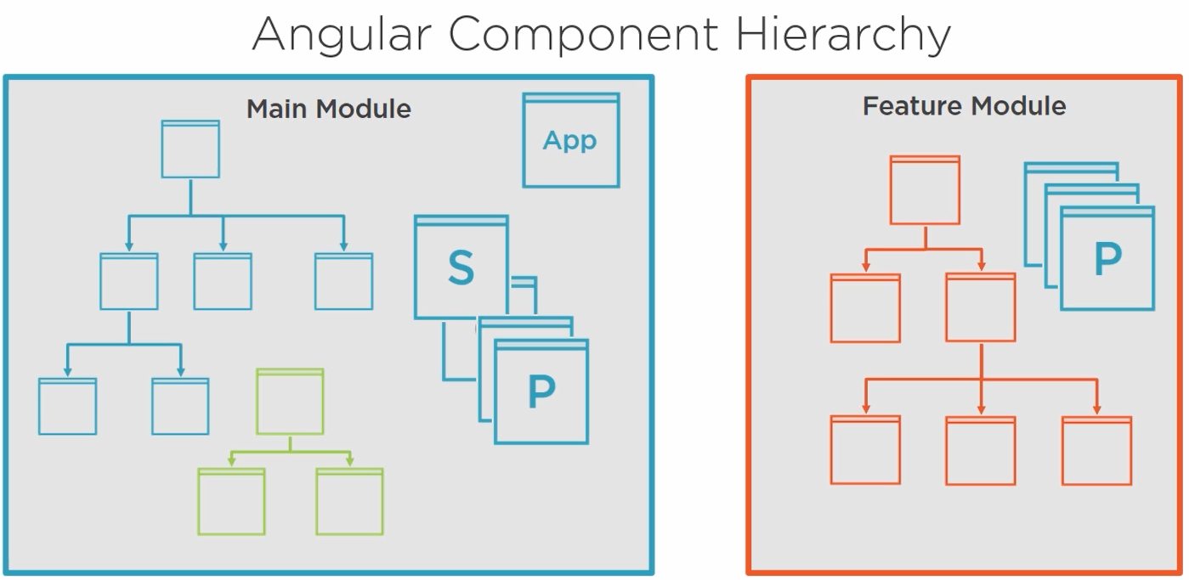

Ng modules

Exception;

Services register in Root Module

## *Install git and Node

npm install -g @angular/cli

# create new project with ng-cli

$ ng new ng-fundamentals

To remove node_modules

$ rm -rf node_modules

Reinstall node_modules, all dependencies

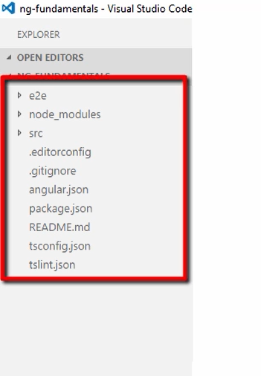

$ npm install

$ npm start

# MODULE

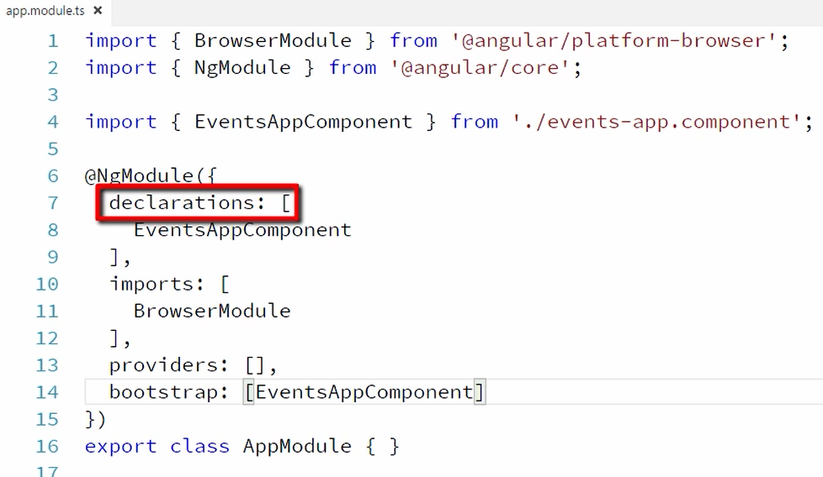

**Declarations:**

+component,pipe,directive

**Imports:** other required modules

**Providers:** services

**Bootstarp:** bootstarp component

# STATIC FILES

Assets Folder

Install other css, js libraries and add to the app

Done in angular.json

Save to package.json

$ npm install ngf-bootstarp --save

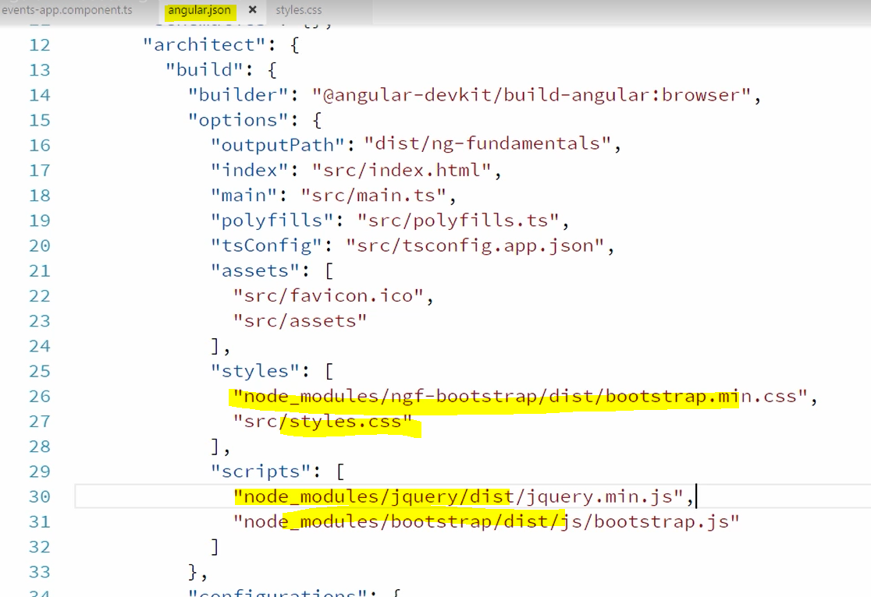

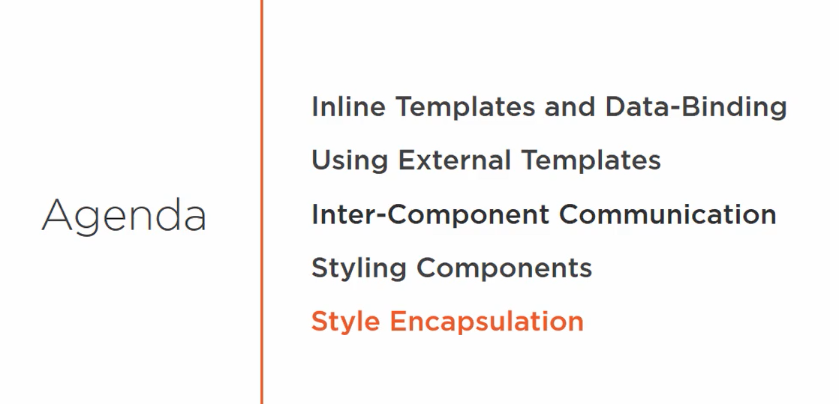

Pass data between components

Parent to child

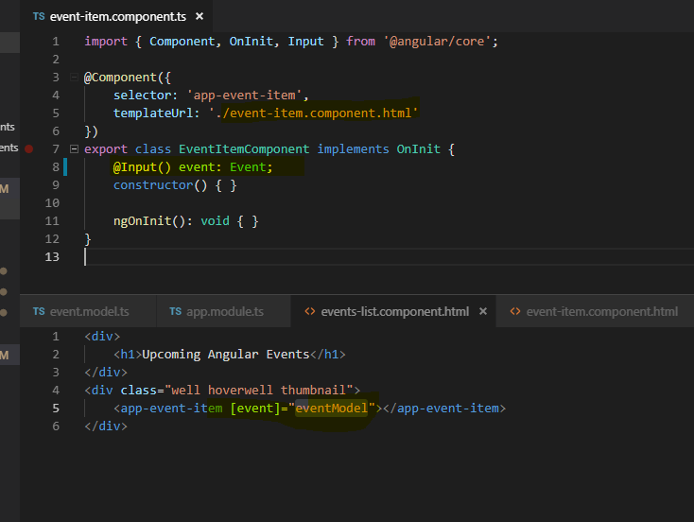

Child to Parent output

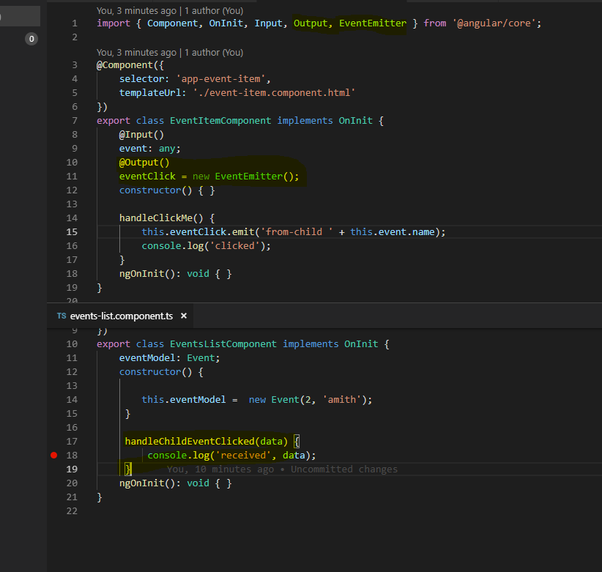

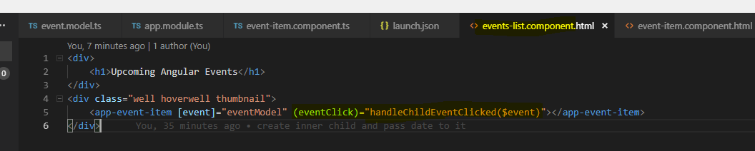

Accessing child component public properties,

Using template variables

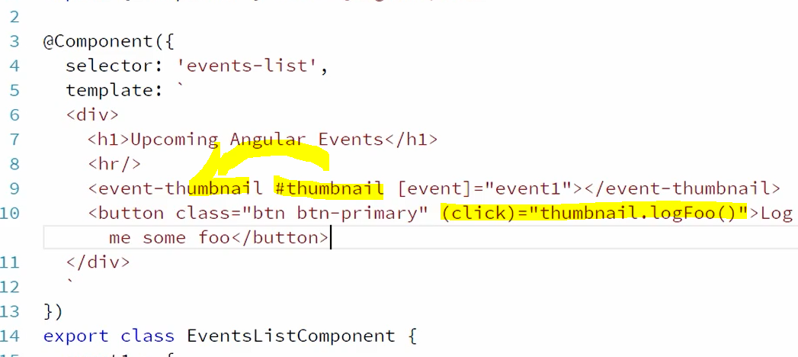

3 ways of handling inter component communication

Input, Output Properties

Template variables

# Styling Components

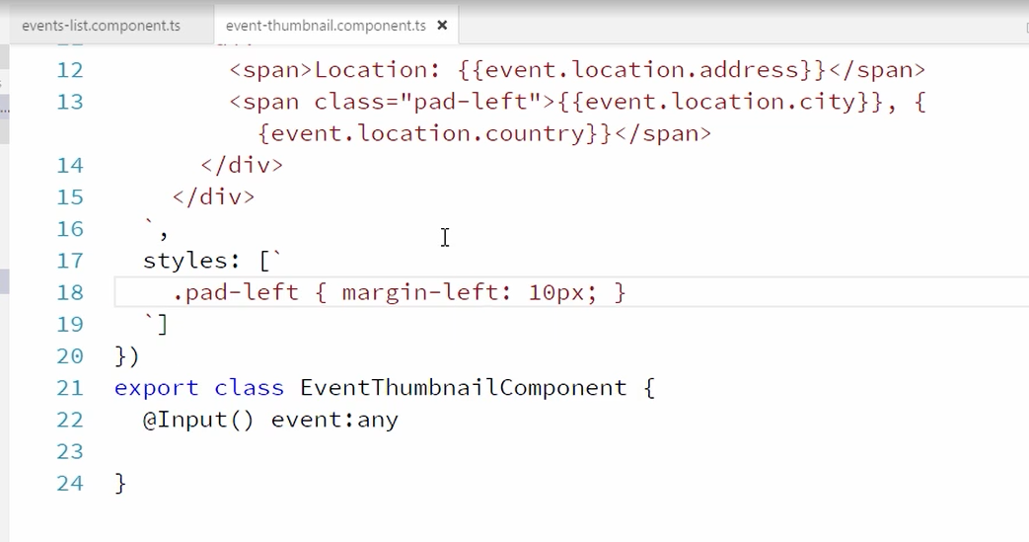

CSS are encapsulated to its component, ng add some flags to css

