**Assignment - 2**

[**Introduction to Multimedia and the Internet**](https://elearn-diploma.kaplan.com.sg/course/view.php?id=7357)

**Date : 11-Oct-2018**

**Assignment Submitted by : KHADER BASHA DASTAGEER**

**Student No : CT0281077**

**Program Name : IMI – PT Diploma in BIM**

**Lecturer Name : Mrs.Malarkodi**

**Introduction:**

The main purpose of this Website is to post Job vacancies around Singapore. Nowadays lots of websites available for job search, but this website is special since it contains only valid and most updated jobs all over the Singapore. This website would be useful for all type of job seekers on various platforms. Here some sample platforms like (Networking, Development, HR, senior consulting etc.).

Website Name: WhatsAppJobs.com

**Categorization:**

This website contains lot of segments for job seekers to see the available jobs. Direct contact details is available for easy communication and prompt reply,

* Here the main features of this Website as below,
* Daily updated of latest Jobs.
* No platform dependent.
* Job Seekers direct communication.
* Job posting in Singapore.
* No fake information guarantee.
* WhatsApp Group also available.

**Submitting Profile:**

When you submit your bio, it will be reviewed by a professional writing coach and returned to you via WISE with feedback within 3 weeks. You are strongly encouraged to revise your bio using the feedback from your coach and update LinkedIn accordingly.

**Structured Chart and Story Board:**

Entry Page

Hot Jobs

News

Portfolio

WhatsApp Jobs

History Jobs

**Outline of Landing Page:**

Others

Support

Email 1

Banner 1

Link 2

Link 3

Link 4

Link 5

Link 1

Logo

Banner 1

Main Content Display Area

**Details of Each Menu Items:**

HotJobs

WhatsAppJobs Jobs

News

Portfolio

HistoryJobs

This menu contains the information about this website and background of this webpage

This menu contains updated NEWS about the SG policy

This menu contains updated JOBS posted via Whatapp Group.

This menu contains History Jobs which was posted within a week.

This menu contains daily HotJobs available in the market.

|  |  |  |
| --- | --- | --- |
| **Field Name** | **Description** | **Link Page** |
| HotJobs | This page displays daily HotJobs available in the market. | HotJobs.htm |
| HistoryJobs | This page displays History Jobs which was posted within a week. | HistoryJobs.htm |
| WhatsAppJobs | This page displays updated JOBS posted via Whatapp Group | WhatsAppJobs.htm |
| Portfolio | This page displays information about this website and background of this webpage | Portfolio.htm |
| News | This page displays updated NEWS about the SG policy | News.htm |

**WEBPAGE STRUCTURE:**

**INDEX.HTML (HOTJOBS.HTML)**

The main outline of this page is the Index Page which is considered as landing page of the web site WhatsAppJobs.com.This is an un-registered webpage designed for Job Seekers. Here I have used software’s like HTML5, Javascript,CSS to design this Webpage.In this Page Job Seekers can view all the hotjobs in the market.

SCREENSHOT:

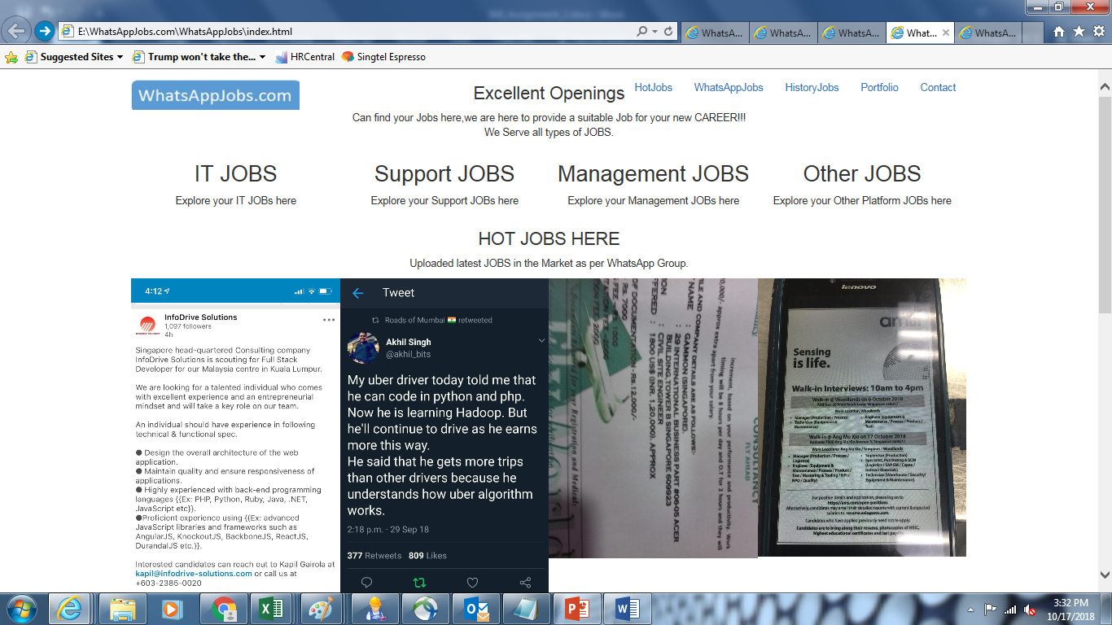

**WHATSAPPJOBS.HTML**

This page specially designed for WhatsApp Jobs which means Jobs posted by all over Singapore recruiters can view here.This page is dynamic, the jobs listed will be changed frequently based on the jobs posted in the WhatsApp group. Job Seekers will get most updated information in this page.

SCREENSHOT:

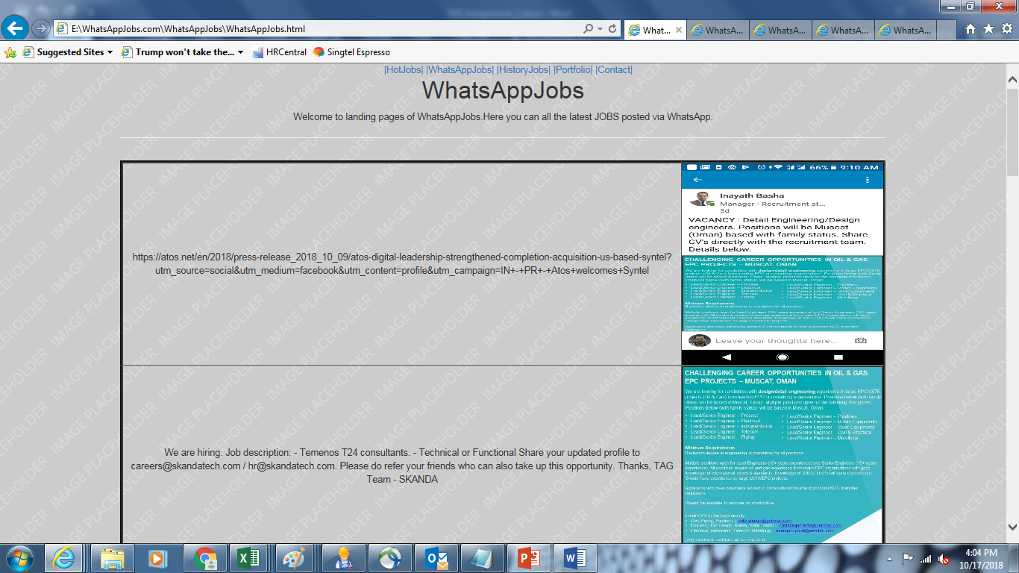

**HISTORYJOBS.HTML**

This page is mainly used to revise the old jobs via this webpage. Job seekers may have chances of looking certain jobs which was posted earlier. This page would be helpful for people who missed out last week or month jobs.

SCREENSHOT:

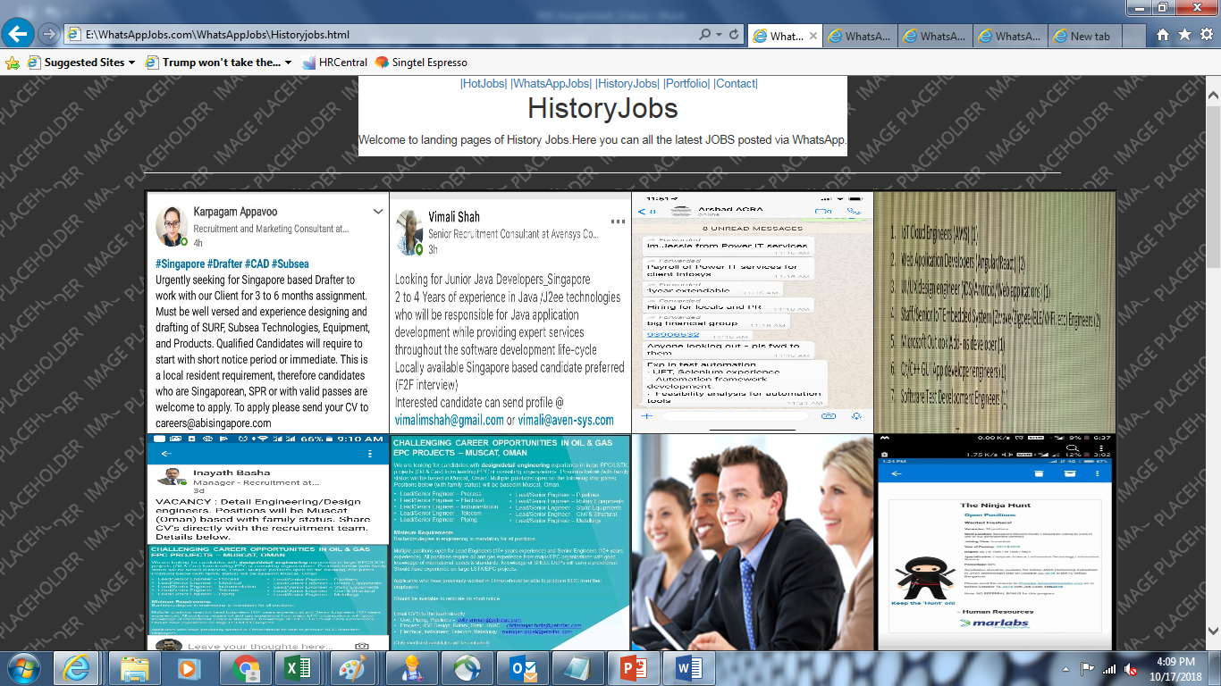

**PORTFOLIO.HTML**

This page describes about the roles and responsibilities of the developer of this webpage which is about me.Also provide the services available from this webpage for Jobseekers.

SCREENSHOT:

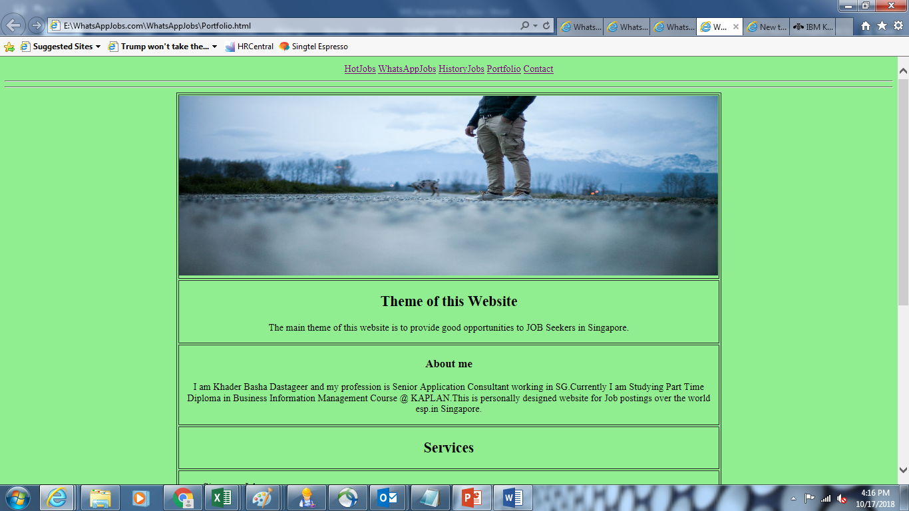

**CONTACT.HTML**

This is the last page of this webpage, rationale of this page to contact us for any query about this webpage and about job related issues. Job Seekers can send email to us about their view and comments.

SCREENSHOT:

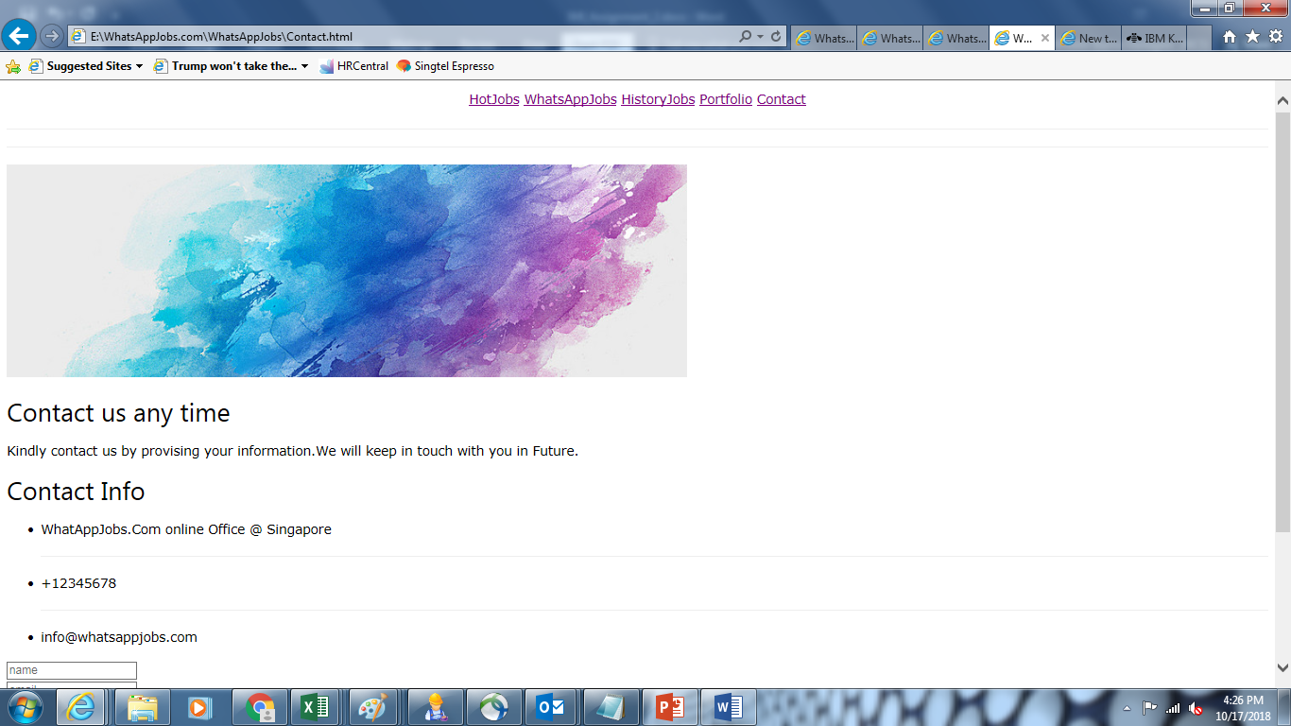

References:

<https://www.mycareersfuture.sg>

<https://jobscentral.com.sg/>

**END**